DEVOPS EXPERIMENTS

**NAME: GAURAV SINGH ROLL NO:19IT1074 BATCH:B/B3**

**Ramrao Adik Institute of Technology DEPARTMENT OF INFORMATION TECHNOLOGY ACADEMIC YEAR: 2021-2022**

## COURSE NAME : DevOps Lab

|  |  |  |  |  |  |  |  |  |
| --- | --- | --- | --- | --- | --- | --- | --- | --- |
| **COURSE CODE** | | | **ITL504** | | | | | |
| **EXPERIMENT NO.** | | | **1** | | | | | |
| **EXPERIMENT TITLE** | | | **TO UNDERSTAND DEVOPS: PRINCIPLES, PRACTICES, AND DEVOPS ENGINEER ROLE AND RESPONSIBILITIES** | | | | | |
| **NAME OF STUDENT** | | | **GAURAV SINGH** | | | | | |
| **ROLL NO.** | | | **19IT1074** | | | | | |
| **CLASS** | | | **TE - IT** | | | | | |
| **SEMESTER** | | | **V** | | | | | |
| **GIVEN DATE** | | | **21-07-2021** | | | | | |
| **SUBMISSION DATE** | | |  | | | | | |
| **CORRECTION DATE** | | |  | | | | | |
| **REMARK** | | |  | | | | | |
| **TIMELY SUBMISSION** | | **PRESENTATION** | | | **UNDERSTANDING** | | **TOTAL MARKS** | |
|  | **4** |  | | **4** |  | **7** |  | **15** |
| **NAME& SIGN. OF FACULTY** | | **Prof. Sujata Oak** | | |  | | | |

#### PRACTICAL NO: 1

**Aim:** To understand DevOps: Principles, Practices, and DevOps Engineer Role and Responsibilities.

**LO Number and Statement: LO1** – To understand the fundamentals of DevOps engineering and be fully proficient with DevOps terminologies, concepts, benefits, and deployment options to meet your business requirements.

#### Theory:

* **What is DevOps?**

DevOps is a set of practices that combines [software development](https://en.wikipedia.org/wiki/Software_development) (Dev) and [IT](https://en.wikipedia.org/wiki/IT_operations) operations (Ops).. It’s a practice that aims at merging development, quality assurance, and operations (deployment and integration) into a single, continuous set of processes. It aims to shorten the [systems development life cycle](https://en.wikipedia.org/wiki/Systems_development_life_cycle) and provide [continuous delivery](https://en.wikipedia.org/wiki/Continuous_delivery) with high [software quality](https://en.wikipedia.org/wiki/Software_quality)

By adopting DevOps companies gain three core advantages that cover technical, business, and cultural aspects of development.

* + **Higher speed and quality of product releases:** DevOps speeds up product release by introducing continuous delivery, encouraging faster feedback, and allowing developers to fix bugs in the system in the early stages. Practicing DevOps, the team can focus on the quality of the product and automate a number of processes.
  + **Faster responsiveness to customer needs:** With DevOps, a team can react to change requests from customers faster, adding new and updating existing features. As a result, the time-to-market and value-delivery rates increase.
  + **Better working environment:** DevOps principles and practices lead to better communication between team members, and increased productivity and agility. Teams that practice DevOps are considered to be more productive and cross-skilled. Members of a DevOps team, both those who develop and those who operate, act in concert.

#### DevOps Principles:

The principles of Devops are:

#### Customer-Centric Action:

It is imperative nowadays to have short feedback loops with real customers and end-users, and that all activity in building IT products and services centers around these clients. To be able to meet these customers’ requirements, DevOps organizations require the guts to act as lean startups that innovate continuously, pivot when an individual strategy is not (or no longer) working, and constantly invests in products and services that will receive a maximum level of customer delight.

#### Create with the End in Mind:

Organizations need to let go of waterfall and process-oriented models where each unit or individual works only for a particular role/function, without overseeing the complete picture. They need to act as product companies that explicitly focus on building working products sold to real customers, and all employees need to share the engineering mindset that is required actually to envision and realize those products.

#### End-To-End Responsibility:

In a DevOps environment teams are vertically organized such that they are fully accountable from concept to grave. IT products or services created and delivered by these teams remain under the responsibility of these stable groups. These teams also provide performance support, until they become end-of-life, which greatly enhances the level of responsibility felt and the quality of the products engineered.

#### Cross-Functional Autonomous Teams:

In product organizations with vertical, fully responsible teams, these teams need to be entirely independent throughout the whole lifecycle. That requires a balanced set of skills and also highlights the need for team members with T-shaped all-round profiles.These teams become a hotbed of personal development and growth.

#### Continuous Improvement:

End-to-end responsibility also means that organizations need to adapt continuously in the light of changing circumstances (e.g. customer needs, changes in legislation, new technology becomes available). In a DevOps culture, a strong focus is put on continuous improvement to minimize waste, optimize for speed, costs, and ease of delivery, and to continuously improve the products/services offered. Experimentation is therefore an

important activity to embed and develop a way of learning from failures is essential.

#### Automate Everything You Can:

Think of automation of not only the software development process (continuous delivery, including continuous integration and continuous deployment) but also of the whole infrastructure landscape by building next-gen container-based cloud platforms that allow infrastructure to be versioned and treated as code as well. Automation is synonymous with the drive to renew the way in which the team delivers its services.

#### DevOps Practices:

DevOps requires a delivery cycle that comprises planning, development, testing, deployment, release, and monitoring with active cooperation between different members of a team.

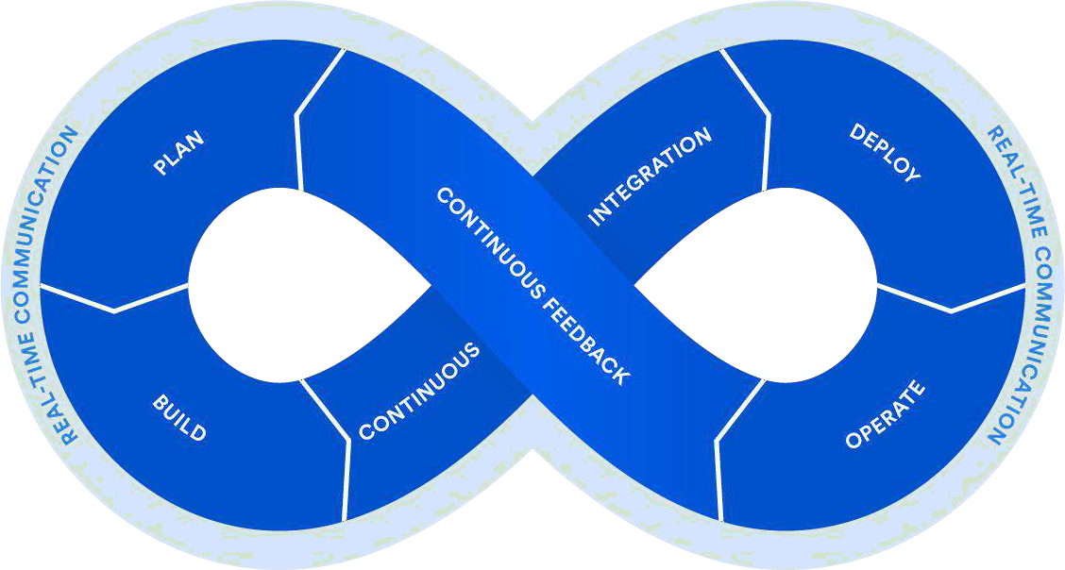

DevOps practices reflect the idea of continuous improvement and automation. Many practices focus on one or more development cycle phases. These practices include:

* + **Continuous development:** This practice spans the planning and coding phases of the DevOps lifecycle. Version-control mechanisms might be involved.
  + **Continuous testing:** This practice incorporates automated, prescheduled, continued code tests as application code is being written or updated. Such tests can speed the delivery of code to production.
  + [**Continuous integration (CI)**](https://www.netapp.com/knowledge-center/what-is-continuous-integration-continuous-delivery-cicd)**:** Continuous integration is a software development practice where developers regularly merge their code changes into a central repository, after which automated builds and tests are run. The key goals of continuous integration are to find and address bugs quicker, improve software quality, and reduce the time it takes to validate and release new software updates.
  + [**Continuous delivery**](https://www.netapp.com/devops-solutions/continuous-integration-continuous-delivery)**:** This practice automates the delivery of code changes, after testing, to a preproduction or staging environment. A staff member might then decide to promote such code changes into production.
  + **Continuous deployment (CD).** Similar to continuous delivery, this practice automates the release of new or changed code into production. A company doing continuous deployment might release code or feature changes several times per day. The use

of [container](https://www.netapp.com/devops-solutions/containers) technologies, such as Docker and Kubernetes, can enable continuous deployment by helping to maintain consistency of the code across different deployment platforms and environments.

* + **Continuous monitoring.** This practice involves ongoing monitoring of both the code in operation and the underlying infrastructure that supports it. A feedback loop that reports on bugs or issues then makes its way back to development.
  + [**Infrastructure as code**](https://www.netapp.com/devops-solutions/what-is-infrastructure-as-code-iac)**:** This practice can be used during various DevOps phases to automate the provisioning of infrastructure required for a software release. Developers add infrastructure “code” from within their existing development tools. For example, developers might create a storage volume on demand from Docker, Kubernetes, or OpenShift. This practice also allows operations teams to monitor environment configurations, track changes, and simplify the rollback of configurations.

#### DevOps Tools:

The main reason to implement DevOps is to improve the delivery pipeline and integration process by automating these activities. As a result, the product gets a shorter time-to-market. To achieve this automated release pipeline, the team must acquire specific tools instead of building them from scratch. Most famous tools are:

1. **Server configuration tools**: are used to manage and configure servers in DevOps.
   * **Puppet** is one of the most widely used systems in this category.
   * **Chef** is a tool for infrastructure as code management that runs both on cloud and hardware servers.
   * **Ansible** is a more popular solution that automates configuration management, cloud provisioning, and application deployment.
2. **CI/CD tools:** CI/CD stages also require task-specific tools for automation such as:
   * **Jenkins** that comes with lots of additional plugins to tweak continuous delivery workflow.
   * **GitLab CI**, a free and open-source CI/CD instrument presented by GitLab.
3. **Containerization and orchestration tools:** These stages rely on a bunch of dedicated tools to build, configure, and manage containers that allow software products to function across various environments.
   * **Docker** is the most popular instrument for building self-contained units and packaging code into them.
   * **OpenShift:** (commercial).
   * **Kubernetes**: (open-source).
4. **Monitoring and alerting tools:** Monitoring and alerting in DevOps is typically facilitated by
   * **Nagios**: a powerful tool that presents analytics in visual reports.
   * **Prometheus**: which is open-source.

#### A DevOps Engineer’s Role and Responsibilities:

The main function of a DevOps engineer is to introduce the continuous delivery and continuous integration workflow, which requires the understanding of the mentioned tools and the knowledge of several programming languages.

#### The basic and widely-accepted responsibilities of a DevOps engineer are:

* + Writing specifications and documentation for the server-side features.
  + Continuous deployment and continuous integration (CI/CD) management.
  + Performance assessment and monitoring.
  + Infrastructure management.
  + Cloud deployment and managemen.t
  + Assistance with DevOps culture adoption.

Additionally, a DevOps engineer can be responsible for IT infrastructure maintenance and management, which comprises hardware, software, network, storages, virtual and remote assets, and control over cloud data storage.

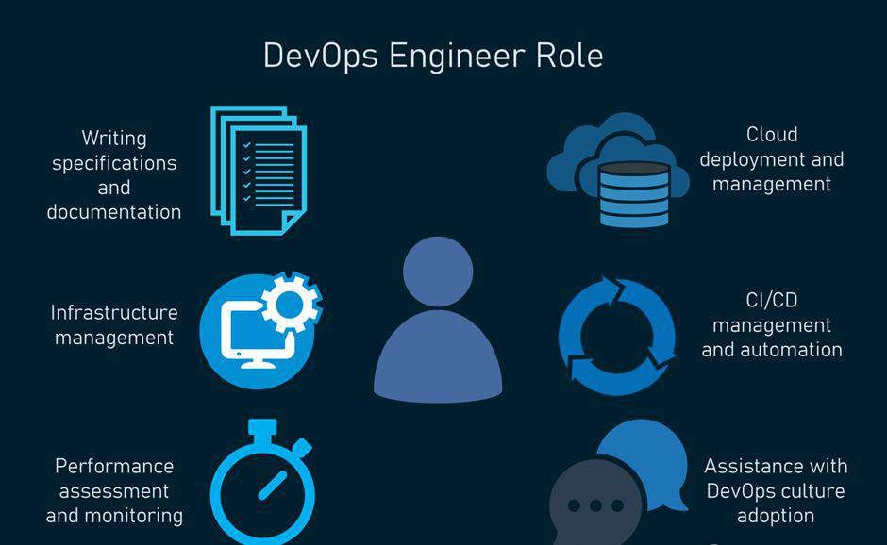

#### DevOps Job Roles:

1. **DevOps Evangelist** – The principal officer (leader) responsible for implementing DevOps.
2. **Release Manager** – The one releasing new features & ensuring post- release product stability.
3. **Automation Expert** – The guy responsible for achieving automation & orchestration of tools.
4. **Software Developer/ Tester** – The one who develops the code and tests it.
5. **Quality Assurance** – The one who ensures the quality of the product confirms to its requirement.
6. **Security Engineer** – The one always monitoring the product’s security & health.

**Conclusion:** Successfully understood the Principles and Practices of DevOps and a DevOps Engineer’s Role and Responsibilities.

**Ramrao Adik Institute of Technology DEPARTMENT OF INFORMATION TECHNOLOGY ACADEMIC YEAR: 2021-2022**

## COURSE NAME : DevOps Lab

|  |  |  |  |  |  |  |  |  |
| --- | --- | --- | --- | --- | --- | --- | --- | --- |
| **COURSE CODE** | | | **ITL504** | | | | | |
| **EXPERIMENT NO.** | | | **2** | | | | | |
| **EXPERIMENT TITLE** | | | **TO UNDERSTAND VERSION CONTROL SYSTEM / SOURCE CODE MANAGEMENT, INSTALL GIT AND CREATE A GITHUB ACCOUNT.** | | | | | |
| **NAME OF STUDENT** | | | **GAURAV SINGH** | | | | | |
| **ROLL NO.** | | | **19IT1074** | | | | | |
| **CLASS** | | | **TE - IT** | | | | | |
| **SEMESTER** | | | **V** | | | | | |
| **GIVEN DATE** | | | **28-07-2021** | | | | | |
| **SUBMISSION DATE** | | |  | | | | | |
| **CORRECTION DATE** | | |  | | | | | |
| **REMARK** | | |  | | | | | |
| **TIMELY SUBMISSION** | | **PRESENTATION** | | | **UNDERSTANDING** | | **TOTAL MARKS** | |
|  | **4** |  | | **4** |  | **7** |  | **15** |
| **NAME& SIGN. OF FACULTY** | | **Prof. Sujata Oak** | | |  | | | |

#### PRACTICAL NO: 2

**Aim:** To understand Version Control System / Source Code Management, install git and create a GitHub account.

**LO Number And Statement:LO2** – To obtain complete knowledge of the “version control system” to effectively track changes augmented with Git and GitHub.

#### Theory:

**GitHub:**

GitHub is a website and cloud-based service that helps developers store and manage their code, as well as track and control changes to their code. To understand exactly what GitHub is, you need to know two connected principles:

* + Version control
  + Git

#### Version Control:

* + Version control helps developers track and manage changes to a software project’s code. As a software project grows, version control becomes essential.
  + Version control lets developers safely work through branching and merging.

●

#### Benefits of using version control:

* + Each file on GitHub has a history, making it easy to explore the changes that occurred to it at different time points.
  + For collaborative projects, GitHub allows you to assign tasks to different users, making it clear who is responsible for which part of the analysis.
  + For personal projects, version control allows you to keep track of your work and easily navigate among the many versions of the files you create, whilst also maintaining an online backup.

#### Git:

* + Git is a specific open-source version control system created by Linus Torvalds in 2005.
  + Specifically, Git is a distributed version control system, which means that the entire codebase and history is available on every developer’s computer, which allows for easy branching and merging.

#### Creating GitHub Account:

1. Go to <https://github.com/join>in a web browser. You can use any web browser on your computer, phone, or tablet to join.
2. Enter your personal details. In addition to creating a username and entering an email address, you'll also have to create a password. Your password must be at least 15 characters in length *or* at least 8 characters with at least one number and lowercase letter.

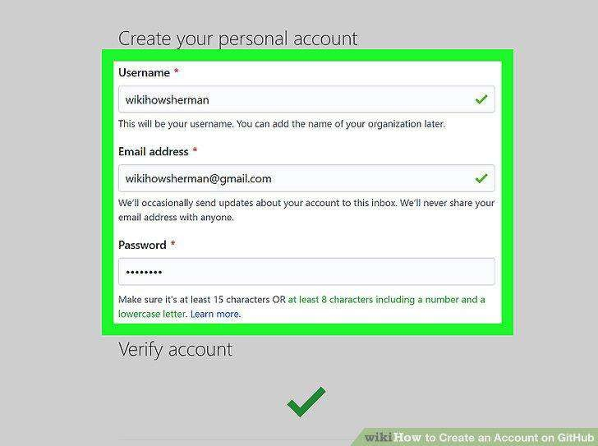

1. Carefully review the Terms of Service and Click the Create an account button.

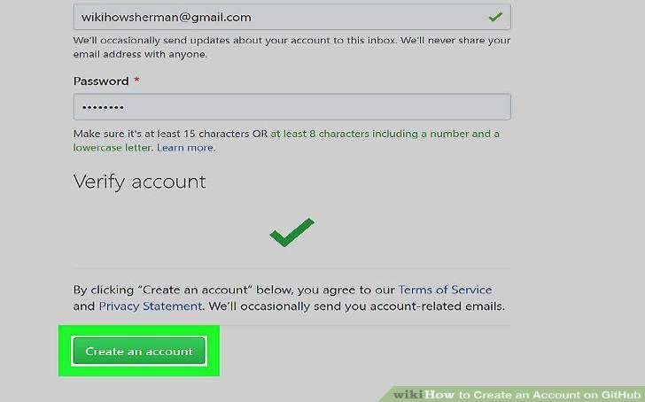

1. Complete the CAPTCHA puzzle. The instructions vary by puzzle, so just follow the on-screen instructions to confirm that you are a human.
2. Select Plan and Click the Choose button for your desired plan. Once you select a plan, GitHub will send an email confirmation message to the address you entered. The plan options are:
   * Free: Unlimited public and private repositories, up to 3 collaborators, issues and bug tracking, and project management tools.
   * Pro: Unlimited access to all repositories, unlimited collaborators, issue & bug tracking, and advanced insight tools.
   * Team: All of the aforementioned features, plus team access controls and user management.
   * Enterprise: All of the features of the Team plan, plus self-hosting or cloud hosting, priority support, single sign-on support, and more.

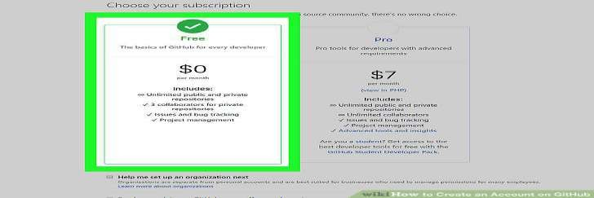

1. Verify Email Address from the mail that you will receive.
2. Select your preferences and whether you want notifications from GitHub.
3. GitHub Account is Created.

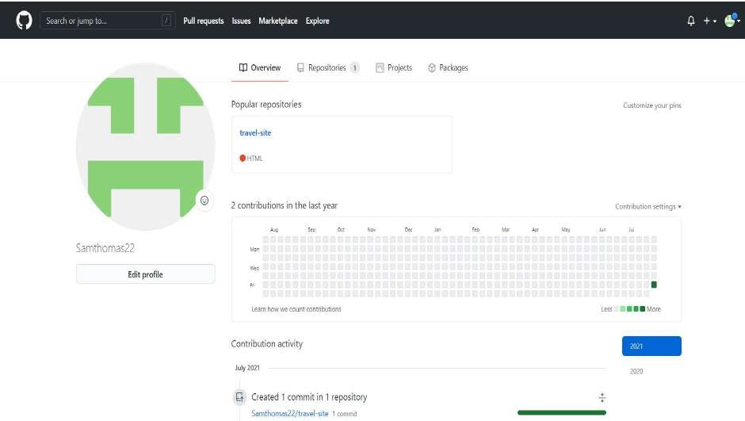

#### Downloading Git for Windows:

1. Browse to the official Git website: <https://git-scm.com/downloads>.
2. Click the download link for Windows and allow the download to complete.

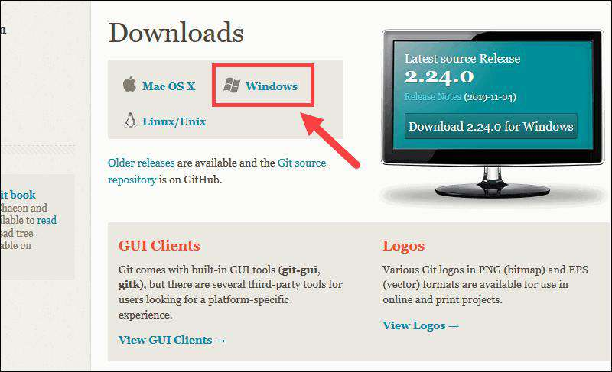

1. Extract and Launch Git Installer: Browse to the download location (or use the download shortcut in your browser). Double-click the file to extract and launch the installer.

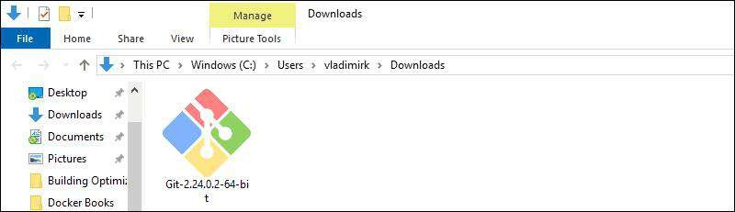

1. Allow the app to make changes to your device by clicking **Yes** on the User Account Control dialog that opens.

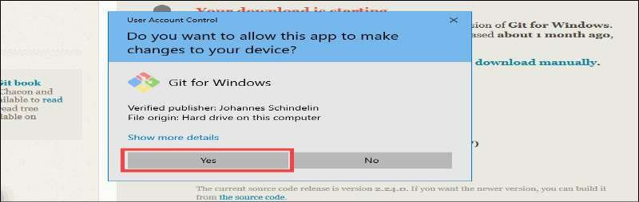

1. Review the GNU General Public License, and when you’re ready to install, click Next.

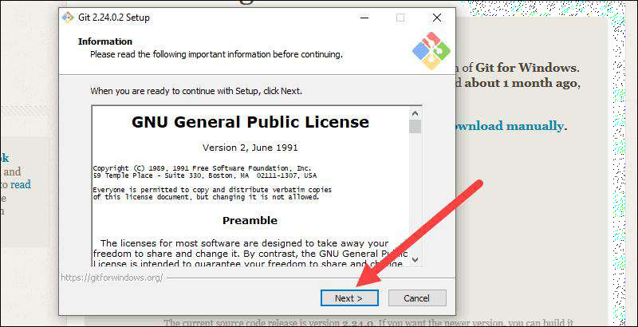

1. The installer will ask you for an installation location. Leave the default, unless you have reason to change it, and click Next.

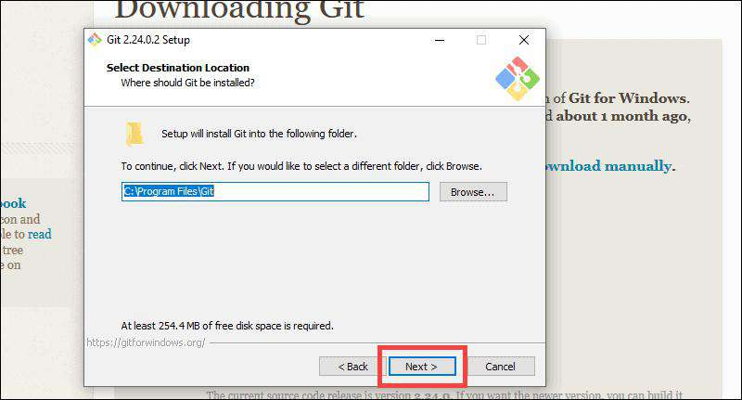

1. A component selection screen will appear. Leave the defaults unless you have a specific need to change them and click Next.

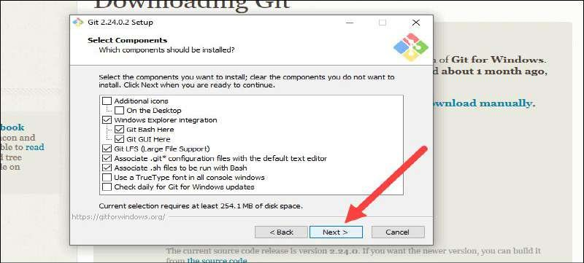

1. The installer will offer to create a start menu folder. Simply click Next.

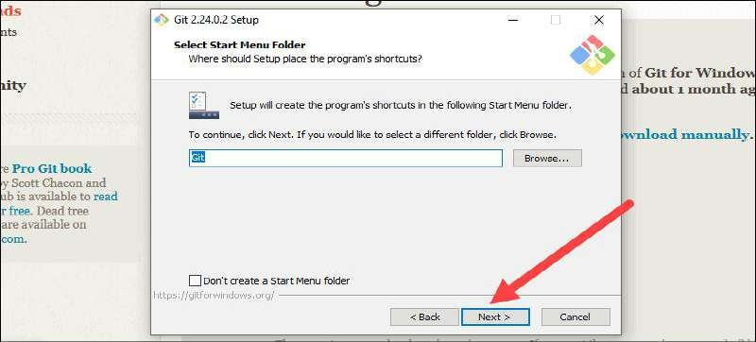

1. Select a text editor you’d like to use with Git. Use the drop-down menu to select Notepad++ (or whichever text editor you prefer) and click Next.

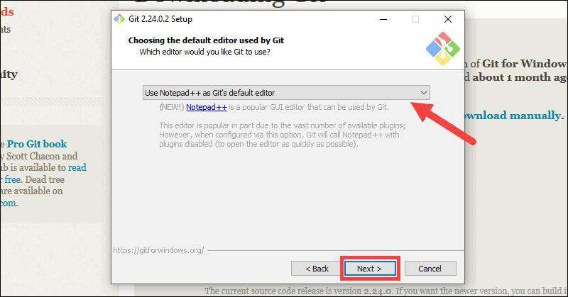

1. This installation step allows you to change the PATH environment. The PATH is the default set of directories included when you run a command from the command line. Leave this on the middle (recommended) selection and click Next.

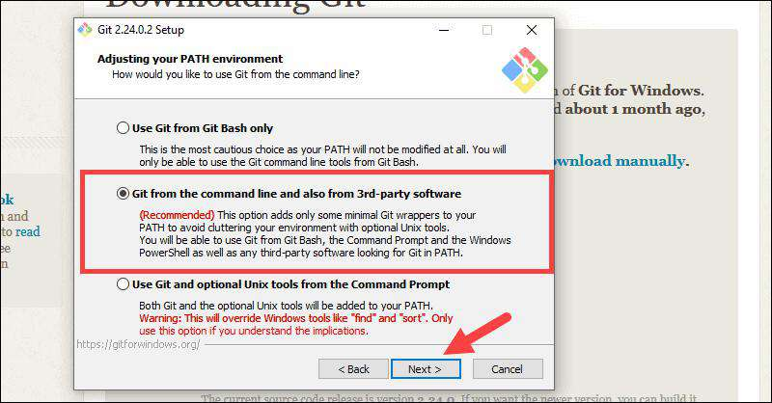

1. Server Certificates, Line Endings and Terminal Emulators: The next option relates to server certificates. Most users should use the default. If you’re working in an Active Directory environment, you may need to switch to Windows Store certificates. Click Next.

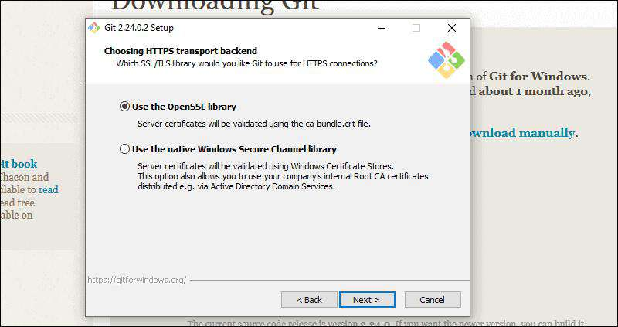

1. The next selection converts line endings. It is recommended that you leave the default selection. This relates to the way data is formatted and changing this option may cause problems. Click Next.

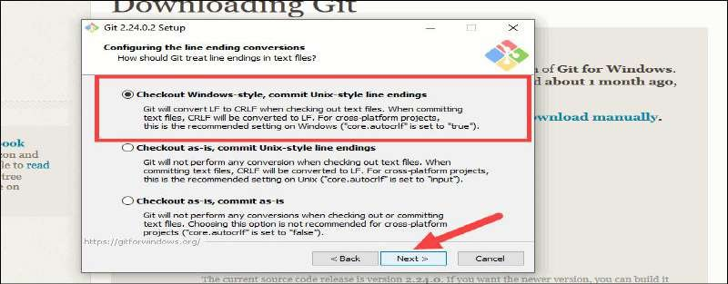

1. Choose the terminal emulator you want to use. The default MinTTY is recommended, for its features. Click Next.

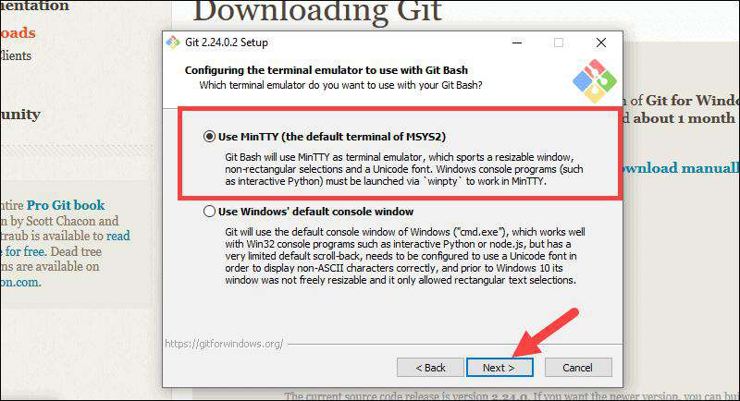

1. The default options are recommended, however this step allows you to decide which extra option you would like to enable. If you use symbolic

links, which are like shortcuts for the command line, tick the box. Click Next.

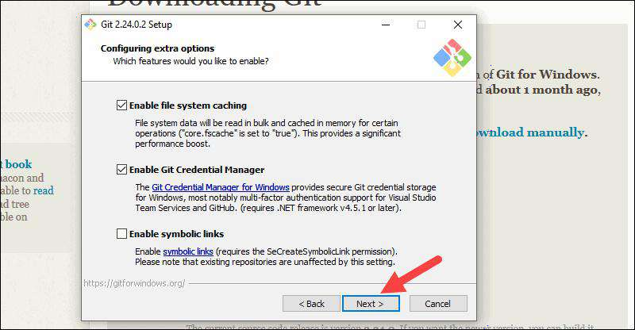

1. Depending on the version of Git you’re installing, it may offer to install experimental features. Unless you are feeling adventurous, leave them unchecked and click Install.

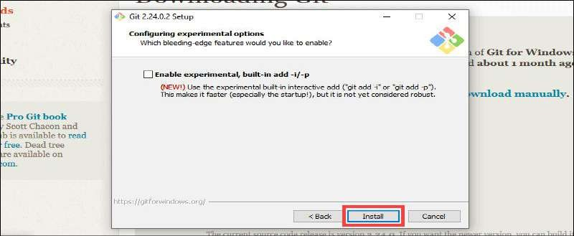

1. Complete Git Installation Process**:** Once the installation is complete, tick the boxes to view the Release Notes or Launch Git Bash, then

click Finish.

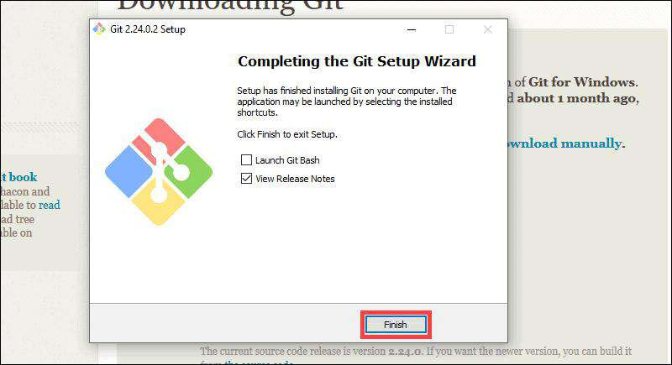

#### How to Launch Git in Windows:

Git has two modes of use – a bash scripting shell (or command line) and a graphical user interface (GUI).

1. Launch Git Bash Shell:

To launch Git Bash open the Windows Start menu, type *git bash* and press Enter (or click the application icon).

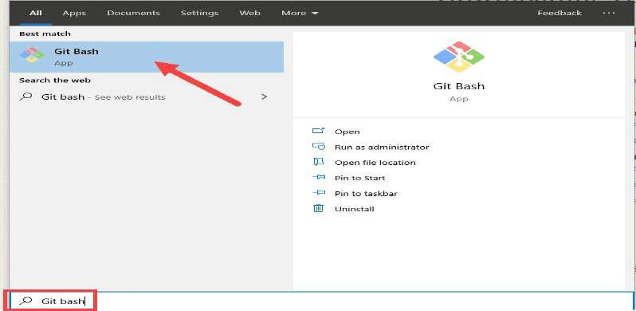

1. Launch Git GUI: To launch Git GUI open the Windows Start menu, type *git gui* and press Enter (or click the application icon).

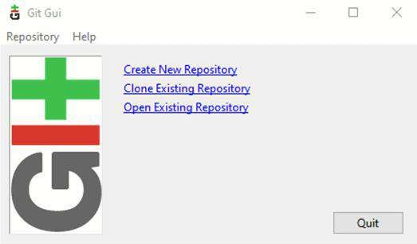

**CONCLUSION:** Successfully created a GitHub account, installed git for windows and understood what is Version Control System / Source Code Management.

**Ramrao Adik Institute of Technology DEPARTMENT OF INFORMATION TECHNOLOGY ACADEMIC YEAR: 2021-2022**

## COURSE NAME : DevOps Lab

|  |  |  |  |  |  |  |  |  |
| --- | --- | --- | --- | --- | --- | --- | --- | --- |
| **COURSE CODE** | | | **ITL504** | | | | | |
| **EXPERIMENT NO.** | | | **3** | | | | | |
| **EXPERIMENT TITLE** | | | **TO PERFORM VARIOUS GIT OPERATIONS ON LOCAL AND REMOTE REPOSITORIES USING GIT CHEAT-SHEET** | | | | | |
| **NAME OF STUDENT** | | | **GAURAV SINGH** | | | | | |
| **ROLL NO.** | | | **19IT1074** | | | | | |
| **CLASS** | | | **TE - IT** | | | | | |
| **SEMESTER** | | | **V** | | | | | |
| **GIVEN DATE** | | | **28-07-2021** | | | | | |
| **SUBMISSION DATE** | | |  | | | | | |
| **CORRECTION DATE** | | |  | | | | | |
| **REMARK** | | |  | | | | | |
| **TIMELY SUBMISSION** | | **PRESENTATION** | | | **UNDERSTANDING** | | **TOTAL MARKS** | |
|  | **4** |  | | **4** |  | **7** |  | **15** |
| **NAME& SIGN. OF FACULTY** | | **Prof. Sujata Oak** | | |  | | | |

#### PRACTICAL NO: 3

**Aim:** To Perform various GIT operations on local and Remote repositories using GIT Cheat-Sheet

**LO Number And Statement: LO2** – To obtain complete knowledge of the “version control system” to effectively track changes augmented with Git and GitHub.

#### Theory:

**GitHub Repository:**

* + You can think of a repository (*aka* a repo) as a “main folder”, everything associated with a specific project should be kept in a repo for that project.
  + Repos can have folders within them, or just be separate files.
  + You will have a local copy (on your computer) and an online copy (on GitHub) of all the files in the repository**.**

#### GitHub Workflow:

The GitHub workflow can be summarised by the “commit-pull-push” mantra.

1. **Commit:** Once you’ve saved your files, you need to commit them - this means the changes you have made to files in your repo will be saved as a version of the repo, and your changes are now ready to go up on GitHub (the online copy of the repository).
2. **Pull:** Now, before you send your changes to Github, you need to pull, i.e. make sure you are completely up to date with the latest version of the online version of the files - other people could have been working on them even if you haven’t. You should always pull before you start editing and before you push.
3. **Push:** Once you are up to date, you can push your changes - at this point in time your local copy and the online copy of the files will be the same.

Each file on GitHub has a history, so instead of having many files you can have only one and by exploring its history, you can see what it looked at different points in time.

#### Creating Repository:

* + To make a repository, go to Repositories/New repository - choose a concise and informative name that has no spaces or funky characters in it.
  + This can be your master repo that holds together past and ongoing research, data, scripts, manuscripts.
  + Later on you might want to have more repositories - e.g. a repository associated with a particular project that you want to make public or a project where you are actively seeking feedback from a wider audience.
  + With a free GitHub account, you can use public or private repositories.
  + Create a new repository. You can call it whatever you like if the name is available.

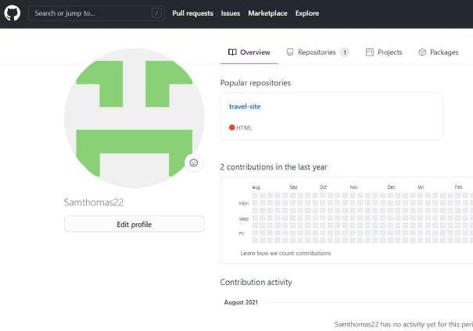

New Repos itory



* + Enter the name of the repository, choose public or private and select if you want to add Readme file or .gitignore or a license and click on create repository

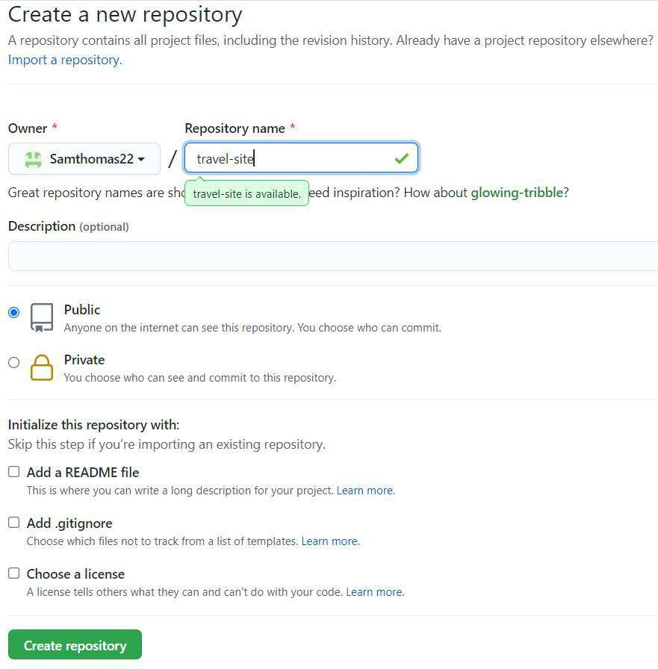

* + Repository is created:

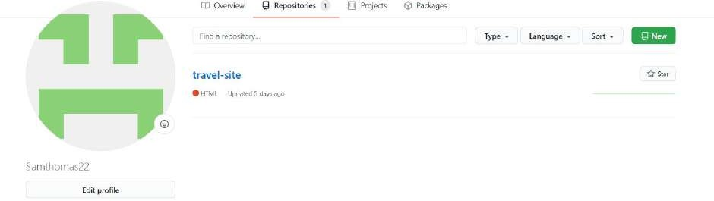

#### Git Commands:

|  |  |  |  |
| --- | --- | --- | --- |
| **Command** | **Origin** | **Destination** | **Description** |
| *git clone REPO_URL* | Personal Github | Local | Creates a local copy of a Github repo. The URL can be copied from Github.com by clicking the `Clone or Download` button. |
| *git add README.md* | Working Dir | Staging Area | Add "README.md" to staging area. |
| *git commit* | Staging Area | Local | Commits changes to files to the local repo. |
| *git commit -a* | Working Dir | Local | adds and commits all file changes to the local repo. |
| *git pull* | Personal Github | Local | Retrieve any changes from a Github repo. |
| *git push* | Local | Personal Github | Sends commited file changes to Github repo. |
| *git merge* | Other branch | Current branch | Merge any changes in the named branch with the current branch. |
| *git checkout - b patch1* | NA | NA | Create a branch called "patch1" from the current |

|  |  |  |  |
| --- | --- | --- | --- |
|  |  |  | branch and switch to it. |
| *git init* | NA | NA | Initialise a directory as a Git repo. |
| *git log* | NA | NA | Display the commit history for the current repo |
| *git status* | NA | NA | See which files are staged/unstaged/changed |
| *git diff* | NA | NA | See the difference between staged uncomitted changes and the most recent commit |
| *git stash* | NA | NA | Save uncommitted changes in a temporary version and revert to the most recent commit |

**GIT operations on Local Repositories:**

#### git config: Controlling the behaviour of git

This will set the default user name as Sam.

1. **git init: Creating a Local Repository mkdir:** make directory

**cd:** change directory

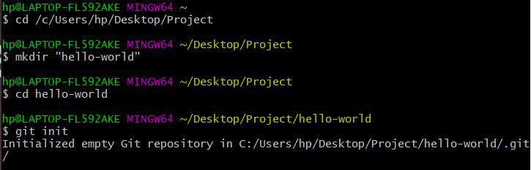

#### git status: Check status of our repository

1. **git add : Staging a File**

For the git repository to know which files within this directory you would like to keep track of, you must add them to version control. First, you'll need to create one, then we'll learn the git add command.

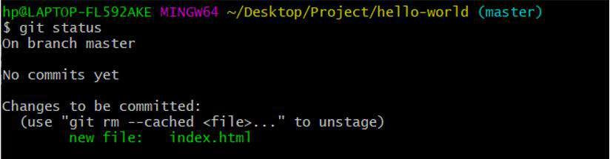

#### git commit : Saving a Snapshot

In order to save a snapshot of the current state (revision) of the repository, we use the commit command. This command is always associated with a message describing the changes since the last commit and indicating their purpose. Informative commit messages will serve you well someday, so make a habit of never committing changes without at least a full sentence description.

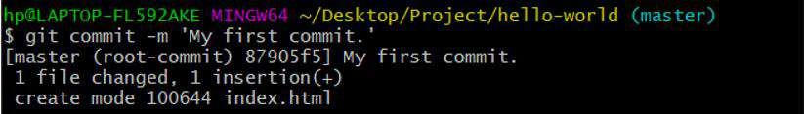-m indicates message which is helpful in keeping track of the changes.

#### git checkout: Removing changes made to the file and restoring it back to previous commit.

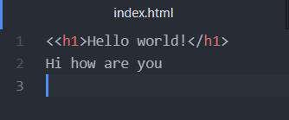

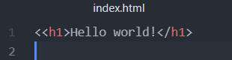

1. **git clone: Copying a Repository**

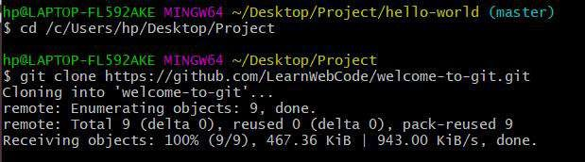

#### GIT operations on Remote Repositories:

1. **git remote: Showing Your Remotes**

#### -v shows you the URLs that Git has stored for the short name to be used when reading and writing to that remote:

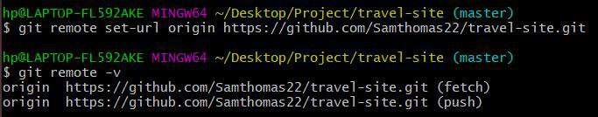

1. 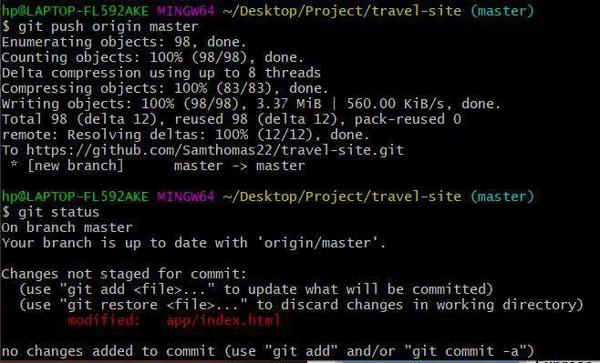**git push: Pushing to Your Remotes**

#### git add -A: Staging a File

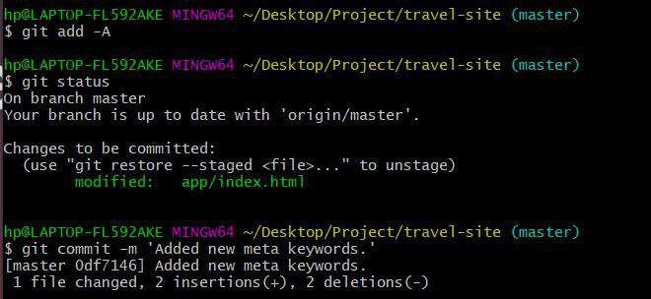

**CONCLUSION:** Successfully Performed various GIT operations on local and Remote repositories using GIT Cheat-Sheet

**Ramrao Adik Institute of Technology DEPARTMENT OF INFORMATION TECHNOLOGY ACADEMIC YEAR: 2021-2022**

## COURSE NAME : DevOps Lab

|  |  |  |  |  |  |  |  |  |
| --- | --- | --- | --- | --- | --- | --- | --- | --- |
| **COURSE CODE** | | | **ITL504** | | | | | |
| **EXPERIMENT NO.** | | | **4** | | | | | |
| **EXPERIMENT TITLE** | | | **TO UNDERSTAND CONTINUOUS INTEGRATION, INSTALL AND CONFIGURE JENKINS** | | | | | |
| **NAME OF STUDENT** | | | **GAURAV SINGH** | | | | | |
| **ROLL NO.** | | | **19IT1074** | | | | | |
| **CLASS** | | | **TE - IT** | | | | | |
| **SEMESTER** | | | **V** | | | | | |
| **GIVEN DATE** | | | **4-08-2021 & 11-08-2021** | | | | | |
| **SUBMISSION DATE** | | |  | | | | | |
| **CORRECTION DATE** | | |  | | | | | |
| **REMARK** | | |  | | | | | |
| **TIMELY SUBMISSION** | | **PRESENTATION** | | | **UNDERSTANDING** | | **TOTAL MARKS** | |
|  | **4** |  | | **4** |  | **7** |  | **15** |
| **NAME& SIGN. OF FACULTY** | | **Prof. Sujata Oak** | | |  | | | |

#### PRACTICAL NO: 4

**Aim:** To understand Continuous Integration, install and configure Jenkins with Maven/Ant/Gradle to setup a build Job.

**LO Number and Statement: LO3** – To understand the importance of Jenkins to Build and deploy Software Applications on server environment

#### Theory:

**Continuous Integration:**

Continuous integration is a process in which all development work is integrated as early as possible. The resulting artifacts are automatically created and tested. This process allows to identify errors in an early stage of the project.

The Jenkins build server is a tool to provide this functionality.

#### Jenkins:

Jenkins is a popular open source tool to perform continuous integration and build automation. Jenkins allows to execute a predefined list of steps, e.g. to compile Java source code and build a JAR from the resulting classes. The trigger for this execution can be time or event based.

For example, you can compile your Java based application every 20 minutes or after a new commit in the related Git repository.

Possible steps executed by Jenkins are for example:

* perform a software build using a build system like Apache Maven or Gradle
* execute a shell script
* archive a build result
* run software tests

Jenkins monitors the execution of the steps and allows to stop the process, if one of the steps fails. Jenkins can also send out notifications in case of a build success or failure.

Jenkins can be extended by additional plug-ins. For example, you can install plug-ins to support building and testing Android applications.

#### Installing Jenkins and setting it up:

* Prerequisite: JDK 8+
* Go to Jenkins official website download page <https://www.jenkins.io/download/>and download **Jenkins 2.289.3 LTS** for your Operating System. (**Windows** in my case)
* Follow Installation Setup to select the Installation Directory,Account and Port.
* Once installation is you will automatically be redirected to a local Jenkins page, or you can paste the URL http://localhost:8080 in a browser.
* Here you will have to enter the password given in indicated location.

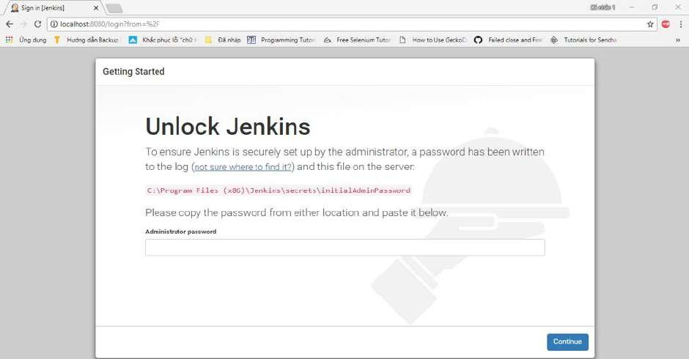

* You can install either the suggested plugins or selected plugins you choose. I installed the suggested plugins.

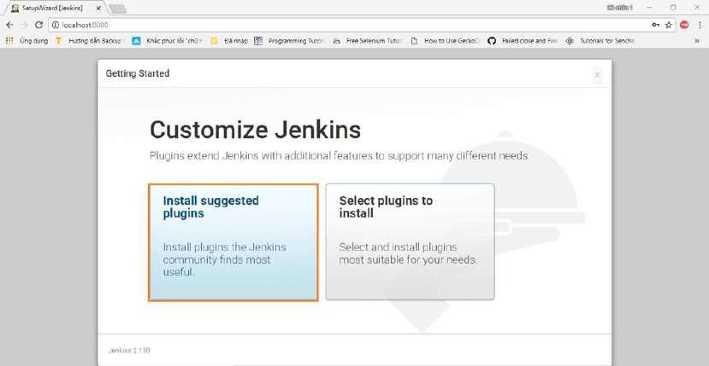

* Wait until the plugins are completely installed.

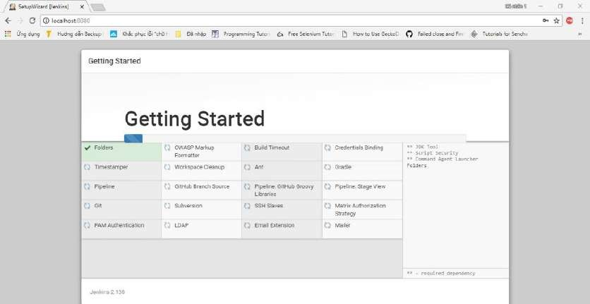

* The next thing that you should do is create an Admin user for Jenkins. Then, enter your details and click **“Save and Continue”**.
* Click **“Save and Finish”** to complete the Jenkins installation.
* Now, click **“Start using Jenkins”** to start Jenkins.

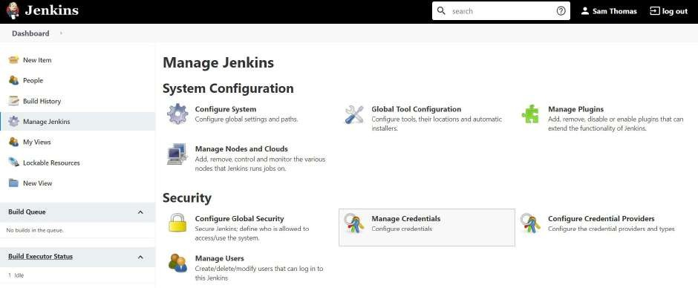

* Download the *jenkins.war* file from the Jenkins Homepage. From this file you can start Jenkins directly via the command line with java -jar jenkins*.war.
* If you start it locally, you find it running under the following URL: http://localhost:8080/

#### Gradle:

Gradle is a build automation tool known for its flexibility to build software. A build automation tool is used to automate the creation of applications. The building process includes compiling, linking, and packaging the code. The process becomes more consistent with the help of build automation tools.

Gradle nicely combines both Ant and Maven, taking the best from both frameworks. Flexibility from Ant and convention over configuration, dependency management and plugins from Maven.

#### Installing Gradle:

* Go to Gradle official downloads page <https://gradle.org/install/>
* There are multiple installation options provided, I selected Manual Installation.
* Download the latest Gradle distribution
* The current Gradle release is version 7.1.1, released on 02 Jul 2021. The distribution zip file comes in two flavors:
  1. Binary-only
  2. Complete, with docs and sources
* If in doubt, choose the binary-only version and browse doca and sources online.
* Create a new directory C:\Gradle with File Explorer.
* Open a second File Explorer window and go to the directory where the Gradle distribution was downloaded. Double-click the ZIP archive to expose the content. Drag the content folder gradle-7.1.1 to your newly created C:\Gradle folder.
* Alternatively, you can unpack the Gradle distribution ZIP into C:\Gradle using an archiver tool of your choice.
* Configure your system environment
* To do this In File Explorer right-click on the This PC (or Computer) icon, then click Properties -> Advanced System Settings -> Environmental Variables.
* Under System Variables select Path, then click Edit. Add an entry for C:\Gradle\gradle-7.1.1\bin. Click OK to save.
* To verify installation open a console (or a Windows command prompt) and run gradle -v to run gradle and display the version,

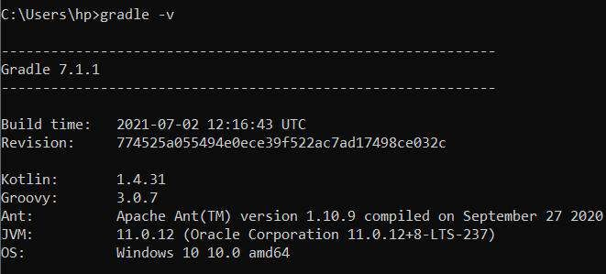

#### Configure Jenkins:

* In the Jenkins dashboard (Home screen) click on manage Jenkins from the left-hand side menu.
* Click on "Global Tool Configuration" option.



* To configure Java, click on "**Add JDK**" button in the JDK section.

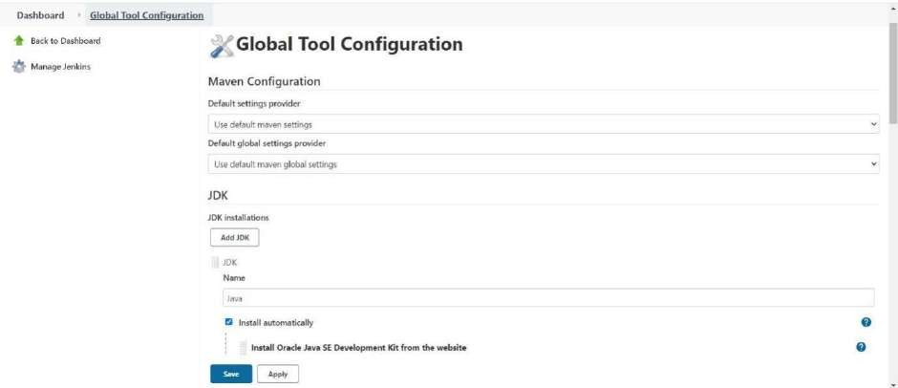

* Similarly add Git and Gradle.

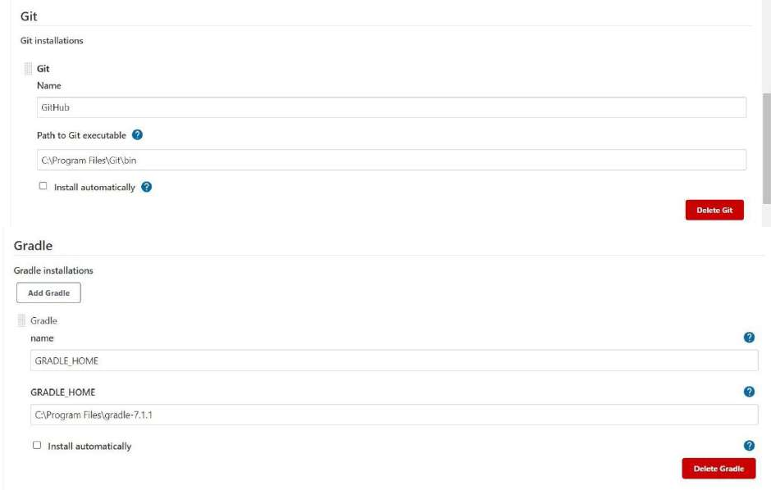

* Then, click on the "**Save**" button at the end of the screen.

#### Creating a Job with Gradle:

* To do this, click on the New Item option or create a new job option.
* Enter Name of Project.
* Select **Freestyle Project.**

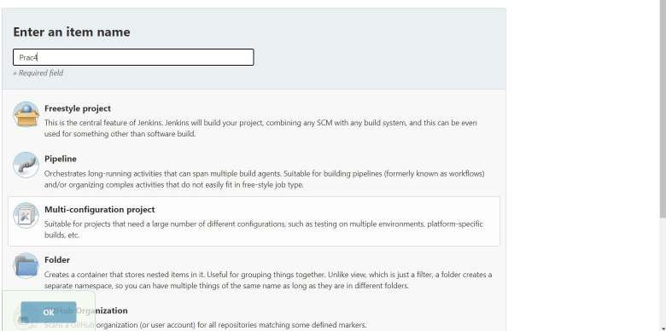

* Now enter Description of your project.
* In source Code management select appropriate option, like git repository or none. I have selected none as my project is not a git repo.

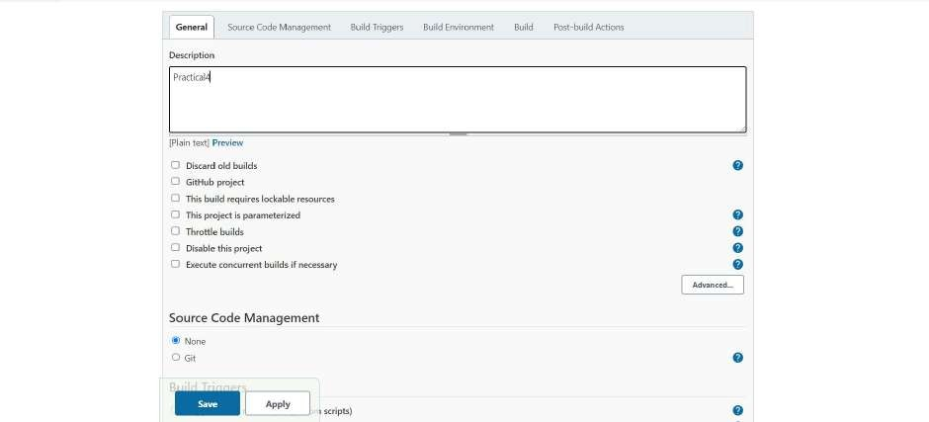

* Create a "Build step" in the section "Build" by selecting "Invoke Gradle build script"
* Here we can select Invoke Gradle and select our Gradle which we previously added.
* In the "Tasks" input box enter the build

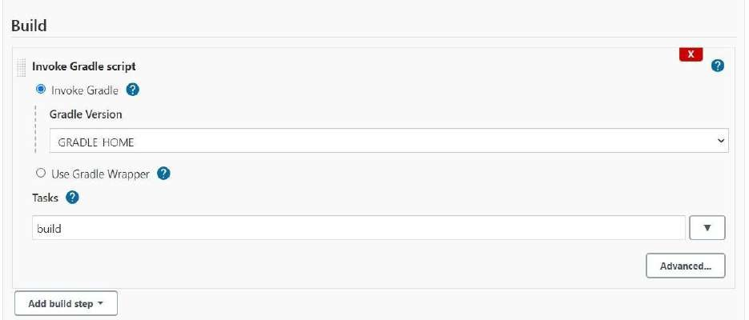

* Save the configuration of job.
* This will take you to your Project Page.

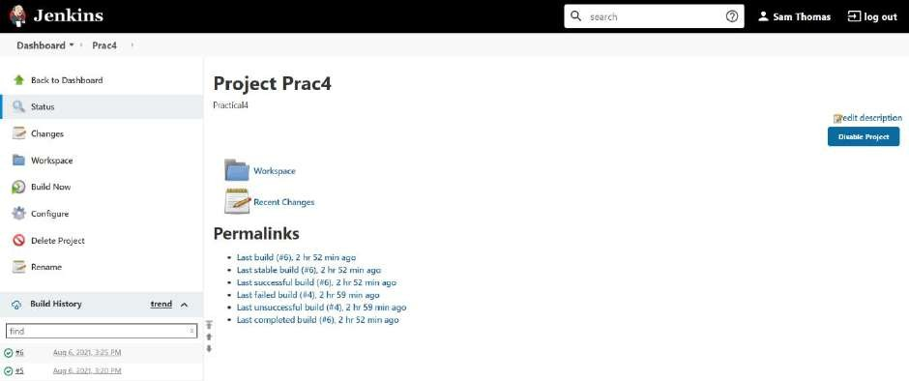

* Insert a **settings.gradle** file in the project workspace.
* Execute a build by triggering the "Build Now" button. The build should finish successfully.
* Check Build Status

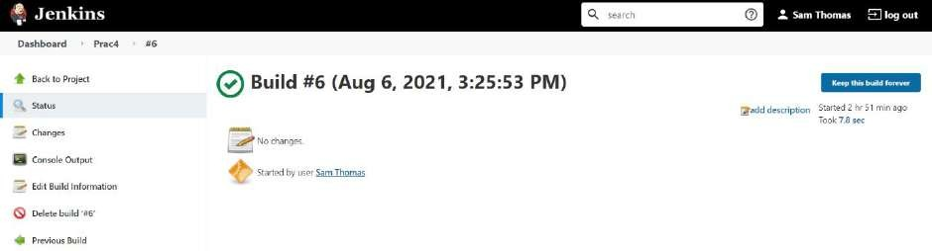

* Also check the Console Output

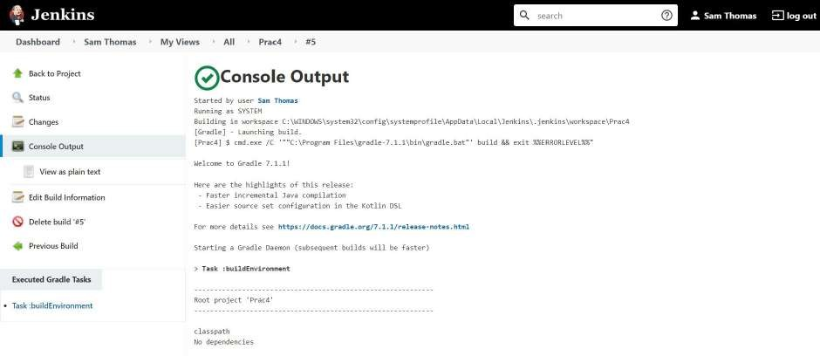

* Build is Successful and we can see our project on our Dashboard.

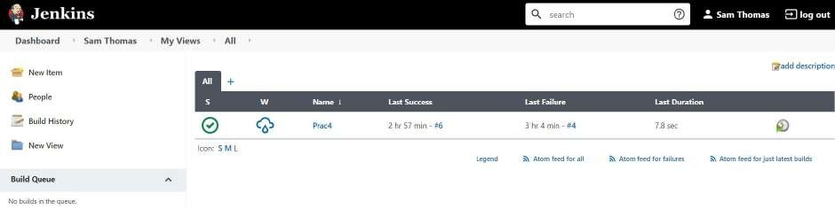

**Conclusion:** Successfully understood Continuous Integration, installed and configured Jenkins with Gradle to setup a build Job.

**Ramrao Adik Institute of Technology DEPARTMENT OF INFORMATION TECHNOLOGY ACADEMIC YEAR: 2021-2022**

## COURSE NAME : DevOps Lab

|  |  |  |  |  |  |  |  |  |
| --- | --- | --- | --- | --- | --- | --- | --- | --- |
| **COURSE CODE** | | | **ITL504** | | | | | |
| **EXPERIMENT NO.** | | | **5** | | | | | |
| **EXPERIMENT TITLE** | | | **TO BUILD THE PIPELINE OF JOBS IN JENKINS AND CREATE A PIPELINE SCRIPT** | | | | | |
| **NAME OF STUDENT** | | | **GAURAV SINGH** | | | | | |
| **ROLL NO.** | | | **19IT1074** | | | | | |
| **CLASS** | | | **TE - IT** | | | | | |
| **SEMESTER** | | | **V** | | | | | |
| **GIVEN DATE** | | | **4-08-2021 & 11-08-2021** | | | | | |
| **SUBMISSION DATE** | | |  | | | | | |
| **CORRECTION DATE** | | |  | | | | | |
| **REMARK** | | |  | | | | | |
| **TIMELY SUBMISSION** | | **PRESENTATION** | | | **UNDERSTANDING** | | **TOTAL MARKS** | |
|  | **4** |  | | **4** |  | **7** |  | **15** |
| **NAME& SIGN. OF FACULTY** | | **Prof. Sujata Oak** | | |  | | | |

#### PRACTICAL NO: 5

**Aim:** To build the pipeline of jobs using Maven / Gradle / Ant in Jenkins, create a pipeline script to test and deploy an application over the tomcat server.

#### LO Number and Statement:-

**LO1:** To understand the fundamentals of DevOps engineering and be fully proficient with DevOps terminologies, concepts, benefits, and deployment options to meet your business requirements.

**LO3:** To understand the importance of Jenkins to Build and deploy Software Applications on server environment

#### Theory:

* **Tomcat:**

It is an open-source Java servlet container that implements many Java Enterprise Specs such as the Websites API, Java-Server Pages and last but not least, the Java Servlet. It is still one of the most widely used java-sever due to several capabilities such as good extensibility, proven core engine, and well-test and durable. Here we used the term "servlet" many times, so what is java servlet; it is a kind of software that enables the webserver to handle the dynamic(java-based) content using the Http protocols.

#### Jenkins Tomcat deploy prerequisites:

The following pieces of software are required to follow this example of a Jenkins deployment of a WAR file to Tomcat:

* Java web application that Jenkins can deploy to Tomcat;
* Git source code management tool installation;
* Java 8 or newer installation of the JDK;
* build tool -- this tutorial uses Maven, but any build tool, such as Ivy, ANT or Gradle, that can package a Java application into a WAR file will do; and
* Jenkins CI tool installation.
* **A WAR file for Jenkins to deploy:**

**Step 2: Install Tomcat Server**

1. Go to <https://tomcat.apache.org/download-80.cgi>and download the 32 or 64 bit zip file depending on your PC
2. Once the zip file is downloaded, move it to a preferred location
3. In this location, extract the folder and once extracted delete the zip file
4. The folder will appear like this

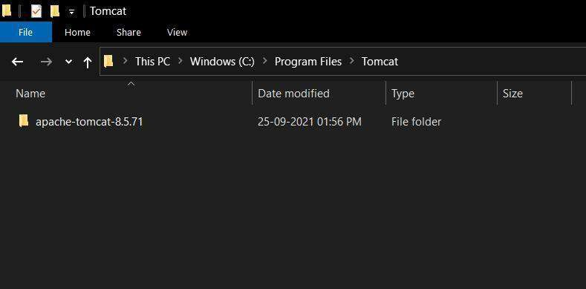

1. Once done, search environment variables in windows search and open it

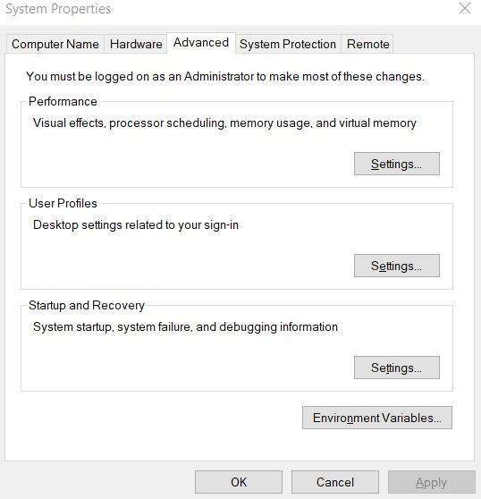

1. Click on environment variables and verify whether JAVA_HOME variable is present, if not, click new under system variables and in the window that appears, put JAVA_HOME as variable name and add location to jdk folder in variable value

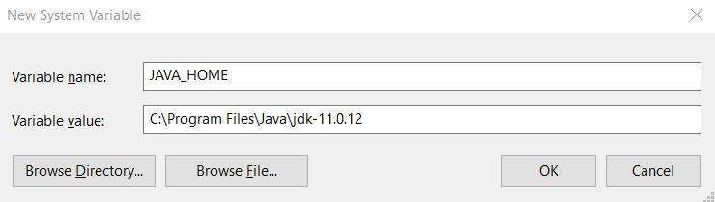

1. Once added, click OK and close the window
2. Tomcat server default port is 8080, however, since Jenkins runs on the same port we have to modify the default port for Tomcat
3. To change the default port, go to tomcat installation folder and open conf folder. Inside conf folder, open server.xml with notepad
4. Now search for Connector port and change 8080 to your preferred port

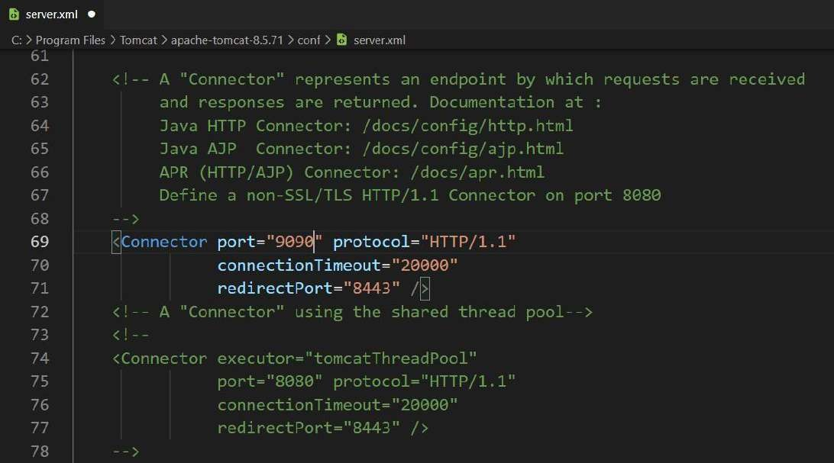

1. Save the file and exit
2. Now, inside Tomcat installation directory, open bin folder and copy the path
3. Right click on command prompt and run as administrator
4. In command prompt window, type cd and paste path of bin folder.
5. Once the directory changed to bin folder, type startup and click enter

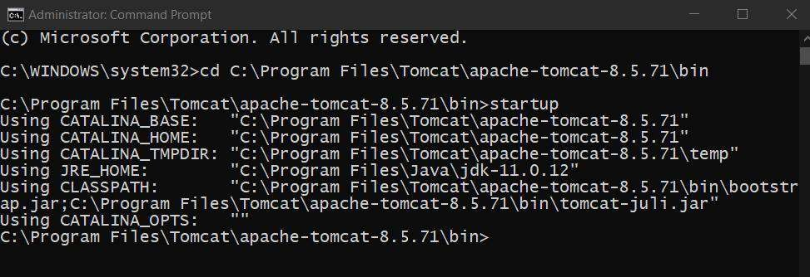

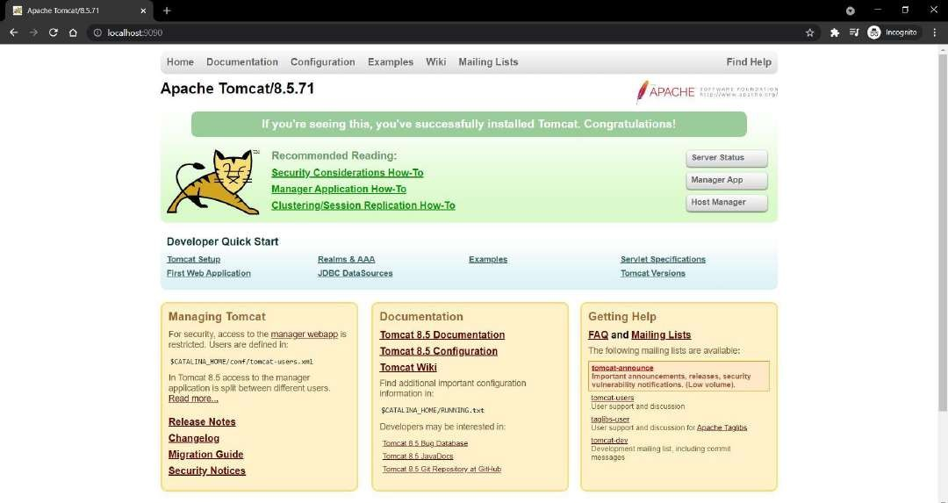

18. To shutdown tomcat server, open the same administrator command prompt window, make sure directory is set to bin folder and type shutdown and hit enter.

### Step 3: Deployment of WAR file on Tomcat server using Jenkins

1. Ensure that tomcat server is not running, go to conf folder inside tomcat installation directory
2. Open tomcat-users.xml and in second last line, just above </tomcat-users> add the following line, specifing username and password of your choice. Make sure to keep the role to “manager- script” as it is:

<user username="deployer" password="pass123" roles="manager-script"/>

.6.OAncneawddTeodm, scavt eWthinedfoilwe awnidll eaxpipt ear, now Tomcat is up and running

41.7.NToowterustnifthteomtocmatcastersvervr eisr raunndnminagk,eospuernebirtsowupsearnadnrdutnynpienglocalhost:<port you specified in s5e. rNverx.tx,mopl>e.nItbrsohwousledr oapnedntyapeaclohceatlohmoscta:8t 0h8o0mienpaadgderess bar to open Jenkins, sign in using your username and password and Jenkins dashboard will be available

1. Now, from the left pane go to Manage Jenkins and click Manage Plugins

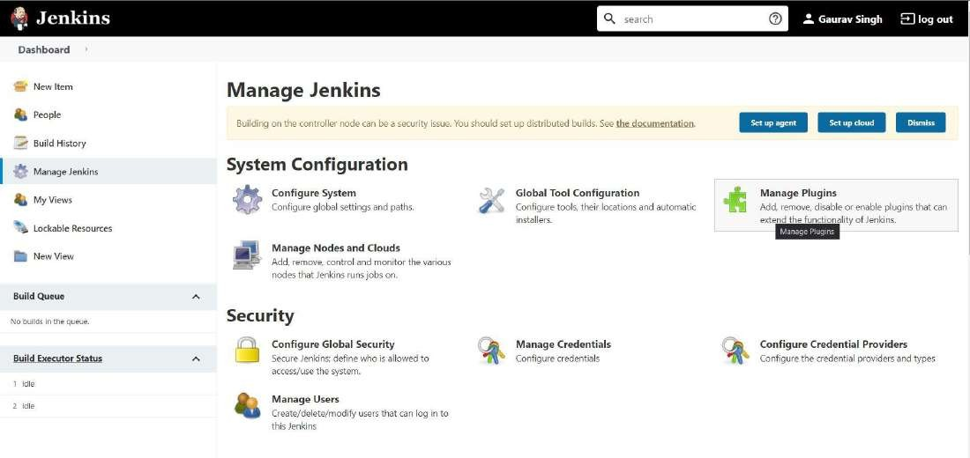

1. Inside manage plugins, go to available tab and search for “Deploy to container”

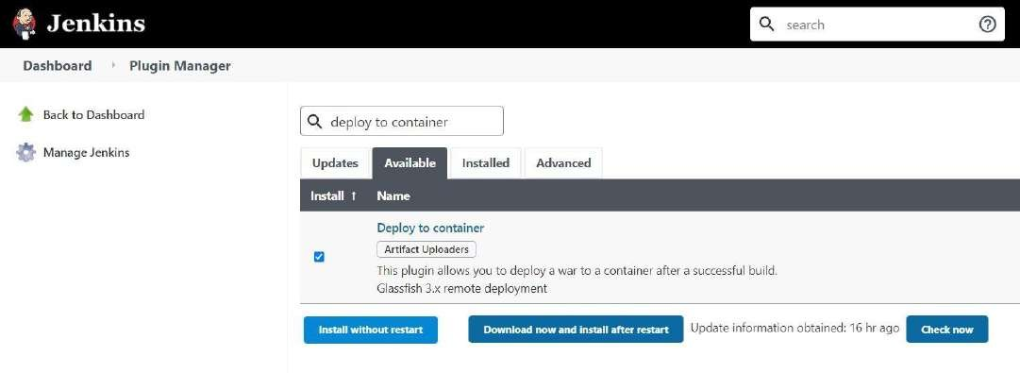

1. Click the checkbox and click “Install without restart”
2. Similarly, also install “Maven Integration Plugin” if not already installed
3. Once installed, go back to the dashboard. Now we’ll start deploying the war file
4. Go back to the Jenkins Dashboard and click on “New Item”
5. In the new item window, enter item name as “webAppExample”, select “Maven Project” and click OK

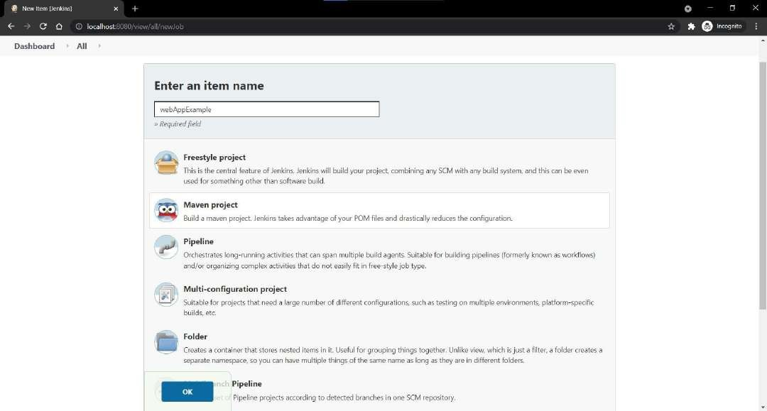

1. In Source Code Management tab, select git and paste the project repository URL <https://github.com/sujataoak799/webAppExample.git>

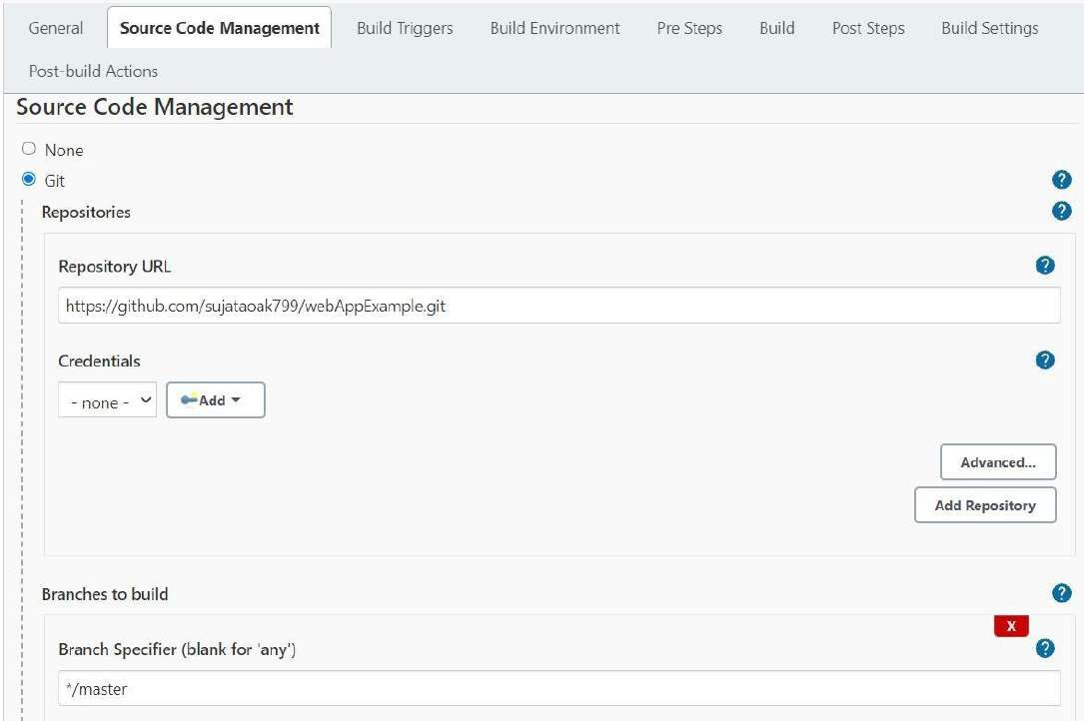

1. Now scroll to the Build tab, if the following alert is shown, we need to maven tool configuration. If the alert is not shown and maven is already configured, continue from step 17

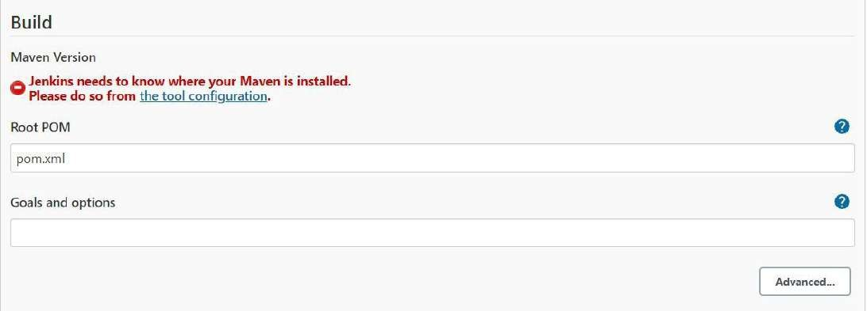

1. Click on Apply button then click on link with alert that says, “the tool configuration”. Scroll down to Maven section and click add Maven, provide the name and select checkbox that says “Install automatically”, make sure that latest version is selected from “install from apache” dropdown. Click Apply and Save

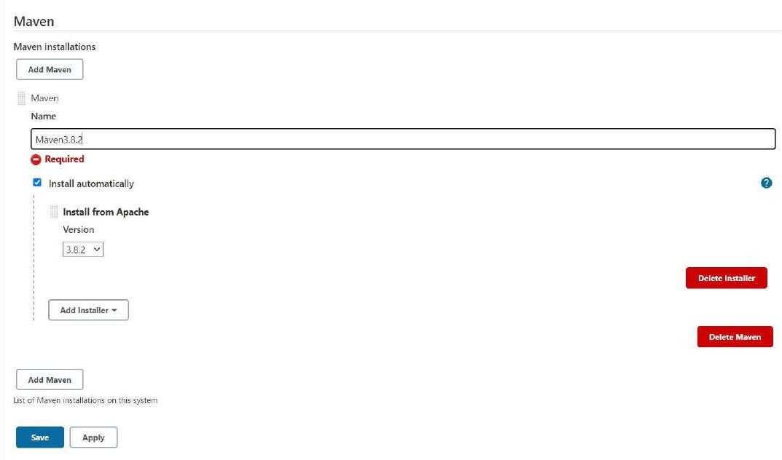

1. Now go back to dashboard and continue the setup by clicking on project name and selecting configure from left pane

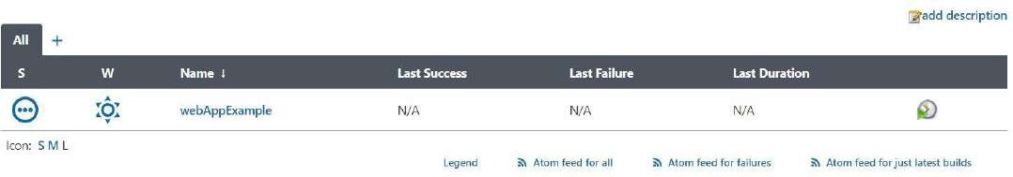

1. Make sure the previous configuration is intact, scroll down to Build section and in “Goals and options” type “clean package”

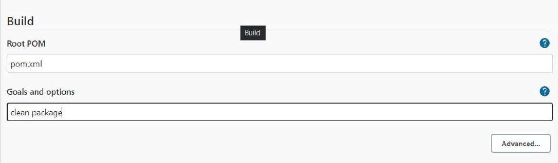

1. Now scroll down to “Add post-build action” click and select “Deploy war/ear to container”

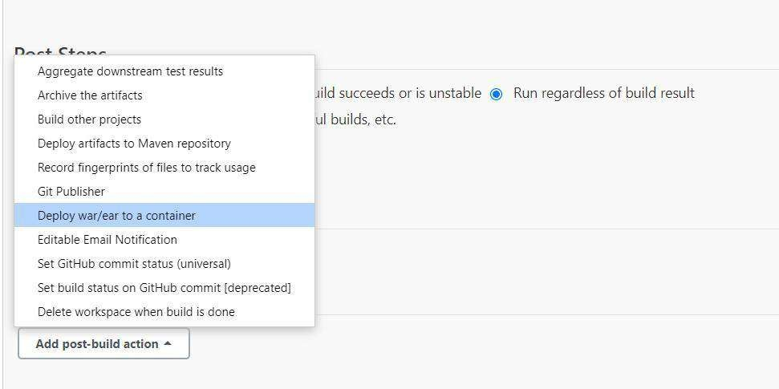

1. Now in WAR/EAR files type **/*.war . In context path type the name of project that is webAppExample

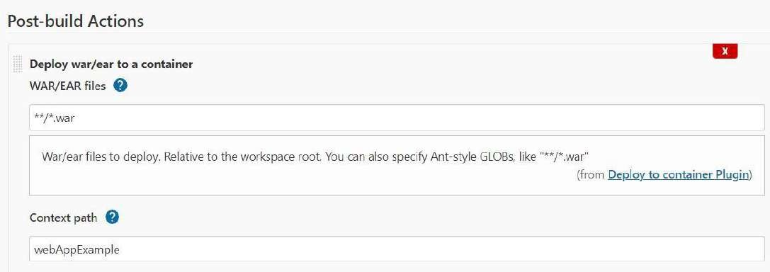

1. Now, click on Add Container and select Tomcat 8.x remote from the dropdown menu. Now in credentials, click add and select Jenkins
2. In the window that opens up, provide Tomcat username and password set in step 2. Scroll down and click add

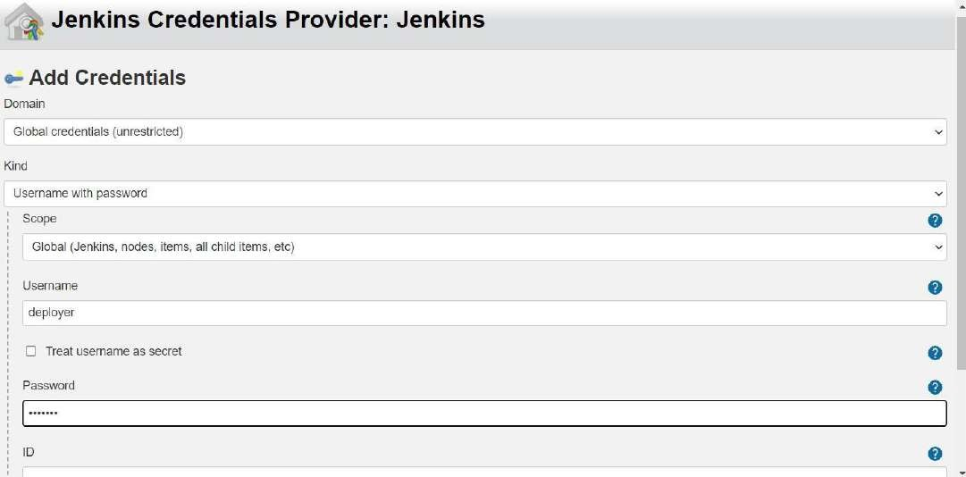

1. Now select the newly added credentials. In Tomcat URL provide the localhost address where tomcat works on your machine, such as http://localhost:9090/. After adding these, click

Apply and Save

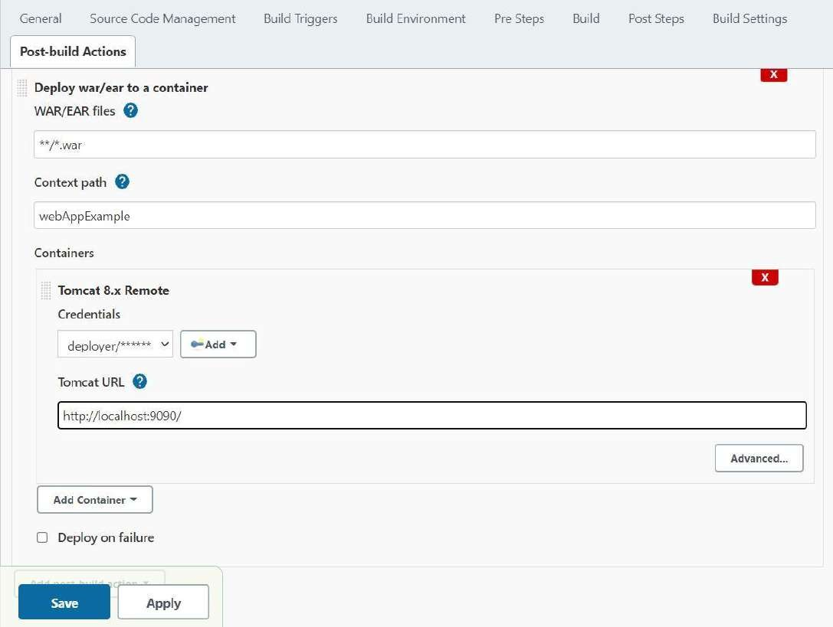

1. Now the configuration is done, its time to build and test the project, make sure tomcat server is running on your machine, click on Build Now

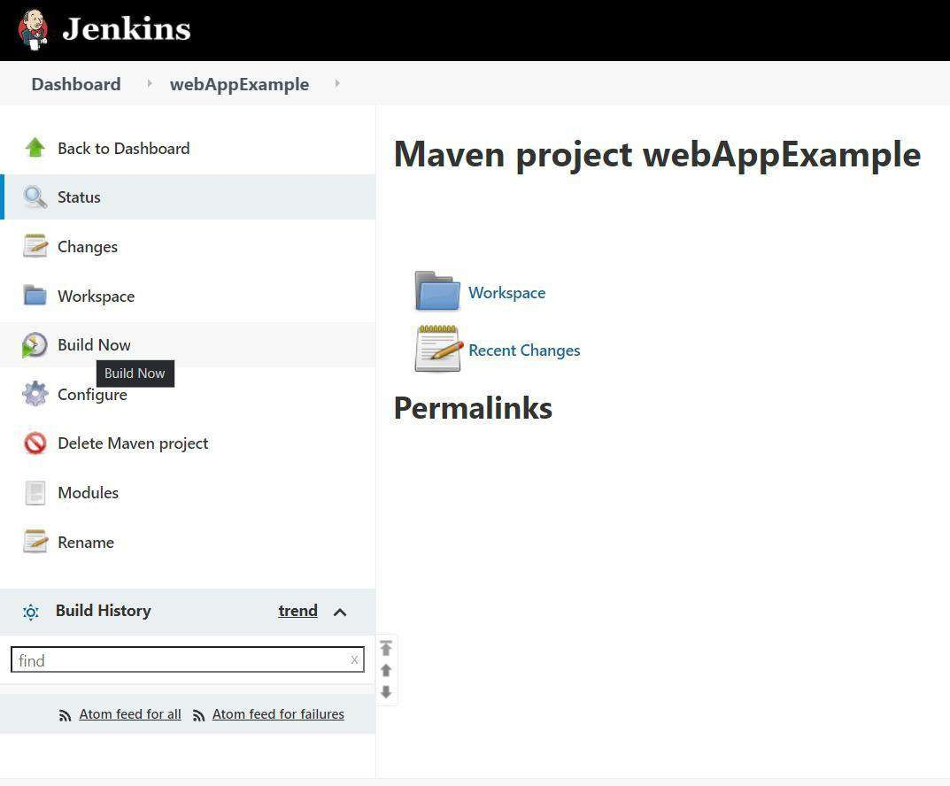

1. Now the build is started, it will be displayed in the Build History section. You can click on it to see the build process

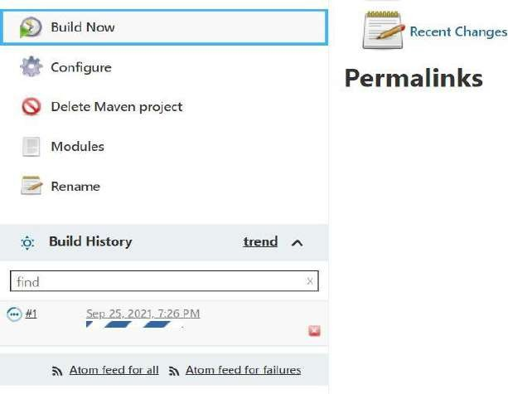

1. Once the build is successful, open a new tab and type tomcat URL followed by name of project, such as http://localhost:9090/webAppExample/
2. The deployed project should be visible on the URL

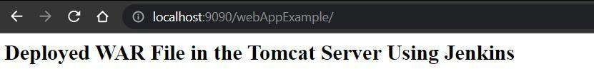

**Conclusion:** We have successfully built the pipeline of jobs using Maven / Gradle / Ant in Jenkins and also created a pipeline script to test and deploy an application over the tomcat server.

**Ramrao Adik Institute of Technology DEPARTMENT OF INFORMATION TECHNOLOGY ACADEMIC YEAR: 2021-2022**

## COURSE NAME : DevOps Lab

|  |  |  |  |  |  |  |  |  |
| --- | --- | --- | --- | --- | --- | --- | --- | --- |
| **COURSE CODE** | | | **ITL504** | | | | | |
| **EXPERIMENT NO.** | | | **6** | | | | | |
| **EXPERIMENT TITLE** | | | **TO UNDERSTAND JENKINS MASTER-SLAVE ARCHITECTURE** | | | | | |
| **NAME OF STUDENT** | | | **GAURAV SINGH** | | | | | |
| **ROLL NO.** | | | **19IT1074** | | | | | |
| **CLASS** | | | **TE - IT** | | | | | |
| **SEMESTER** | | | **V** | | | | | |
| **GIVEN DATE** | | | **18-08-2021 & 25-08-2021** | | | | | |
| **SUBMISSION DATE** | | |  | | | | | |
| **CORRECTION DATE** | | |  | | | | | |
| **REMARK** | | |  | | | | | |
| **TIMELY SUBMISSION** | | **PRESENTATION** | | | **UNDERSTANDING** | | **TOTAL MARKS** | |
|  | **4** |  | | **4** |  | **7** |  | **15** |
| **NAME& SIGN. OF FACULTY** | | **Prof. Sujata Oak** | | |  | | | |

#### PRACTICAL NO: 6

**Aim:** To understand Jenkins Master-Slave Architecture and scale your Jenkins standalone implementation by implementing slave nodes.

**LO Number And Statement: LO1** – To understand the fundamentals of DevOps engineering and be fully proficient with DevOps terminologies, concepts, benefits, and deployment options to meet your business requirements.

**LO3** – To understand the importance of Jenkins to Build and deploy Software Applications on server environment

#### Theory:

**Need of Jenkins Mater-[Agent-slave] Architecture:**

When we build the Jenkins job in a single Jenkins master node then Jenkins uses the resource of the base machine and If no executor is available then the jobs are queued in the Jenkins server. Sometimes you might need several different environments to test your builds. This cannot be done by a single Jenkins server. It is recommended not to run different jobs in the same system that required a different environment. In such scenarios where we need a different machine with a different environment that takes the specific job from the master to build.

On the same Jenkins setup, multiple teams are working with their jobs. All jobs are running on the same base operating system and the base operating system has limited resources. Also, we don't want to put our personal data on the same system where other teams can read.

#### Jenkins Distributed Architecture:

Jenkins uses A Master-Slave architecture to manage distributed builds. The machine where we install Jenkins software will be Jenkins master and that run’s on port 8080 by default. On the slave machine, we install a program called Agent. This agent requires JVM. This agent executes the tasks provided by Jenkins master. We can launch n numbers of agents and we can configure which task will be run on which agent server from Jenkins master by assigning the agent to the task.

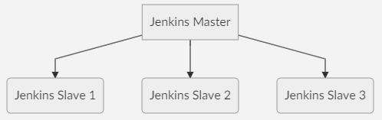

#### Steps to Configure Jenkins Master and Slave Nodes:

* 1. Click on Manage Jenkins in the left corner on the Jenkins dashboard.
  2. Click on Manage Nodes.

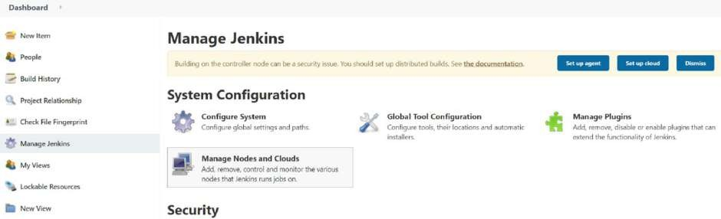

* 1. Select New Node and enter the name of the node in the Node Name field.
  2. Select Permanent Agent and click the OK button. Initially, you will get only one option, "Permanent Agent." Once you have one or more slaves you will get the "Copy Existing Node" option.

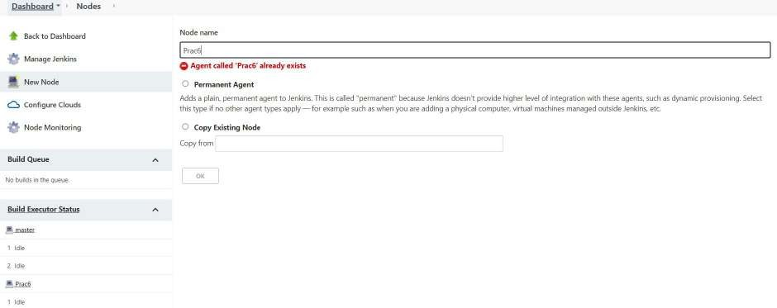

* 1. After Clicking OK, following configuration page will appear for machine Test, enter the required information.

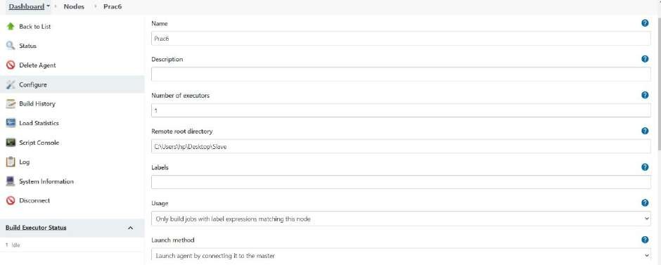

* 1. Node is Created

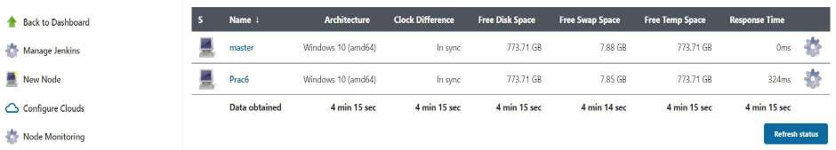

* 1. Click on agent.jar to download the agent.

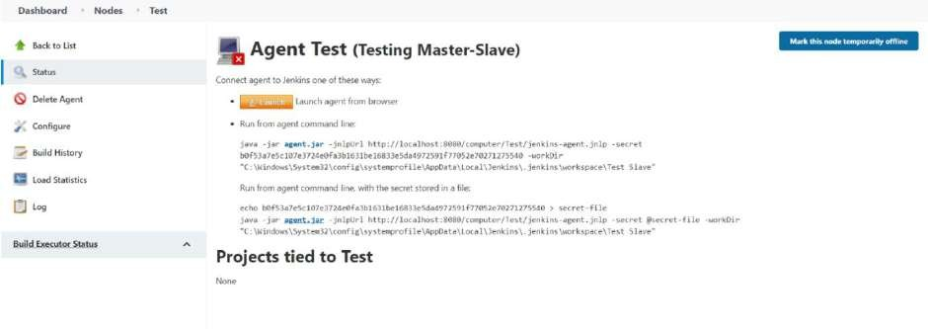

* 1. In the same directory, where you have downloaded the agent you have to run the command.

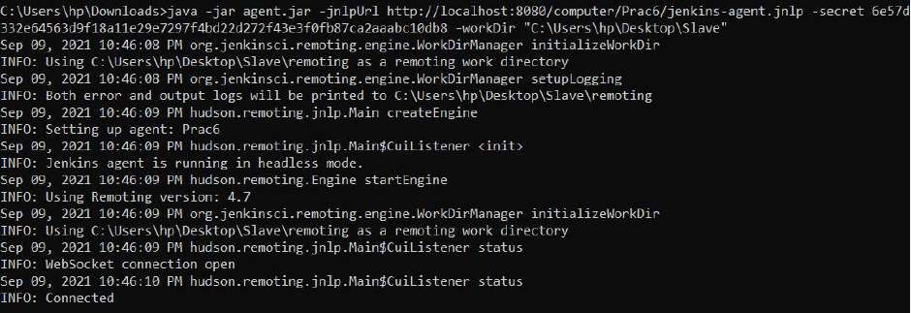

We can see Node Is Connected.

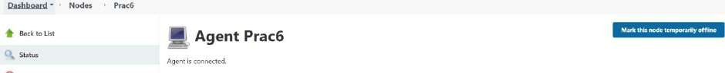

#### Creating a Pipeline and Running on The Slave Machine:

1. Click New Item in the top left corner on the dashboard.
2. Enter the name of your project in the Enter an item name field, and select the Pipeline project, and click OK button.

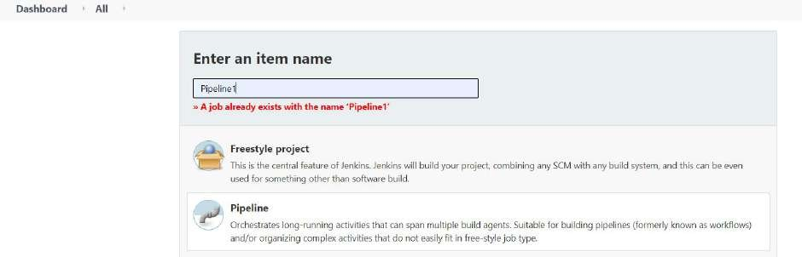

1. Enter Description (optional).
2. Go to the Pipeline section, make sure the Definition field has the Pipeline script option selected.
3. Copy and paste the following declarative Pipeline script into a script field.

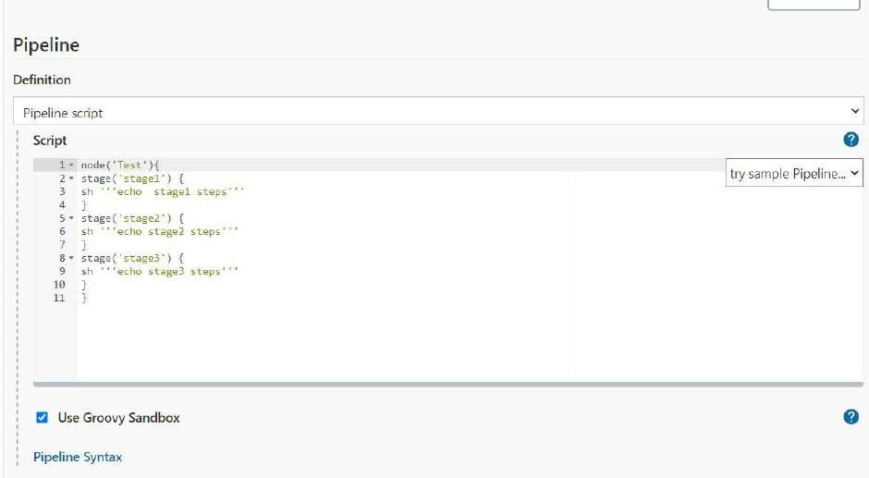

1. Click on **Save**, it will redirect to the Pipeline view page.

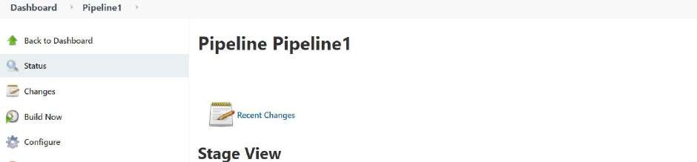

1. Add C:\Program Files\Git\bin to the PATH environment variable of the slave node in Jenkins to get access to sh.

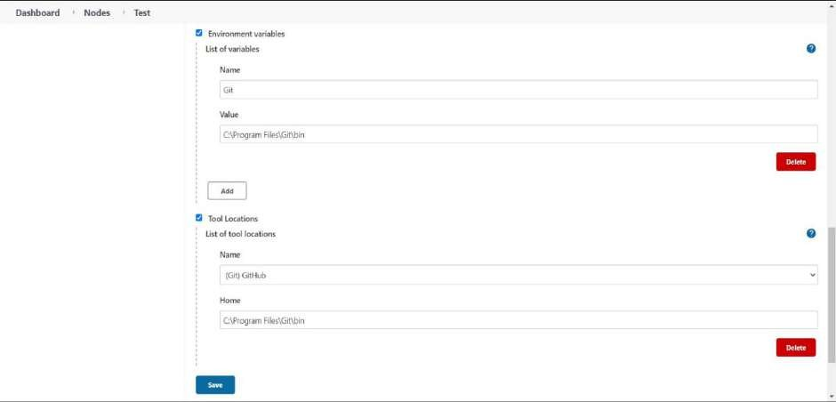

1. Then add C:\Program Files\Git\usr\bin to the PATH environment variable locally on the Windows Master slave to get access to nohup.

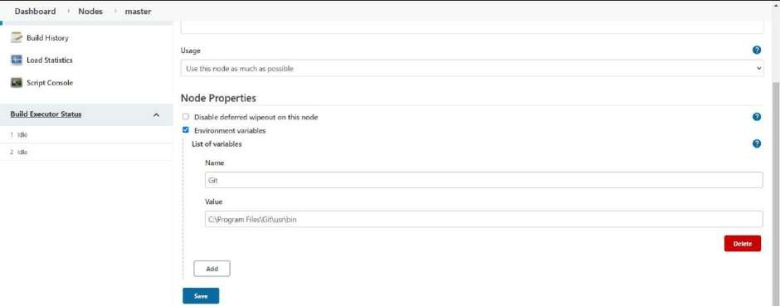

1. Restart the Node.
2. Go back to your Project Dashboard.
3. On the left pane, click the **Build Now** button to execute your Pipeline. 14.After Pipeline execution is completed, the Pipeline view will be as shown

below.

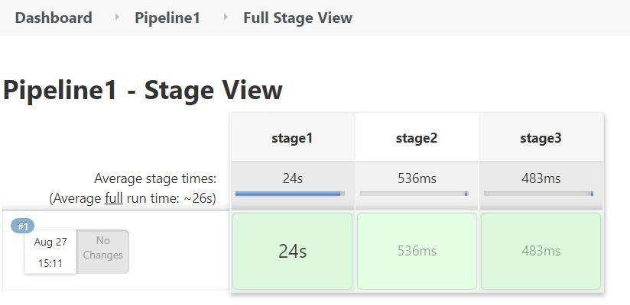

1. We can verify the history of executed build under the **Build History** by clicking the build number.
2. Click on build number and select **Console Output**. Here you can see that the pipeline ran on a slave machine.

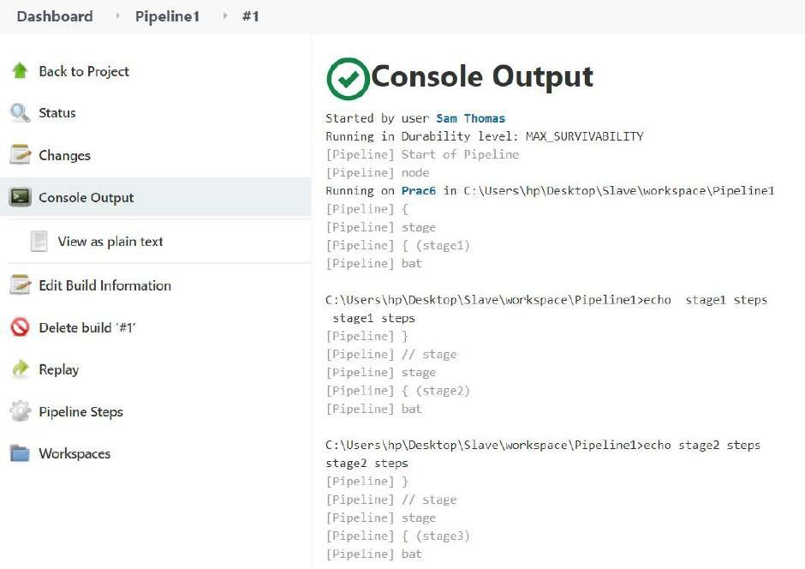

**Conclusion:** Successfully understood Jenkins Master-Slave Architecture, created a Slave Node and created a Pipeline Running on the Slave Machine.

**Ramrao Adik Institute of Technology DEPARTMENT OF INFORMATION TECHNOLOGY ACADEMIC YEAR: 2021-2022**

## COURSE NAME : DevOps Lab

|  |  |  |  |  |  |  |  |  |
| --- | --- | --- | --- | --- | --- | --- | --- | --- |
| **COURSE CODE** | | | **ITL504** | | | | | |
| **EXPERIMENT NO.** | | | **7** | | | | | |
| **EXPERIMENT TITLE** | | | **TO SETUP AND RUN SELENIUM TESTS IN JENKINS USING MAVEN** | | | | | |
| **NAME OF STUDENT** | | | **GAURAV SINGH** | | | | | |
| **ROLL NO.** | | | **19IT1074** | | | | | |
| **CLASS** | | | **TE - IT** | | | | | |
| **SEMESTER** | | | **V** | | | | | |
| **GIVEN DATE** | | | **01-09-2021** | | | | | |
| **SUBMISSION DATE** | | |  | | | | | |
| **CORRECTION DATE** | | |  | | | | | |
| **REMARK** | | |  | | | | | |
| **TIMELY SUBMISSION** | | **PRESENTATION** | | | **UNDERSTANDING** | | **TOTAL MARKS** | |
|  | **4** |  | | **4** |  | **7** |  | **15** |
| **NAME& SIGN. OF FACULTY** | | **Prof. Sujata Oak** | | |  | | | |

#### PRACTICAL NO: 7

**Aim:** To Setup and Run Selenium Tests in Jenkins Using Maven

**LO Number And Statement: LO1** – To understand the fundamentals of DevOps engineering and be fully proficient with DevOps terminologies, concepts, benefits, and deployment options to meet your business requirements.

**LO3** – To understand the importance of Jenkins to Build and deploy Software Applications on server environment

**LO4** – Understand the importance of Selenium and Jenkins to test Software Applications

#### Theory:

**Selenium** is a free (open-source) automated testing framework used to validate web applications across different browsers and platforms. You can use multiple programming languages like Java, C#, Python etc to create Selenium Test Scripts. Testing done using the Selenium testing tool is usually referred to as Selenium Testing.

Selenium Software is not just a single tool but a suite of software, each piece catering to different Selenium QA testing needs of an organization. Here is the list of tools

* Selenium Integrated Development Environment (IDE)
* Selenium Remote Control (RC)
* WebDriver
* Selenium Grid

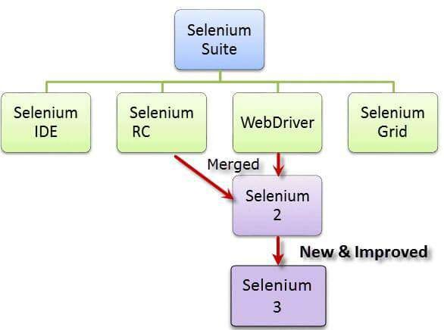

At the moment, Selenium RC and WebDriver are merged into a single framework to form Selenium 2. Selenium 1, by the way, refers to Selenium RC.

How to Choose the Right Selenium Tool for Your Need Tool Why Choose?

* + To learn about concepts on automated testing and Selenium, including:
  + Selenese commands such as type, open, clickAndWait, assert, verify, etc.
  + Locators such as id, name, xpath, css selector, etc.

Selenium IDE

Selenium RC

* Executing customized JavaScript code using runScript
* Exporting test cases in various formats.
* To create tests with little or no prior knowledge in programming.
* To create simple test cases and test suites that you can export later to RC or WebDriver.
* To test a web application against Firefox and Chrome only.
* To design a test using a more expressive language than Selenese
* To run your test against different browsers (except HtmlUnit) on different operating systems.
* To deploy your tests across multiple environments using Selenium Grid.
* To test your application against a new browser that supports JavaScript.
* To test web applications with complex AJAX-based scenarios.

WebDriver

Selenium Grid

* To use a certain programming language in designing your test case.
* To test applications that are rich in AJAX-based functionalities.
* To execute tests on the HtmlUnit browser.
* To create customized test results.
* To run your Selenium RC scripts in multiple browsers and operating systems simultaneously.
* To run a huge test suite, that needs to complete in the soonest time possible.

#### Steps to install Maven and use it with TestNG Selenium:

For this tutorial, we will use Eclipse (Juno) IDE for [Java](https://www.guru99.com/java-tutorial.html) Developers to set up Selenium WebDriver Project. Additionally, we need add m2eclipse plugin to Eclipse to facilitate the build process and create pom.xml file.

Let’s add m2eclipse plugin to Eclipse with following steps:

**Step 1)** In Eclipse IDE, select **Help** | **Install New Software** from Eclipse Main Menu.

**Step 2)** On the Install dialog, Enter the

URL <http://download.eclipse.org/technology/m2e/releases/>. Select **Work with** and m2e plugin as shown in the following screenshot:

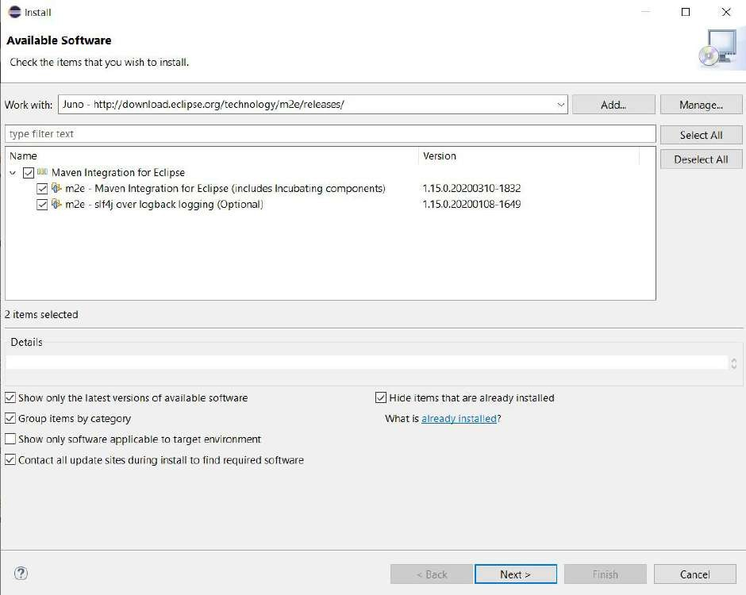

**Step 3)** Click on **Next** button and finish installation.

#### Configure Eclipse with Maven:

With m2e plugin is installed, we now need create Maven project.

**Step 1)** In Eclipse IDE, create a new project by selecting **File** | **New** | **Other** from Eclipse menu.

**Step 2)** On the **New** dialog, select **Maven** | **Maven Project** and click Next

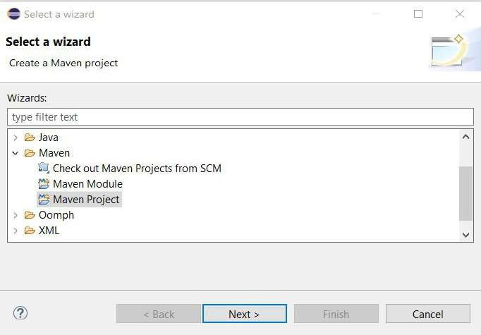

**Step 3)** On the **New Maven Project** dialog select the **Create a simple project** and click Next

**Step 4)** Enter WebdriverTest in **Group Id**: and **Artifact Id**: and click finish

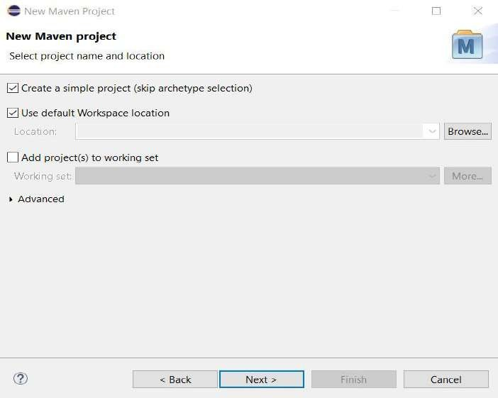

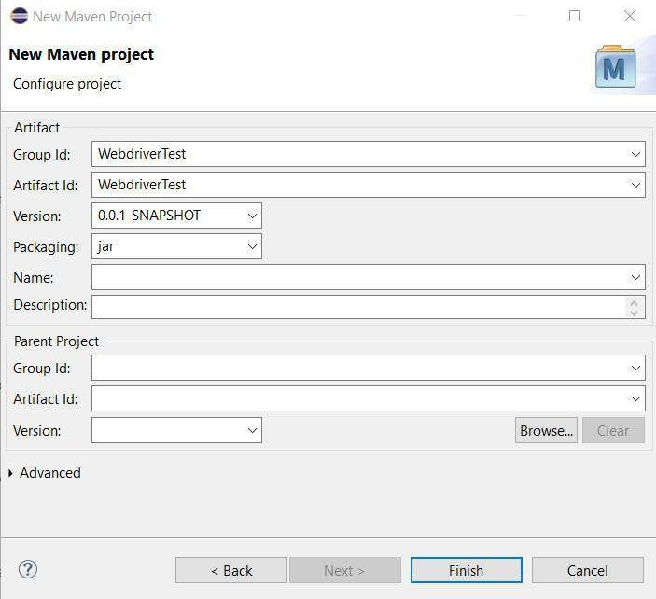

**Step 5)** Eclipse will create **WebdriverTest** with following structure:

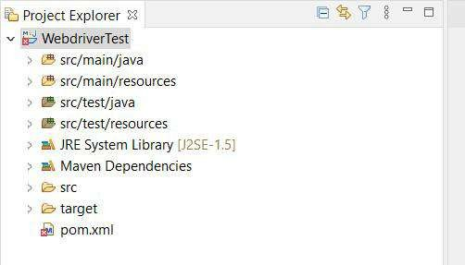

**Step 6)** Right-click on JRE System Library and select the Properties option from the menu. On the Properties for JRE System Library dialog box, make sure **Workspace default JRE** is selected and click OK

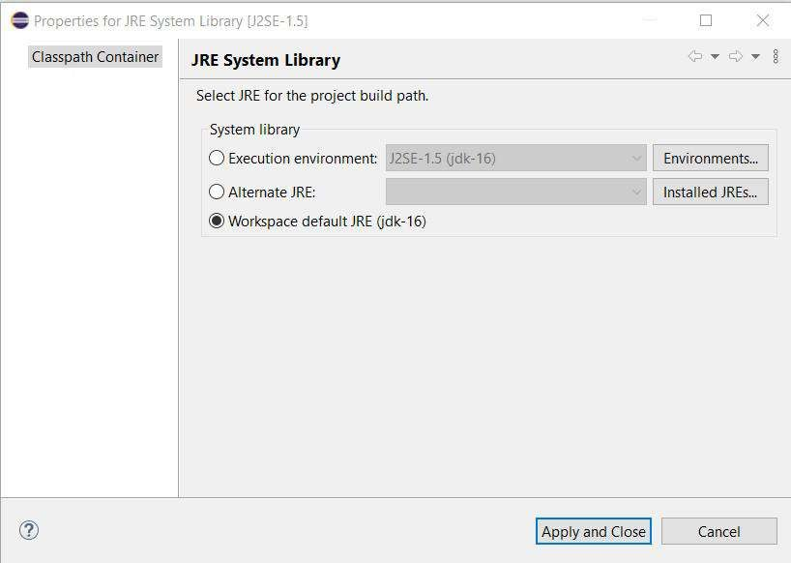

**Step 7)**. Select **pom.xml** from **Project Explorer**, pom.xml file will Open in Editor section

**Step 8)** Add the Selenium, Maven, TestNG, [Junit](https://www.guru99.com/junit-tutorial.html) dependencies to pom.xml in the <project> node:

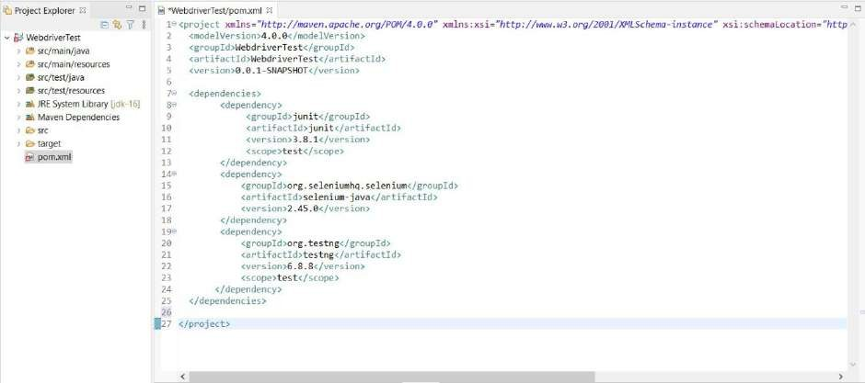

**Step 9)** To add TestNG library in Eclipse install it from Help/Eclipse Marketplace and after installation Restart IDE.

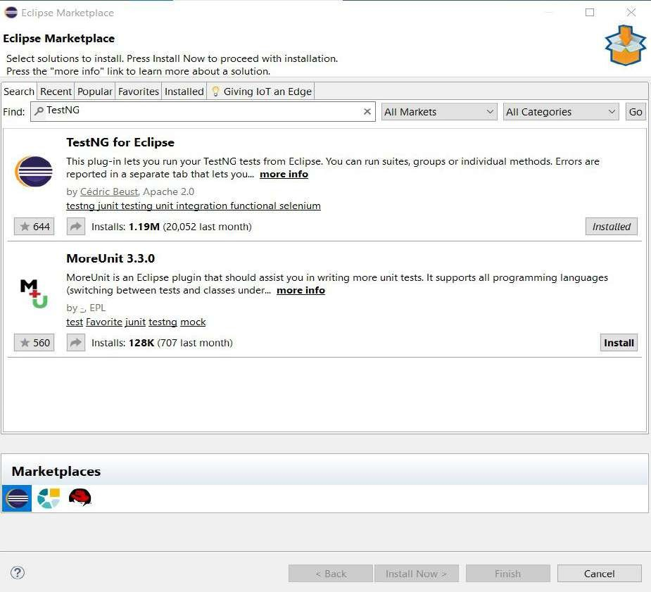

**Step 10)** Create a New TestNG Class. Enter Package name as “example” and “NewTest” in the **Name**: textbox and click on the **Finish** button as shown in the following screenshot:

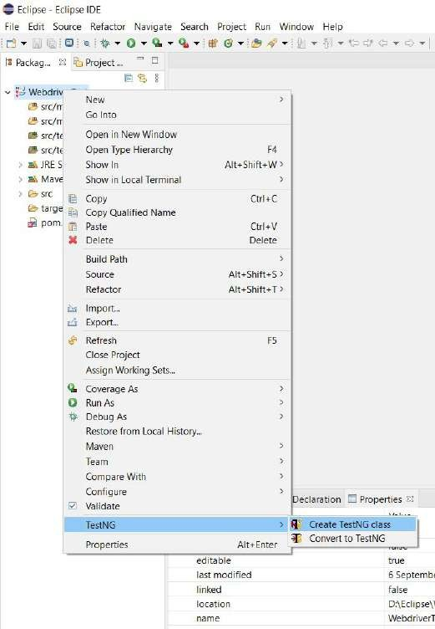

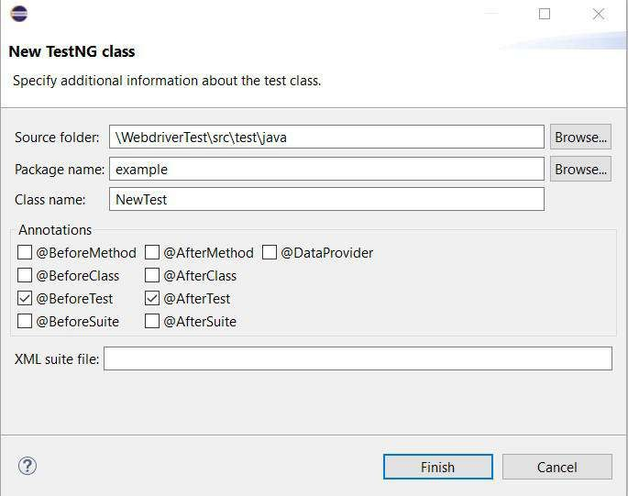

**Step 11)** Eclipse will create the NewTest class as shown in the following screenshot:

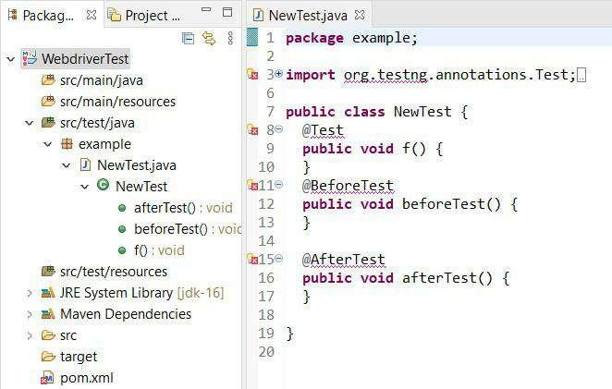

**Step 12)** Add the following code to the **NewTest** class: This code will verify the title of Guru99 Selenium Page

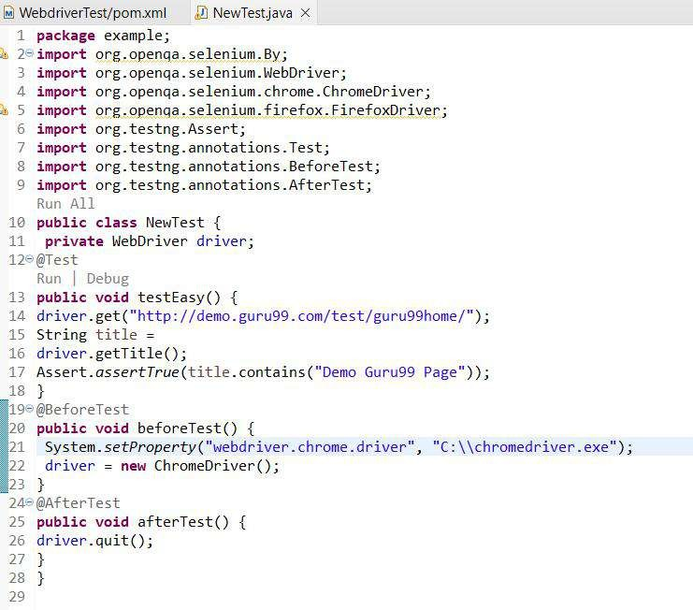

**Step 13)** Right-click on the WebdriverTest and select **TestNG** | **Convert to TestNG**.

Eclipse will create testng.xml which says that you need to run only one test with the name **NewTest** as shown in the following screenshot:

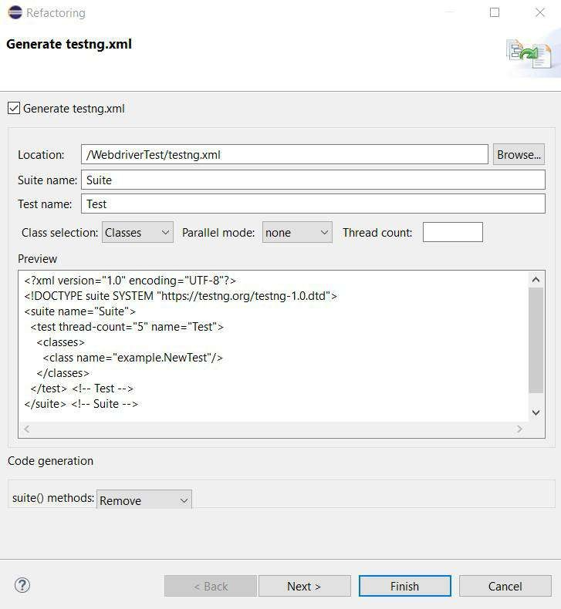

Update the project and make sure that file appears in the tree **Package Explorer** (right click on the project – Refresh).

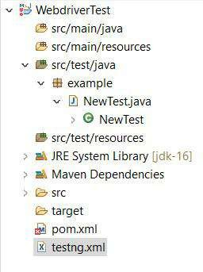

**Step 14)** Now you need to run test through this **testng.xml.**

So, in Nav-Bar go to Run/**Run Configurations** and create a new

launch **TestNG**, select the project and field **Suite** as **testng.xml** and click Run.

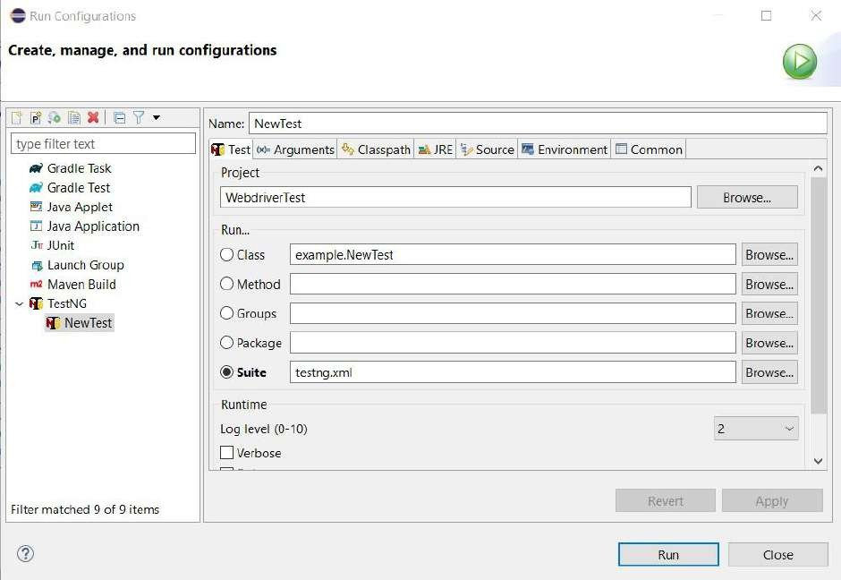

Make sure that build finished successfully.

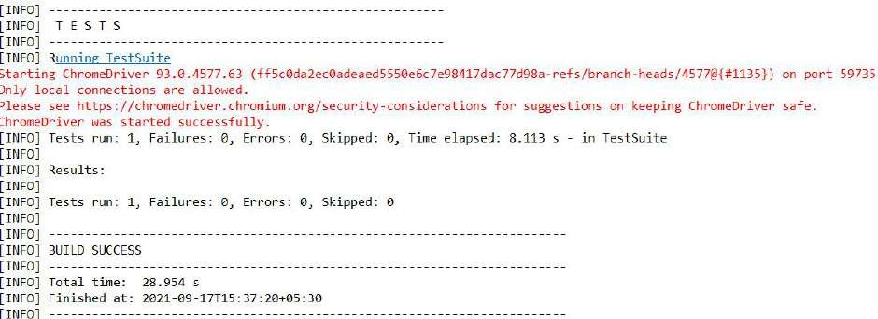

**Step 14)**. Additionally, we need to add

1. maven-compiler-plugin
2. maven-surefire-plugin
3. testng.xml to pom.xml**.**

The maven-surefire-plugin is used to configure and execute tests. Here plugin is used to configure the testing.xml for TestNG test and generate test reports.

The maven-compiler-plugin is used to help in compiling the code and using the particular JDK version for compilation. Add all dependencies in the following code snippet, to pom.xml in the <plugin> node:

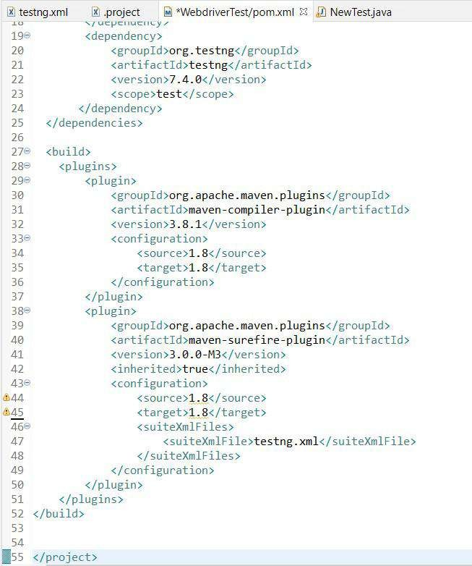

**Step 15)** To run th**e** tests in the Maven lifecycle, Right-click on the WebdriverTest and select **Run As** | **Maven test**. Maven will execute test from the project. Make sure that build finished successfully.



#### Configure Jenkins to Run Maven with TestNg Selenium:

**Step 1)** Navigate to the Jenkins Dashboard (http://localhost:8080 by default) in the browser window. Click on the **New Item** link to create a CI job.

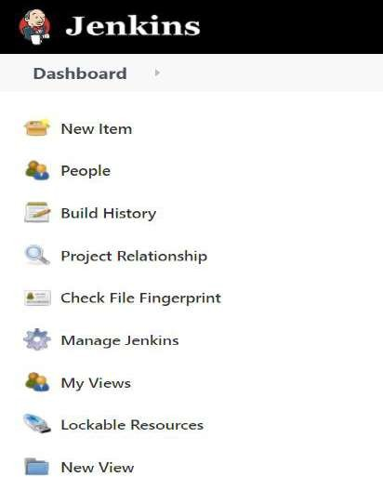

**Step 2)** Select the Maven project button as shown in the following screenshot:

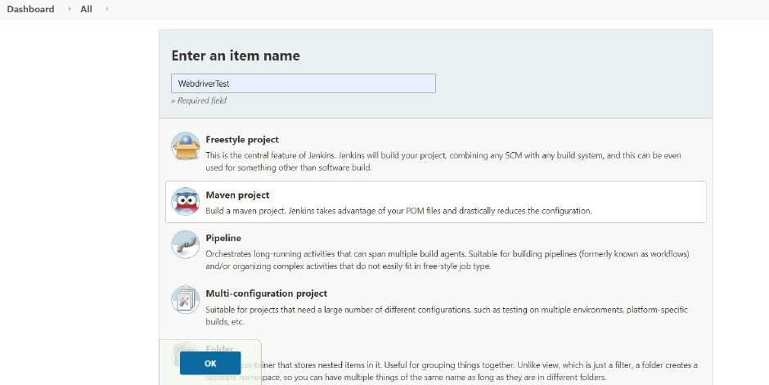

Using the Build a **Maven Project** option, Jenkins supports building and testing Maven projects.

**Step 3)** Click on OK button. A new job with name “WebdriverTest” is created in Jenkins Dashboard.



**Step 4)** Go to the **Build** section of new job.

* + In the **Root POM** textbox, enter full path to pom.xml
  + In Goals and options section, enter “clean test”

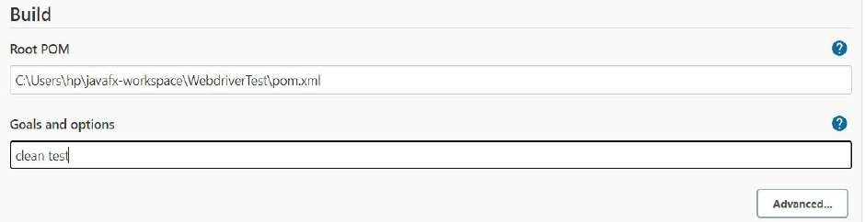

Click on **Apply** button.

**Step 5)** On the WebdriverTest project page, click on the **Build Now** link.

Console Output:

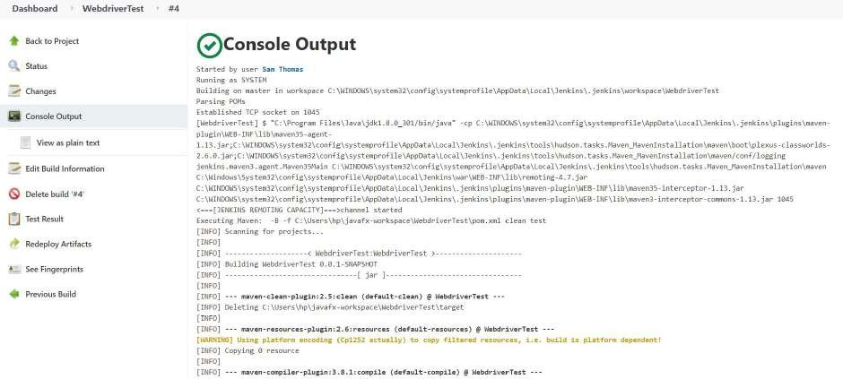

**Step 6)** Once the build process is completed, go back to

the WebdriverTest project. The WebdriverTest project page displays the build history and links to the results as shown in the following screenshot:

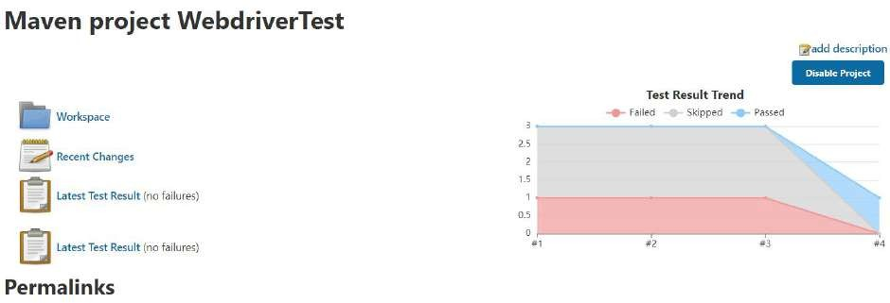

**Step 7)** Click on the “Latest Test Result” link to view the test results as shown in the following screenshot:

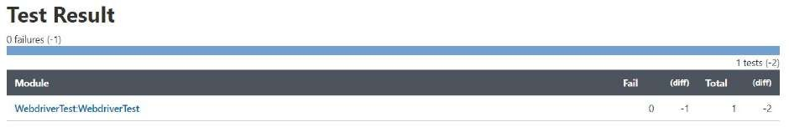

**Conclusion:** Successfully Setup and Run Selenium Tests in Jenkins Using Maven.

**Ramrao Adik Institute of Technology DEPARTMENT OF INFORMATION TECHNOLOGY ACADEMIC YEAR: 2021-2022**

## COURSE NAME : DevOps Lab

|  |  |  |  |  |  |  |  |  |
| --- | --- | --- | --- | --- | --- | --- | --- | --- |
| **COURSE CODE** | | | **ITL504** | | | | | |
| **EXPERIMENT NO.** | | | **8** | | | | | |
| **EXPERIMENT TITLE** | | | **DOCKER ARCHITECTURE AND CONTAINER LIFE CYCLE** | | | | | |
| **NAME OF STUDENT** | | | **GAURAV SINGH** | | | | | |
| **ROLL NO.** | | | **19IT1074** | | | | | |
| **CLASS** | | | **TE - IT** | | | | | |
| **SEMESTER** | | | **V** | | | | | |
| **GIVEN DATE** | | | **08-09-2021** | | | | | |
| **SUBMISSION DATE** | | |  | | | | | |
| **CORRECTION DATE** | | |  | | | | | |
| **REMARK** | | |  | | | | | |
| **TIMELY SUBMISSION** | | **PRESENTATION** | | | **UNDERSTANDING** | | **TOTAL MARKS** | |
|  | **4** |  | | **4** |  | **7** |  | **15** |
| **NAME& SIGN. OF FACULTY** | | **Prof. Sujata Oak** | | |  | | | |

#### PRACTICAL NO:8

**Practical name**: Docker architecture and container Life cycle, install Docker and execute docker commands to manage images and interact with containers.

**Aim**: To understand Docker architecture and container Life cycle, install Docker and execute docker commands to manage images and interact with containers.

**Lab Outcome**: LO1: To understand the fundamentals of DevOps engineering and be fully proficient with DevOps terminologies, concepts, benefits, and deployment options to meet your business requirements.

LO5: To understand the concept containerization and Analyze the containerization of OS image and deployment of application over Docker.

#### Theory:

**What is Docker?**

Docker is an open-source containerization platform. It enables developers to package applications into containers—standardized executable components combining application source code with the operating system (OS) libraries and dependencies required to run that code in any environment. Containers simplify delivery of distributed applications, and have become increasingly popular as organizations shift to cloud-native development and hybrid multicloud environments.

Developers can create containers without Docker, but the platform makes it easier, simpler, and safer to build, deploy and manage containers. Docker is essentially a toolkit that enables developers to build, deploy, run, update, and stop containers using simple commands and work-saving automation through a single API.

Docker also refers to Docker, Inc. (link resides outside IBM), the company that sells the commercial version of Docker, and to the Docker open- source project (link resides outside IBM), to which Docker, Inc. and many other organizations and individuals contribute.

#### Why to use Docker?

Docker is so popular today that “Docker” and “containers” are used interchangeably. But the first container-related technologies were available for

years- even decades (link resides outside IBM)- before Docker was released to the public in 2013.

Most notably, in 2008, LinuXContainers (LXC) was implemented in the Linux kernel, fully enabling virtualization for a single instance of Linux. While LXC is still used today, newer technologies using the Linux kernel are available. Ubuntu, a modern, open-source Linux operating system, also provides this capability.

Docker enhanced the native Linux containerization capabilities with technologies that enable:

* Improved and seamless portability: While LXC containers often reference machine-specific configurations, Docker containers run without modification across any desktop, data center and cloud environment.
* Even lighter weight and more granular updates: With LXC, multiple processes can be combined within a single container. With Docker containers, only one process can run in each container. This makes it possible to build an application that can continue running while one of its parts is taken down for an update or repair.
* Automated container creation: Docker can automatically build a container based on application source code.
* Container versioning: Docker can track versions of a container image, roll back to previous versions, and trace who built a version and how. It can even upload only the deltas between an existing version and a new one.
* Container reuse: Existing containers can be used as base images essentially like templates for building new containers.
* Shared container libraries: Developers can access an open-source registry containing thousands of user-contributed containers.

#### Docker Installation:

The Docker installation package available in the official Ubuntu repository may not be the latest version. To ensure we get the latest version, we’ll install Docker from the official Docker repository. To do that, we’ll add a new package source, add the GPG key from Docker to ensure the downloads are valid, and then install the package.

First, update your existing list of packages:

* sudo apt update

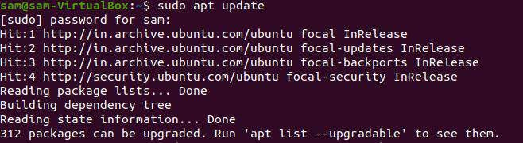

Next, install a few prerequisite packages which let apt use packages over HTTPS:

* sudo apt install apt-transport-https ca-certificates curl software-properties- common

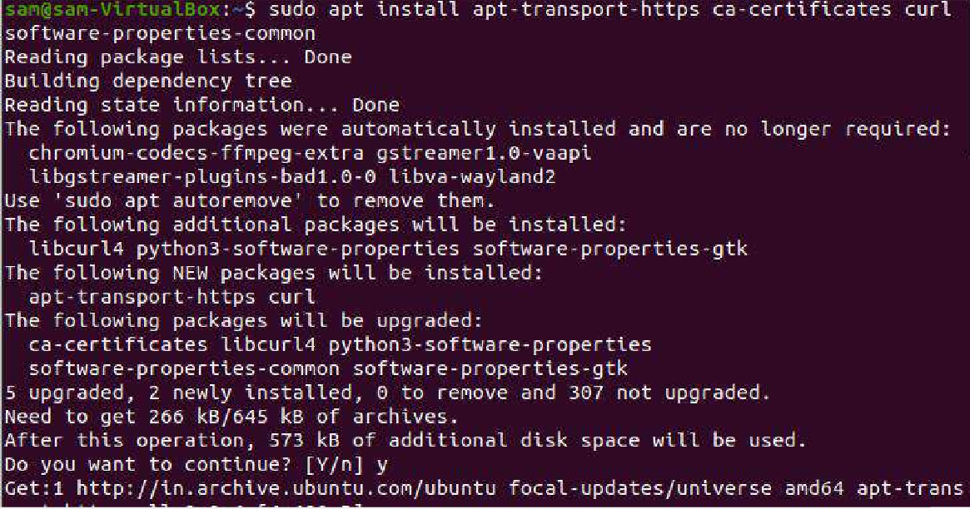

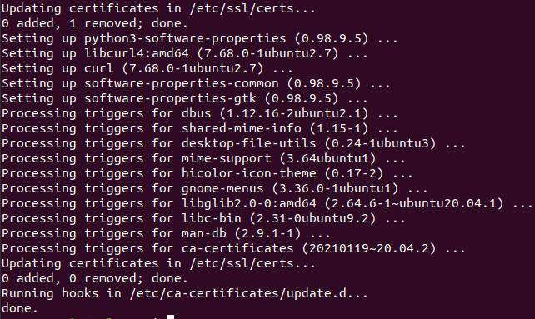

Then add the GPG key for the official Docker repository to your system:

* curl -fsSL https://download.docker.com/linux/ubuntu/gpg | sudo apt- key add –

Add the Docker repository to APT sources:

* sudo add-apt-repository "deb [arch=amd64] https://download.docker.com/linux/ubuntu focal stable"

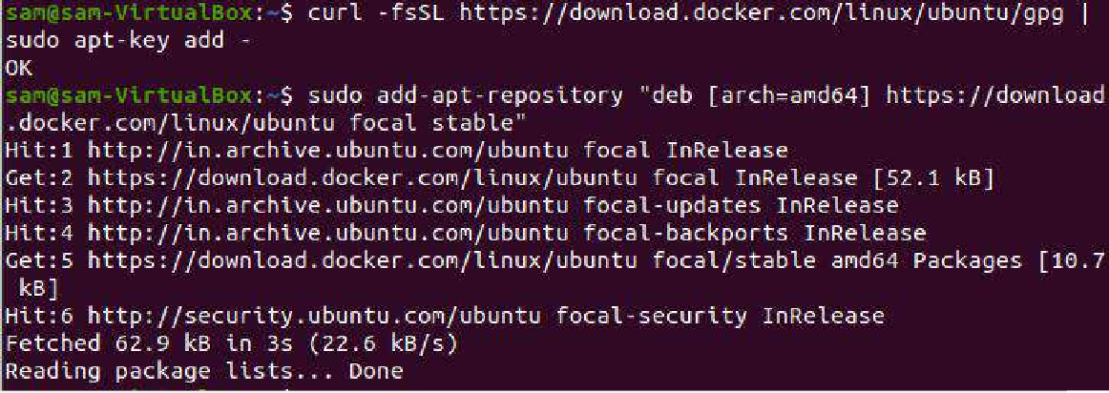

Next, update the package database with the Docker packages from the newly added repo:

* sudo apt update

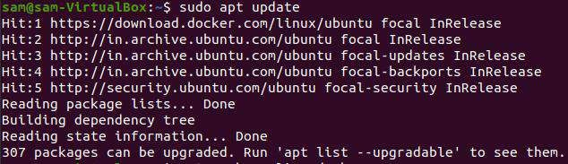

Make sure you are about to install from the Docker repo instead of the default Ubuntu repo:

* apt-cache policy docker-ce

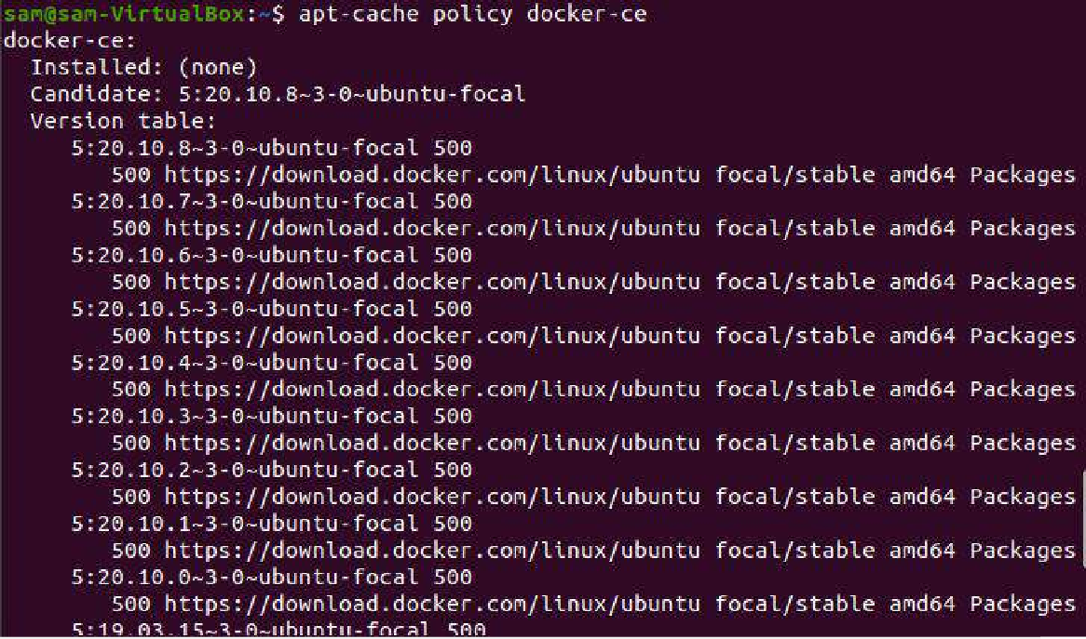

Notice that docker-ce is not installed, but the candidate for installation is from the

Docker repository for Ubuntu 20.04 (focal). Finally, install Docker:

* sudo apt install docker-ce

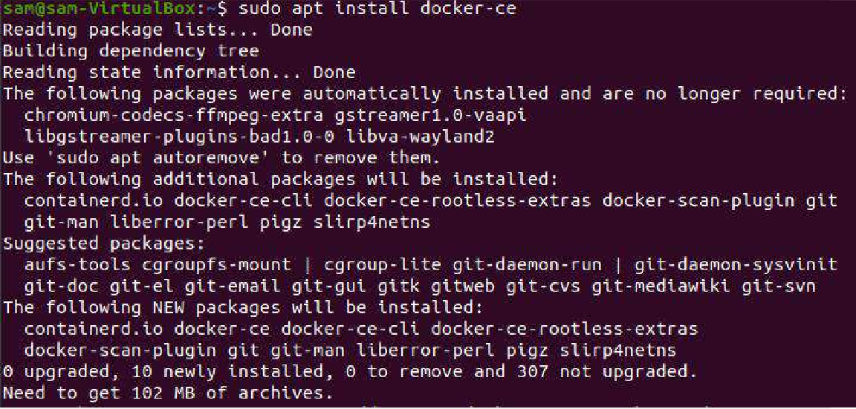

Docker should now be installed, the daemon started, and the process enabled to start on boot. Check that it’s running:

* sudo systemctl status docker

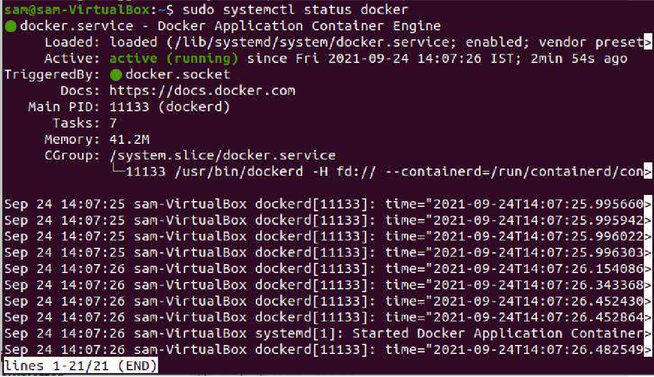

Installing Docker now gives you not just the Docker service (daemon) but also

docker docker

the the

command line utility, or the Docker client. We’ll explore how to use command later in this tutorial.

#### Docker commands:

1. docker images: This command is used to see the downloaded or created images existing in the system



1. docker ps: This command is used to see/list the containers running in your system



1. docker ps -a: This command is used to see/list all the containers in your system i.e running or stopped containers.

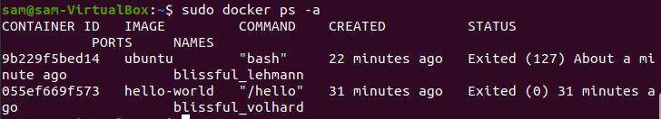

1. docker run: This command is used to create a new container. docker run -it -- name mycentos centos:latest



1. docker rm -f mycentos : This will delete the container named mycentos. Here

—f indicates forecully remove it.

1. docker exec : This command is used to run a command in a running container. docker exec -it mycentos bash : Here we are running bash shell inside our container



#### Building and Testing Dockerfiles:

There’s a free service that lets you quickly spin up Docker instances through a web interface called: “Play with Docker”

First of all, head over to[http://play-with-docker.com](http://play-with-docker.com/) and start a new session. You need to create an account first.

1. Once your session is active click on “Add New Instance”:

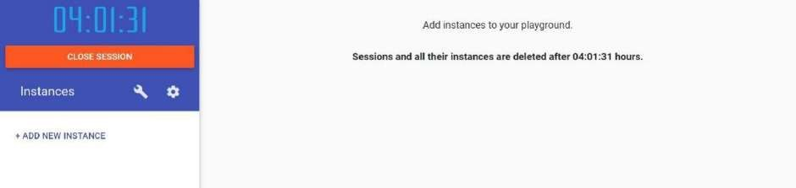

1. A new instance will start with a Docker Engine ready to accept commands
2. Next create/edit the Dockerfile. Run “vi Dockerfile”, press “i” to switch to “Insert Mode”, copy/paste the contents of our Dockerfile, press “Esc” to exit “Insert Mode”, and save+exit by typing “:x”

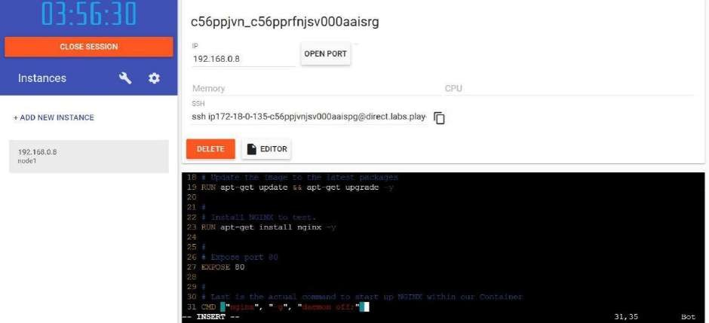

1. Build the new image using the command docker build <path>. Path refers to the directory containing the Dockerfile.
2. At the end of the process, you should see the message “Successfully built

<image ID>”

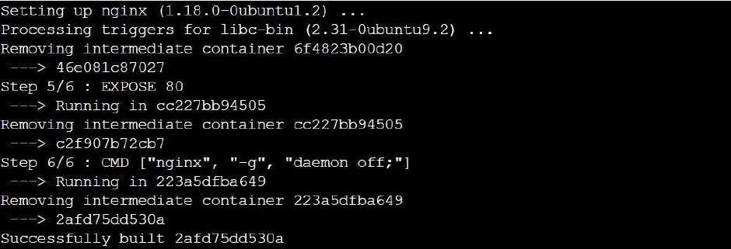

1. Start the new image and test connectivity to NGINX. Run the command docker run -p 80:80 <image ID>. The option -p 80:80 exposes the Container port 80 as the Host port 80 to the world.

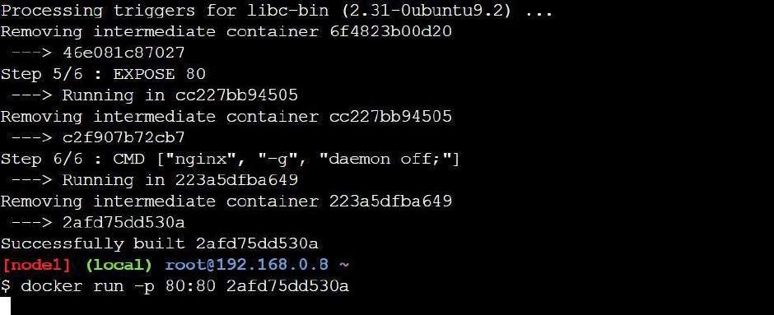

1. As a result, a port 80 link should have become active next to the IP. Click on it to access your NGINX service.

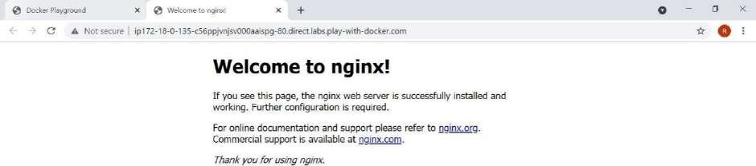

**Conclusion**: Hence, we understood docker architecture and container Life cycle, installed Docker and executed docker commands to manage images and interact with containers.

**Ramrao Adik Institute of Technology DEPARTMENT OF INFORMATION TECHNOLOGY ACADEMIC YEAR: 2021-2022**

## COURSE NAME : DevOps Lab

|  |  |  |  |  |  |  |  |  |
| --- | --- | --- | --- | --- | --- | --- | --- | --- |
| **COURSE CODE** | | | **ITL504** | | | | | |
| **EXPERIMENT NO.** | | | **9** | | | | | |
| **EXPERIMENT TITLE** | | | **BUILD AN IMAGE FOR A SAMPLE WEB APPLICATION USING DOCKERFILE** | | | | | |
| **NAME OF STUDENT** | | | **GAURAV SINGH** | | | | | |
| **ROLL NO.** | | | **19IT1074** | | | | | |
| **CLASS** | | | **TE - IT** | | | | | |
| **SEMESTER** | | | **V** | | | | | |
| **GIVEN DATE** | | | **15-09-2021 & 22-09-2021** | | | | | |
| **SUBMISSION DATE** | | |  | | | | | |
| **CORRECTION DATE** | | |  | | | | | |
| **REMARK** | | |  | | | | | |
| **TIMELY SUBMISSION** | | **PRESENTATION** | | | **UNDERSTANDING** | | **TOTAL MARKS** | |
|  | **4** |  | | **4** |  | **7** |  | **15** |
| **NAME& SIGN. OF FACULTY** | | **Prof. Sujata Oak** | | |  | | | |

#### PRACTICAL NO:9

**Practical name**: To learn Dockerfile instructions, build an image for a sample web application using Dockerfile. Dockerfile can be a web application, python based , java based, nodejs.

**Aim**: To learn Dockerfile instructions, build an image for a sample web application using Dockerfile. Dockerfile can be a web application, python based, java based, nodejs

**Lab Outcome**: LO1: To understand the fundamentals of DevOps engineering and be fully proficient with DevOps terminologies, concepts, benefits, and deployment options to meet your business requirements.

LO5: To understand the concept containerization and Analyze the containerization of OS image and deployment of application over Docker.

#### Theory:

**What is Docker?**

Docker is an open-source containerization platform. It enables developers to package applications into containers—standardized executable components combining application source code with the operating system (OS) libraries and dependencies required to run that code in any environment. Containers simplify delivery of distributed applications, and have become increasingly popular as organizations shift to cloud-native development and hybrid multicloud environments.

Developers can create containers without Docker, but the platform makes it easier, simpler, and safer to build, deploy and manage containers. Docker is essentially a toolkit that enables developers to build, deploy, run, update, and stop containers using simple commands and work-saving automation through a single API.

Docker also refers to Docker, Inc. (link resides outside IBM), the company that sells the commercial version of Docker, and to the Docker open- source project (link resides outside IBM), to which Docker, Inc. and many other organizations and individuals contribute.

#### Why to use Docker?

Docker is so popular today that “Docker” and “containers” are used interchangeably. But the first container-related technologies were available for years- even decades (link resides outside IBM)- before Docker was released to the public in 2013.

Most notably, in 2008, LinuXContainers (LXC) was implemented in the Linux kernel, fully enabling virtualization for a single instance of Linux. While LXC is still used today, newer technologies using the Linux kernel are available. Ubuntu, a modern, open-source Linux operating system, also provides this capability.

Docker enhanced the native Linux containerization capabilities with technologies that enable:

* Improved and seamless portability: While LXC containers often reference machine-specific configurations, Docker containers run without modification across any desktop, data center and cloud environment.
* Even lighter weight and more granular updates: With LXC, multiple processes can be combined within a single container. With Docker containers, only one process can run in each container. This makes it possible to build an application that can continue running while one of its parts is taken down for an update or repair.
* Automated container creation: Docker can automatically build a container based on application source code.
* Container versioning: Docker can track versions of a container image, roll back to previous versions, and trace who built a version and how. It can even upload only the deltas between an existing version and a new one.
* Container reuse: Existing containers can be used as base images essentially like templates for building new containers.
* Shared container libraries: Developers can access an open-source registry containing thousands of user-contributed containers.

#### Docker images and Containers

Docker containers are instances of Docker images, whether running or stopped. In fact, the major difference between Docker containers and images is that containers have a writable layer.

When you create a Docker container, you’re adding a writable layer on top of the Docker image. You can run many Docker containers from the same Docker image. You can see a Docker container as an instance of a Docker image

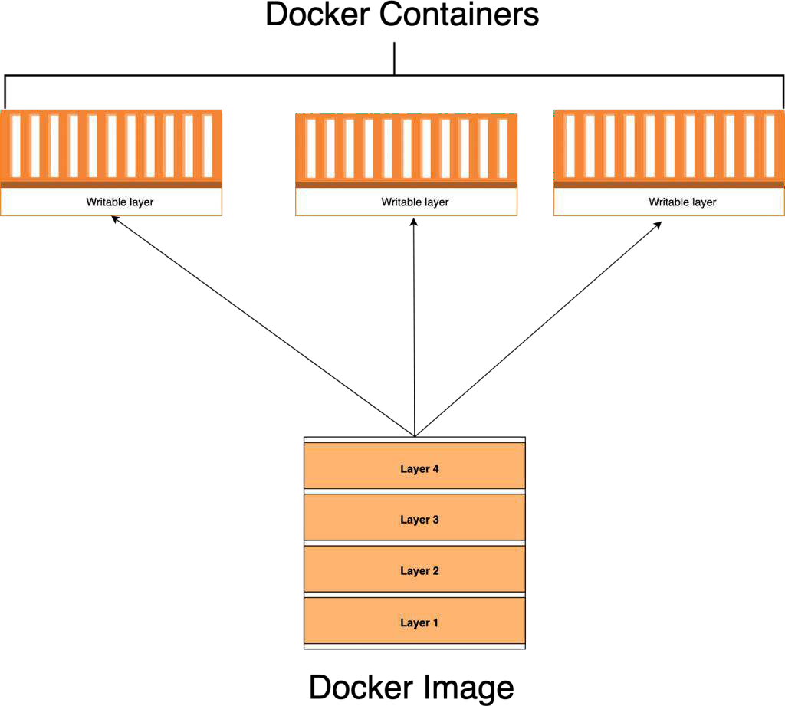

#### Running java-file in a Docker Container: 1.Code of DockerFile:

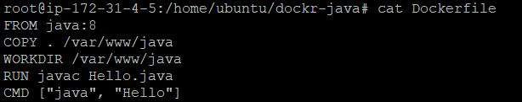

1. **Java code:**

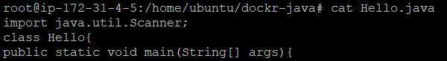

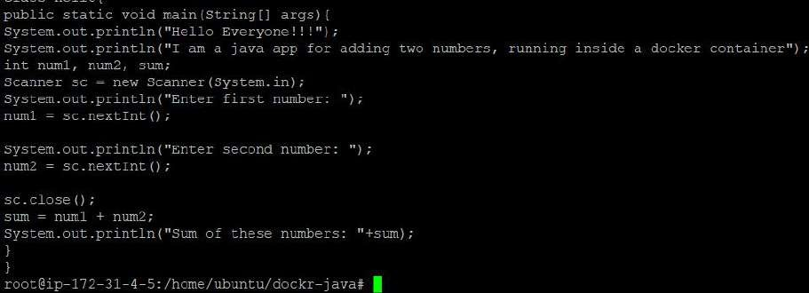

#### Building a Docker container:

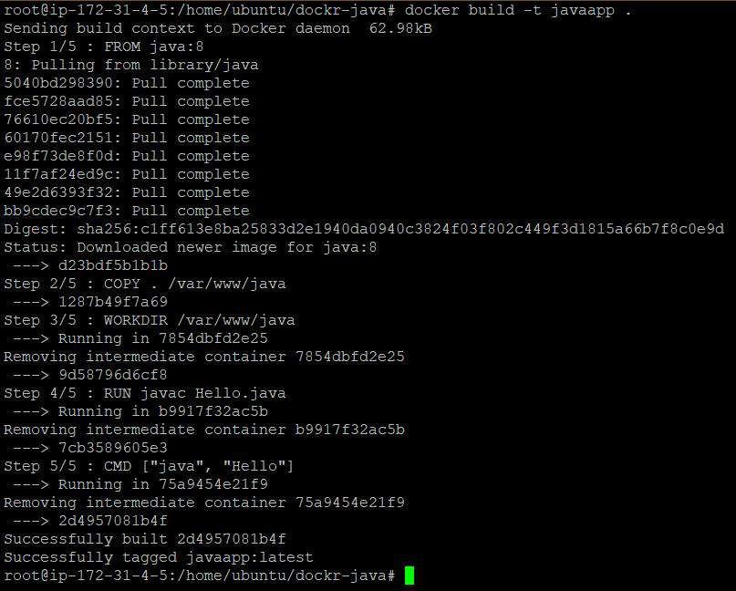

1. **Running a java file inside the docker container:**

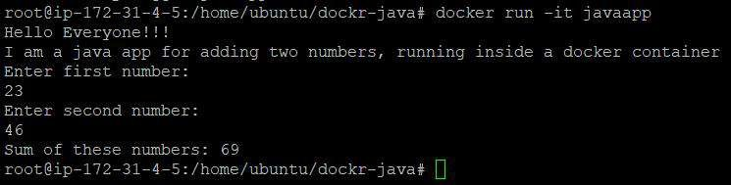

**Conclusion**: Hence, we understood docker architecture and container Life cycle, installed Docker and executed docker commands to manage images and interact with containers.

**Ramrao Adik Institute of Technology DEPARTMENT OF INFORMATION TECHNOLOGY ACADEMIC YEAR: 2021-2022**

## COURSE NAME : DevOps Lab

|  |  |  |  |  |  |  |  |  |
| --- | --- | --- | --- | --- | --- | --- | --- | --- |
| **COURSE CODE** | | | **ITL504** | | | | | |
| **EXPERIMENT NO.** | | | **10** | | | | | |
| **EXPERIMENT TITLE** | | | **TO INSTALL ANSIBLE, CONFIGURE SSH ACCESS TO ANSIBLE HOST/SLAVE AND SET UP ANSIBLE**  **HOST AND TESTED CONNECTION.** | | | | | |
| **NAME OF STUDENT** | | | **GAURAV SINGH** | | | | | |
| **ROLL NO.** | | | **19IT1074** | | | | | |
| **CLASS** | | | **TE - IT** | | | | | |
| **SEMESTER** | | | **V** | | | | | |
| **GIVEN DATE** | | | **29-09-2021** | | | | | |
| **SUBMISSION DATE** | | |  | | | | | |
| **CORRECTION DATE** | | |  | | | | | |
| **REMARK** | | |  | | | | | |
| **TIMELY SUBMISSION** | | **PRESENTATION** | | | **UNDERSTANDING** | | **TOTAL MARKS** | |
|  | **4** |  | | **4** |  | **7** |  | **15** |
| **NAME& SIGN. OF FACULTY** | | **Prof. Sujata Oak** | | |  | | | |

#### PRACTICAL NO: 10

**Aim**: To install Ansible on top of AWS instance, configure SSH access to Ansible host/slave and set up ansible host and tested connection.

#### Theory:

**Ansible:**

Ansible is an open-source software provisioning, configuration management, and application-deployment tool enabling infrastructure as code. It runs on many Unix-like systems, and can configure both Unix-like systems as well as Microsoft Windows. It includes its own declarative language to describe system configuration. Ansible was written by Michael De Haan and acquired by Red Hat in 2015. Ansible is agentless, temporarily connecting remotely via SSH or Windows Remote Management (allowing remote PowerShell execution) to do its tasks.

#### Ansible Playbook:

An Ansible® playbook is a blueprint of automation tasks—which are complex IT actions executed with limited or no human involvement. Ansible playbooks are executed on a set, group, or classification of hosts, which together make up an Ansible inventory.

Ansible playbooks are essentially frameworks, which are prewritten code developers can use ad-hoc or as starting template. Ansible playbooks are regularly used to automate IT infrastructure (such as operating systems and Kubernetes platforms), networks, security systems, and developer personas (such as Git and Red Hat CodeReady Studio).

Ansible playbooks help IT staff program applications, services, server nodes, or other devices without the manual overhead of creating everything from scratch. And Ansible playbooks—as well as the conditions, variables, and tasks within them—can be saved, shared, or reused indefinitely.

Ansible Playbooks offer a repeatable, re-usable, simple configuration management and multi-machine deployment system, one that is well suited to deploying complex applications. If you need to execute a task with Ansible more than once, write a playbook and put it under source control. Then you can use the playbook to push out new configuration or confirm the configuration of remote systems.

#### Implementation and Output:

1. Login to AWS Console and search for EC2. Inside EC2 select instances.

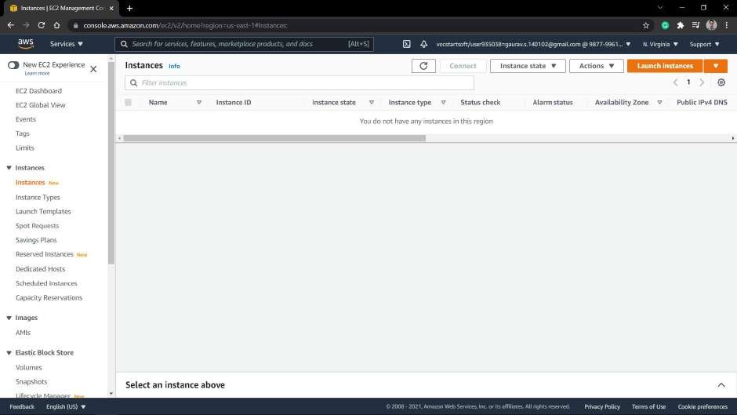

1. On this page, click on Launch instances, then select Ubuntu 20.04 LTS, free tier eligible.

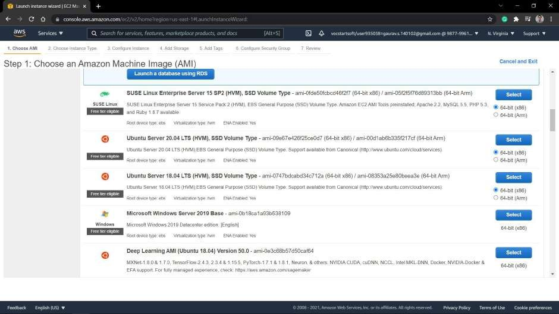

1. In instance type, select t2.micro as it is free tier eligible. Then click on Next: Configure Instance details

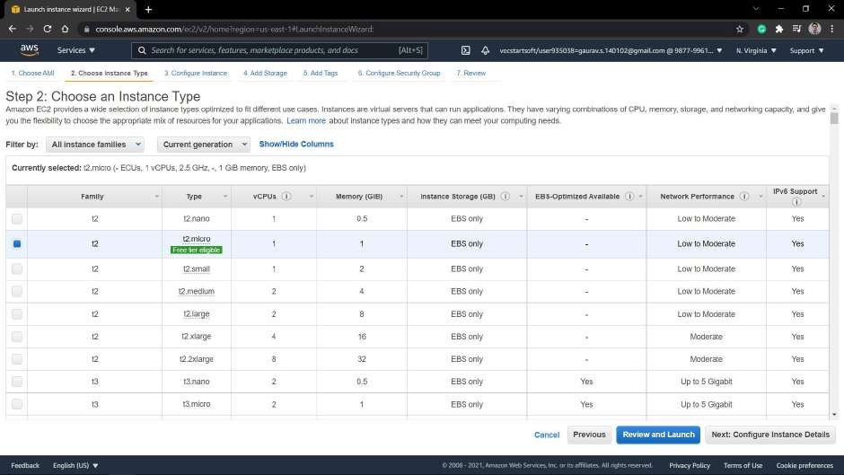

1. On the “Configure instance details” page, type number of instances 2 as minimum 2 instances would be required. One for Ansible controller and other for host machine

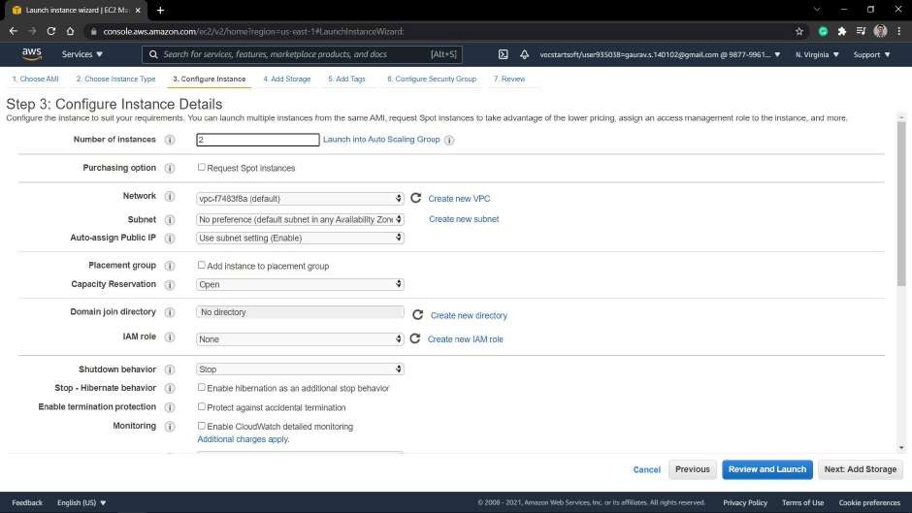

1. On security group page, click on “Create a new security group”, then provide a name for security group. Now we need to add 3 rules which will be used for connecting to instances. First, select the type as ssh and keep other settings as default. Click on Add rule and add HTTP, and select source from

anywhere. Similarly, add another rule for “All ICMP -IPv4’ and source from anywhere.

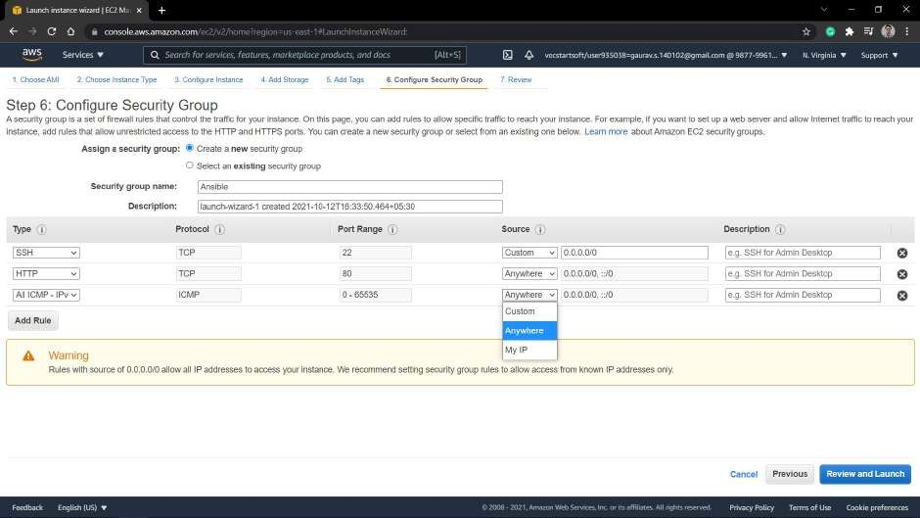

1. Next step is review. Here, review all the configuration and if everything is as supposed, click launch.

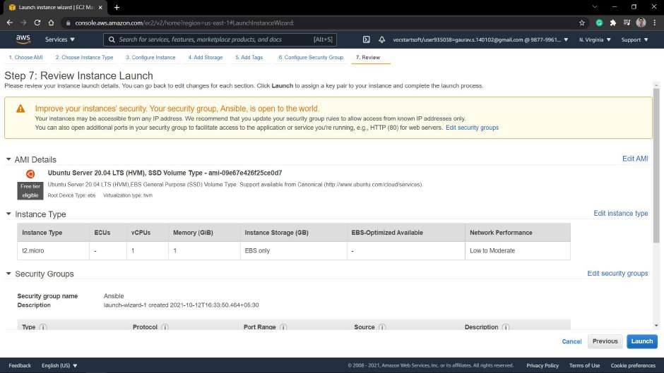

1. When you click on the launch button, AWS console will ask you for key pair which will be used for connecting to your instances. If you already have a key pair available you can choose an existing pair or select, create a new key pair. Make sure RSA is selected and download the key pair. Once that is done, click on launch instances.

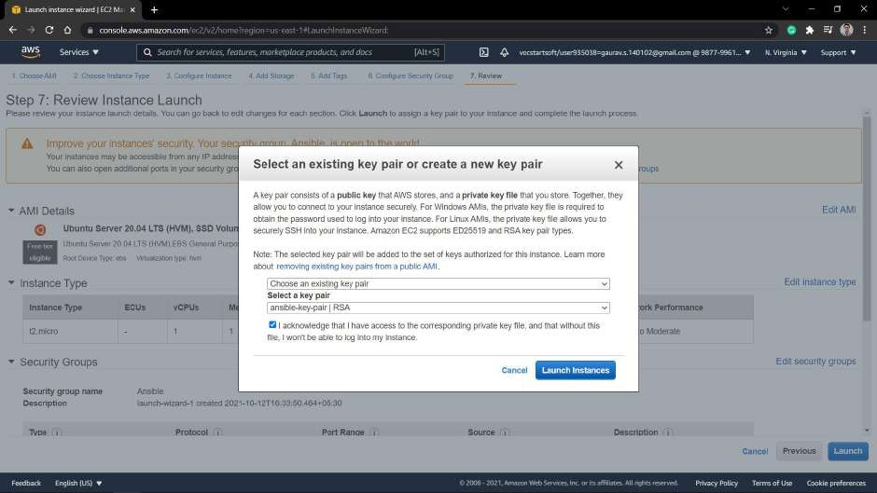

1. It will start initializing your instances with the configuration provided.

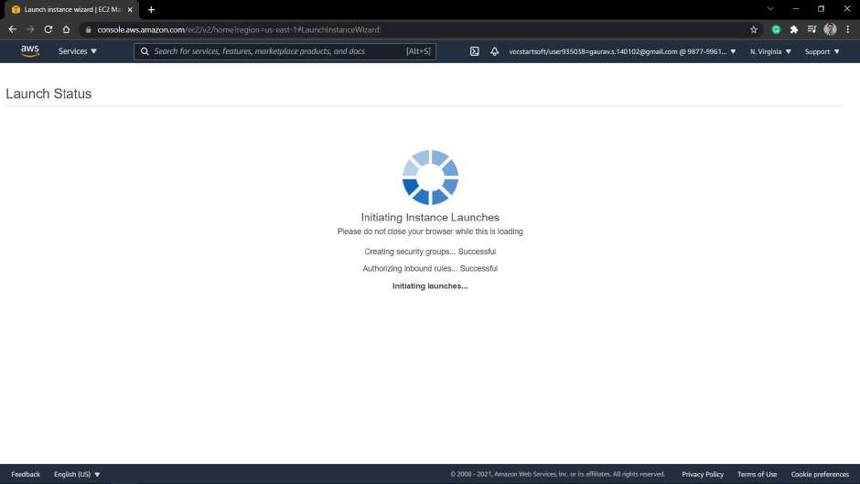

1. Once the instances are ready and in running state, you can name them to easily identify one from another. For e.g, we name the first instance as “Ansible-controller” and the second as “host1”.

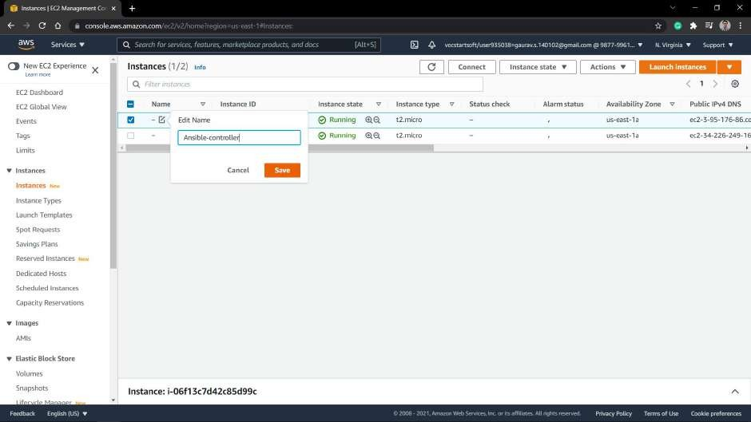

1. After renaming, the instance window should appear like this.

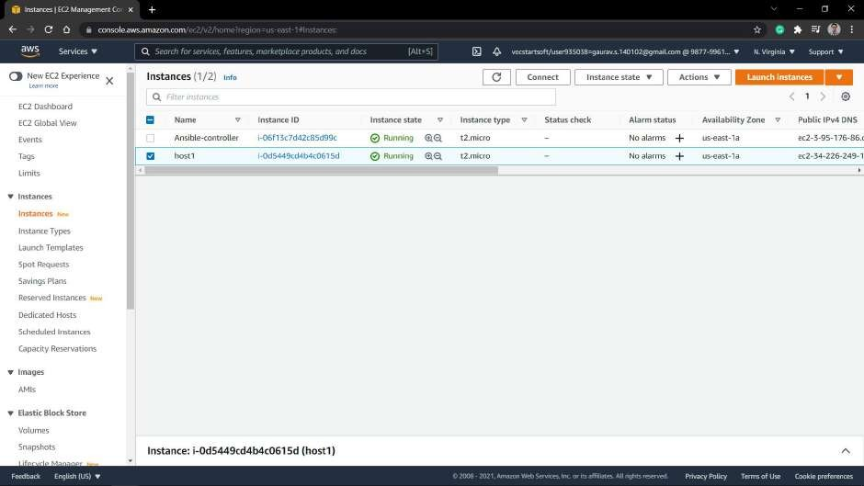

1. Now, select the “Ansible-controller” instance and click on connect.

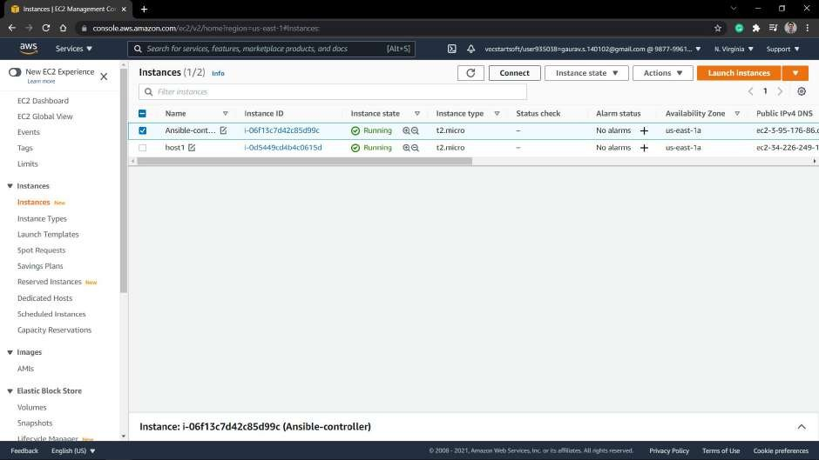

1. From this window, copy the Public DNS.

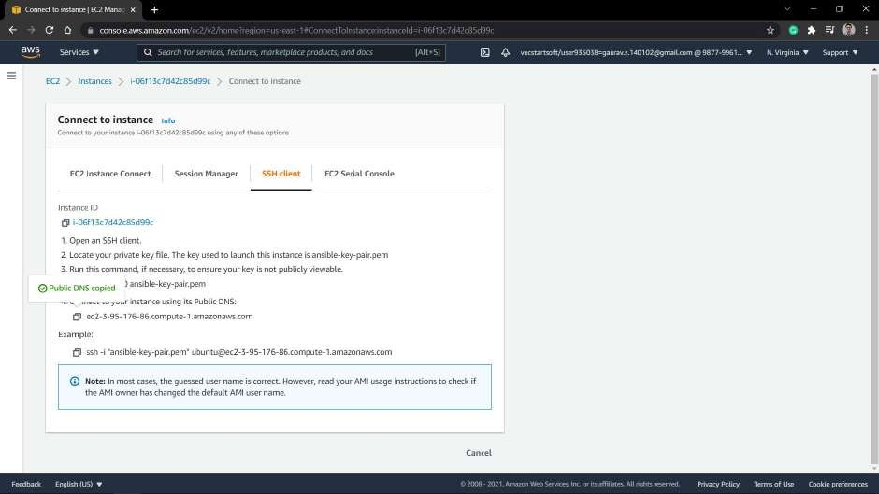

1. Now, we’ll connect to the instance using MobaXterm. Open MobaXterm and click on “Session” on top left. Click on SSH, then in Remote Host under Basic SSH settings, paste the public DNS copied from console. Click on specify username and type “ubuntu”.
2. In advanced SSH setting, check on “Use private key” and from the file picker beside it choose the key-pair downloaded from console.

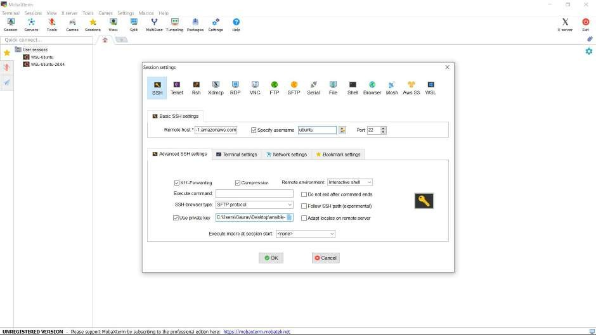

1. In terminal settings, you can modify the foreground or background color of your terminal for easy identification of controller machine from host.

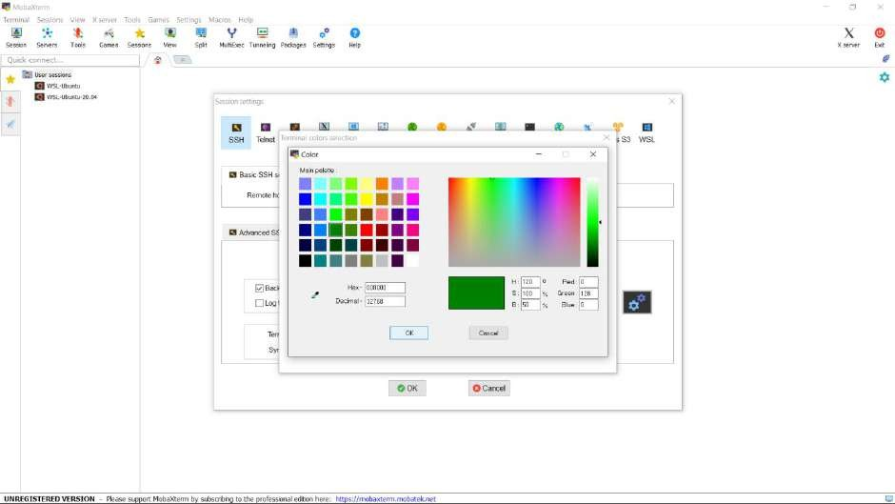

1. Similarly, you can also change the font style and size to make it appear legible.

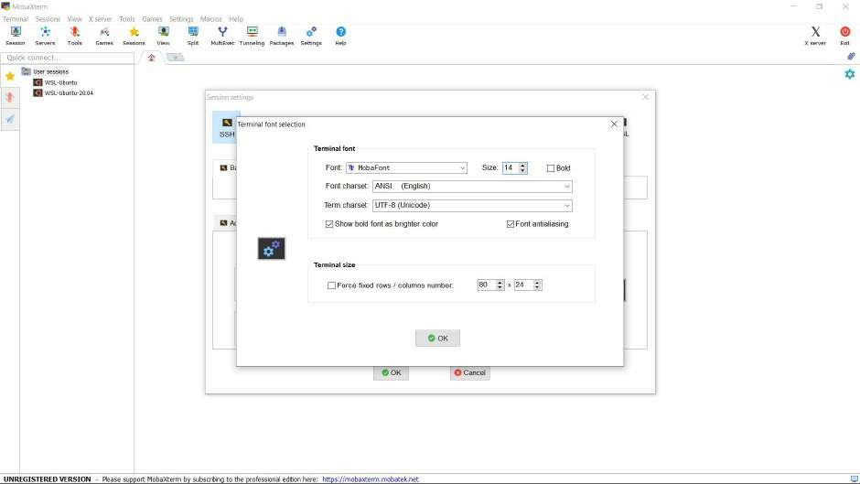

1. Now, in the bookmark machine, add the session name as master for the controller machine.

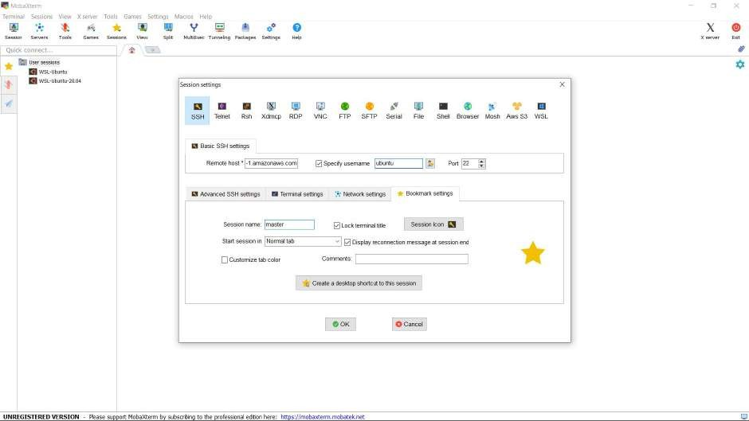

1. Similarly, also connect the host machine in MobaXterm using similar steps.

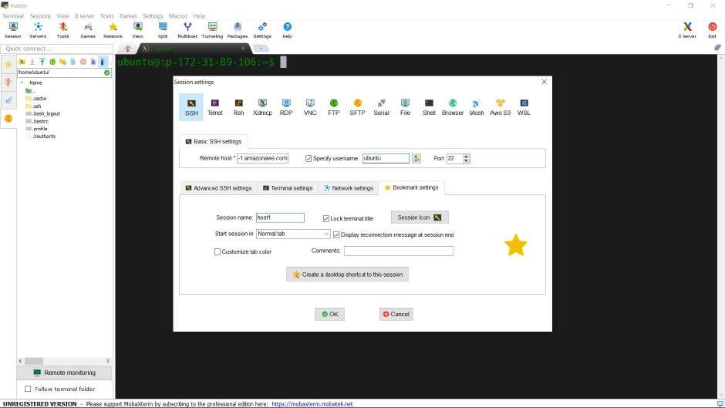

1. Once the machines are ready, they’ll appear like this. In this demonstration, green is chosen for controller machine and orange for host machine.

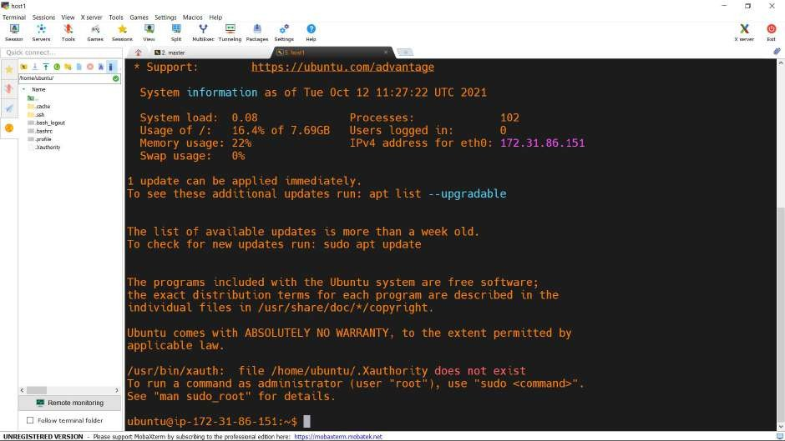

1. Now, after configuring both the machines in MobaXterm we need to check if the machines are able to communicate with each other. For verifying this, we’ll make use of ping command. From both the machines, we’ll ping the ip of the other respective machine.
2. To check the ip of a machine, type ‘ip a’

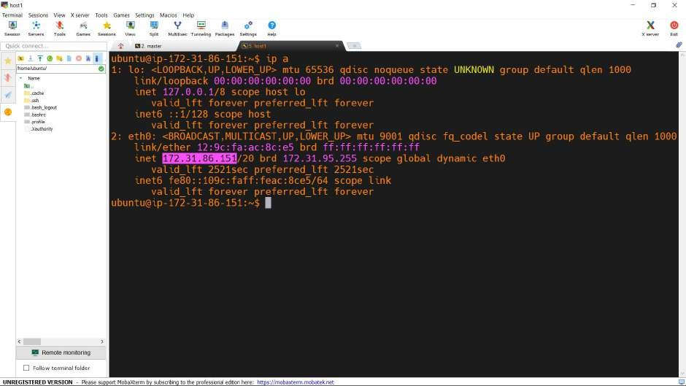

1. Before pinging to the machine, make sure to provide sudo priveleges in both machines, as it will also be required for further steps. To provide root priveleges, type “sudo su”

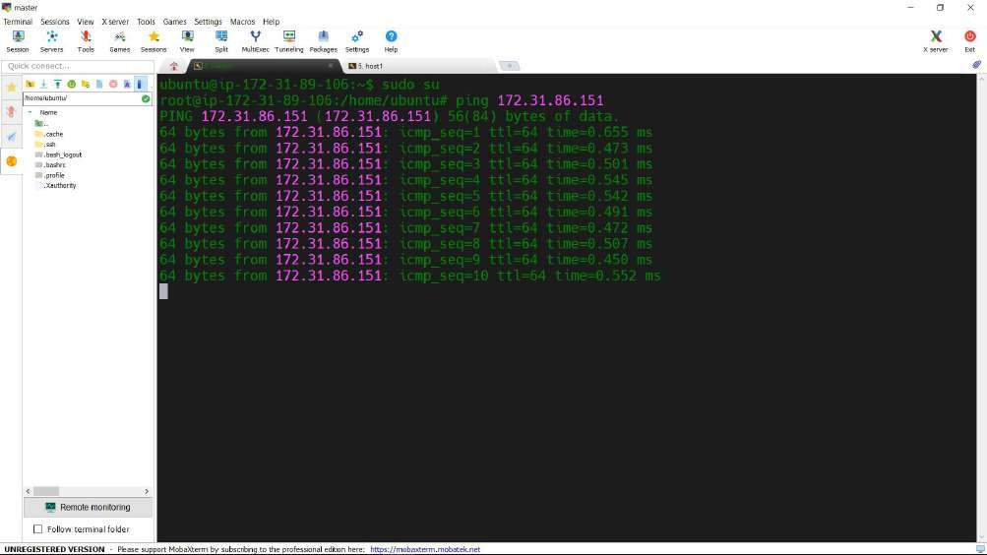

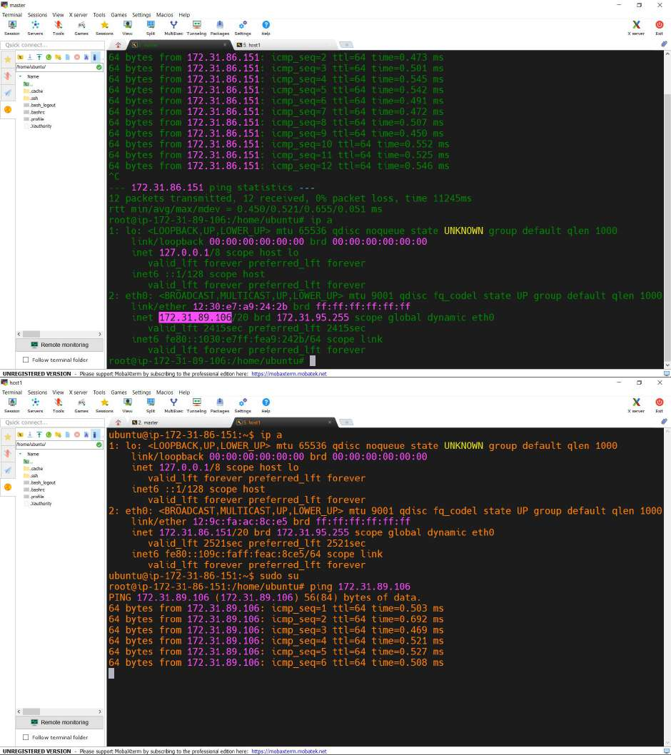

1. Once both machines are able to ping each other we can continue with further steps. First step before dealing with packages, as a good practice, is always to update. This makes sure always the latest available packages are ready for us to install. Update the package in both machines using “apt update - y”

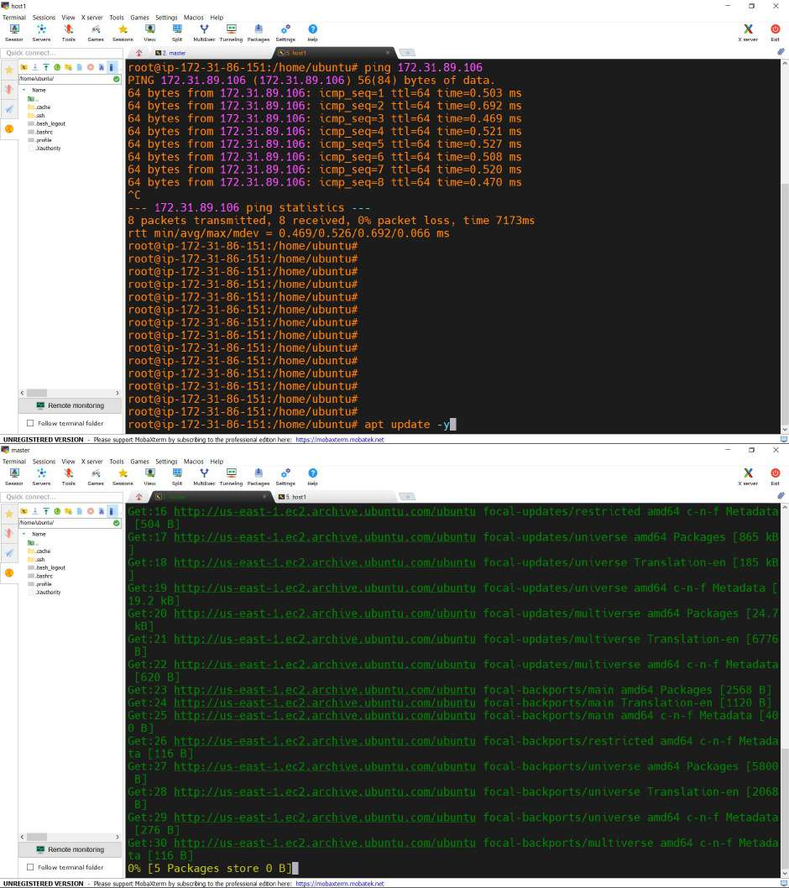

1. Once the packages are updated we need to add ansible repository to our instance. Do this using the command “apt-add-repository ppa:ansible/ansible”

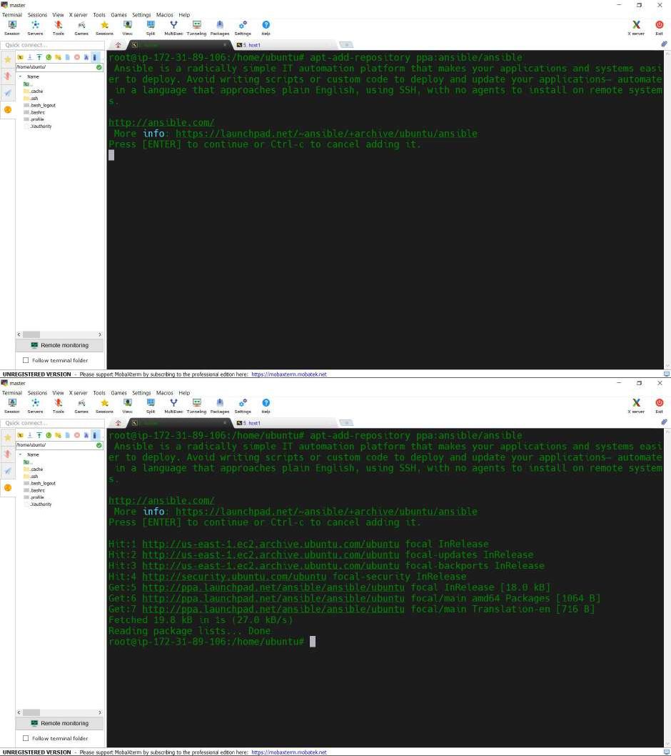

1. Now we can install ansible. We only need to install ansible on our master/controller machine. On controller machine, type “apt-get install ansible” and hit enter. Ansible will be installed in your controller instance.

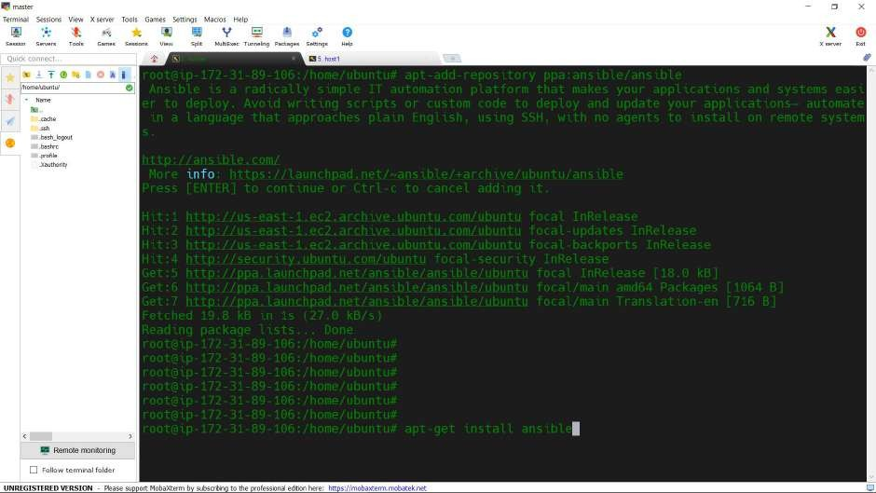

1. You can verify the installation by typing “ansible --version”. This command should display the version of Ansible installed.

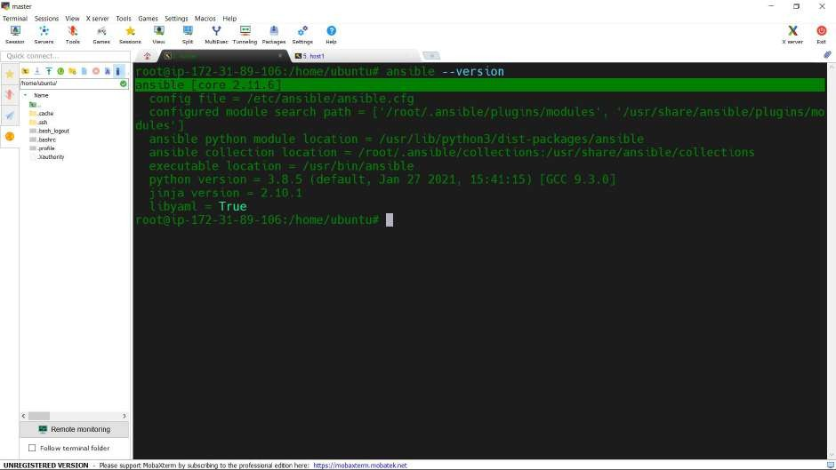

1. Now we’ll configure the instances so that the master machine is able to control host. For this, open the file “/etc/ansible/hosts” using nano editor by running the command “nano /etc/ansible/hosts”

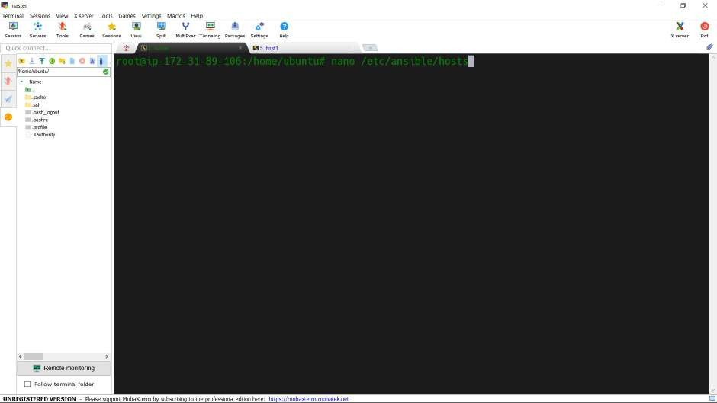

1. Now, using arrow keys navigate to the line below Ex 2: and type in the following

[client_1]

<ip_address of host machine>

This specifies the group of host machines with the name of “client_1” and their corresponding ip addresses, that can be controlled by the master machine.

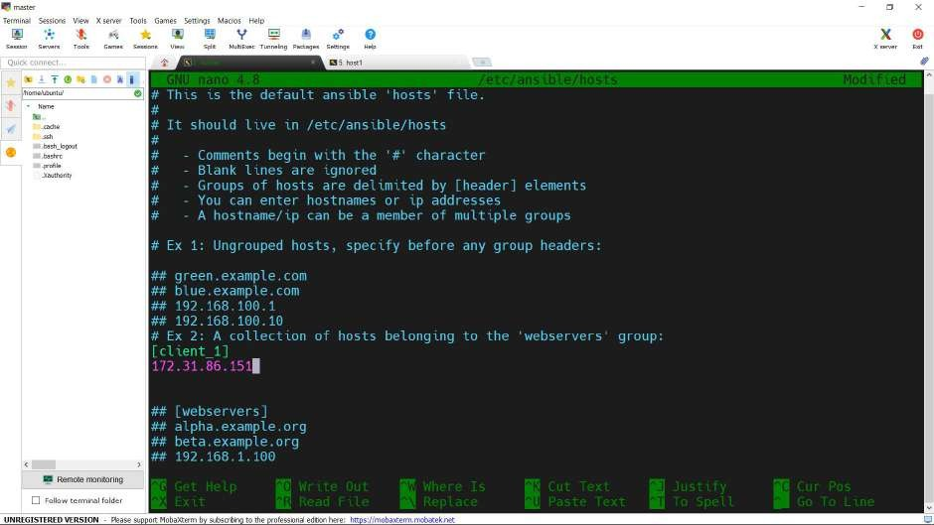

1. Once added, exit out of the editor using Ctrl+X, save the buffer and click enter to exit.
2. Now, we’ll generate the key pair to authorize the master machine in host. To generate the key pair, type the command, “ssh-keygen -t rsa”. We need to keep this password less so as to allow machines to communicate without human intervention.
3. After typing the command, click enter for each of the queries and the key pair will be generated at ‘/root/.ssh/id_rsa.pub’.

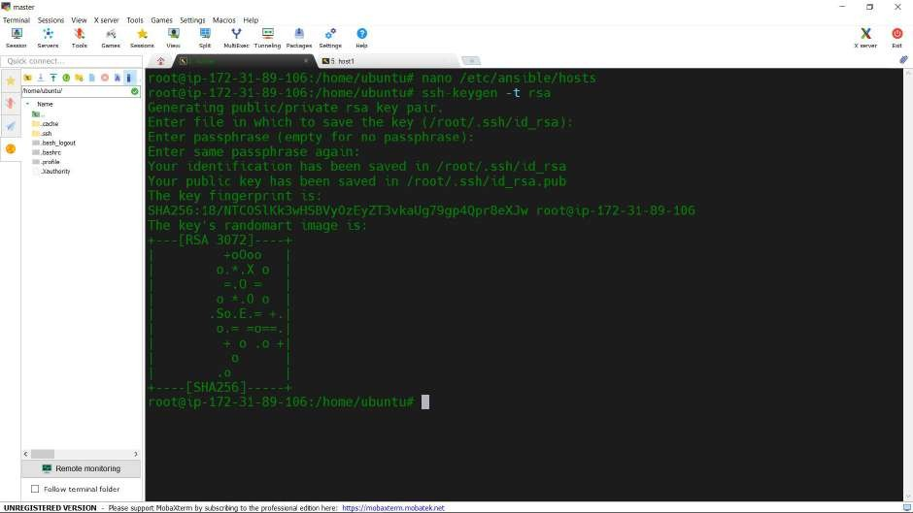

1. Now, change directory to this location and see output of the file id_rsa.pub using cat command.

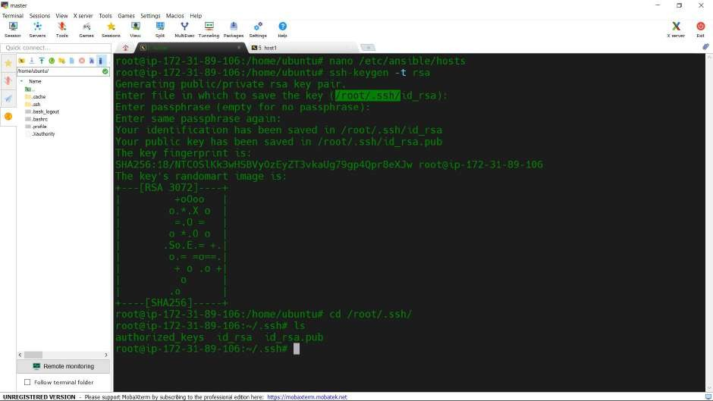

1. Copy the key displayed here

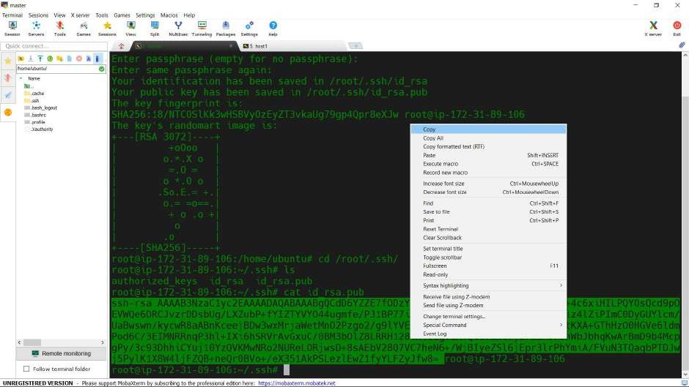

1. Now, on the host machine, go to /root/.ssh. On listing the directory files, there should be an authorized keys file.

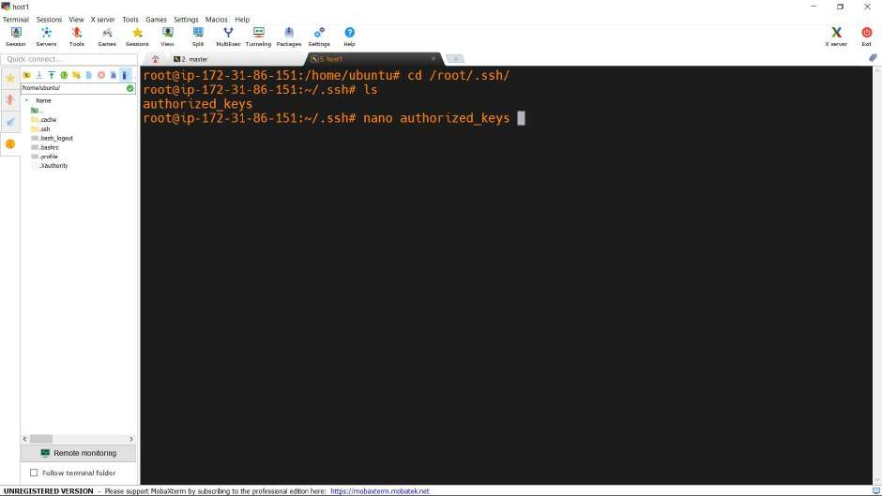

1. Open the file using nano editor, remove everything and paste the code copied from master machine. Then save the file.

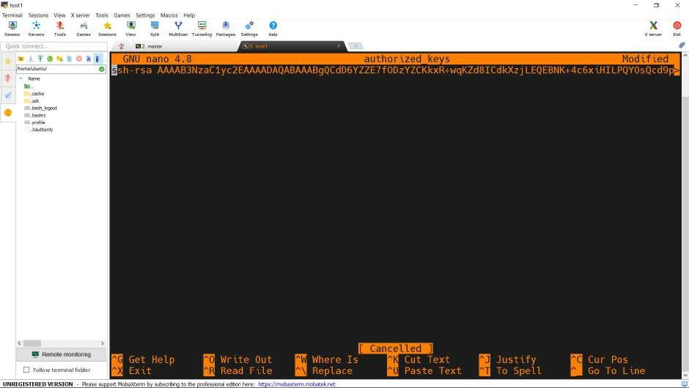

1. Now open the file /etc/ssh/sshd_config using nano editor

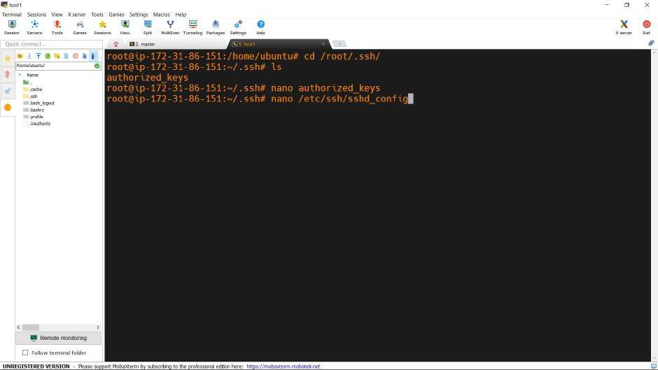

1. Find the line that says PermitRootLogin, enter a line below it and type “PermitRootLogin yes”. Then save the file

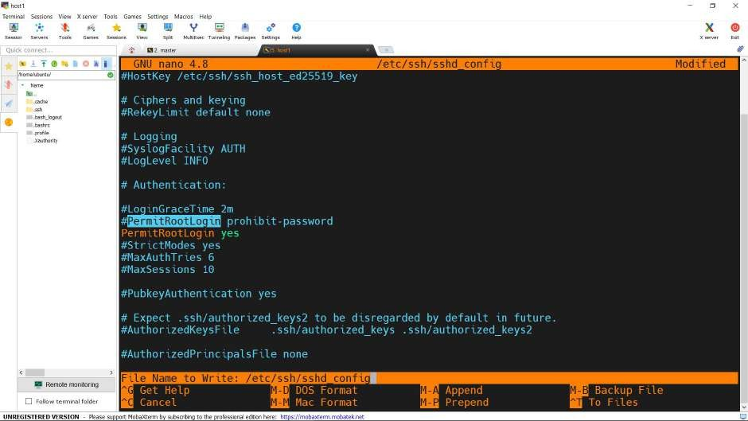

1. Now, in master machine, try the command “ansible -m ping all” to test if master machine is able to ping to host machine. If it displays a success message, then the configuration is successful.

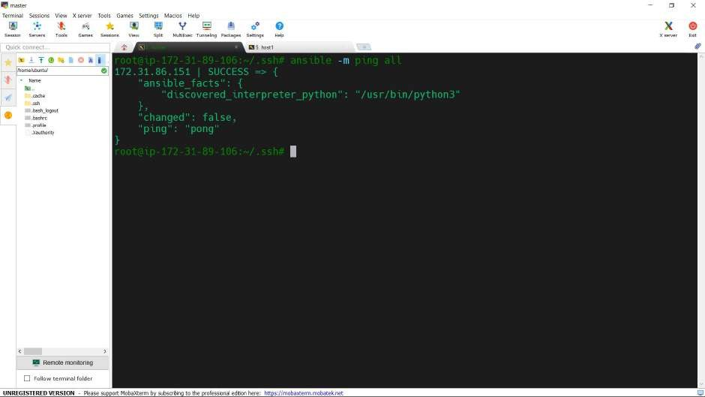

1. To gather all information about host machine from master, type the command “ansible client_1 -m setup”

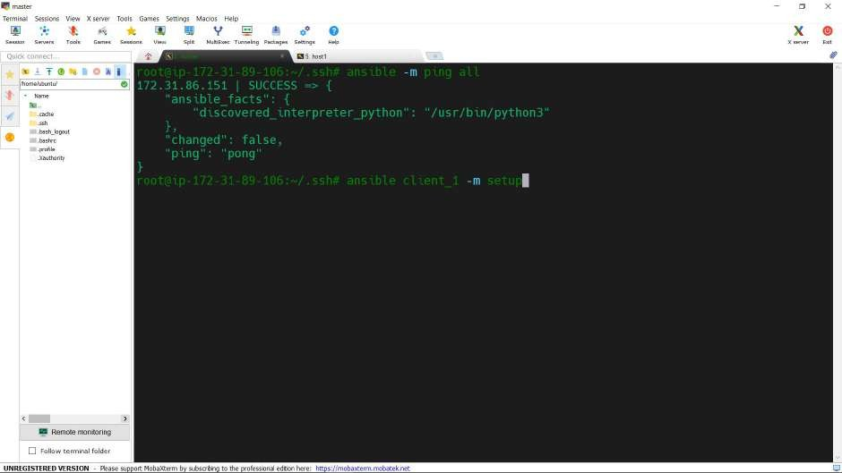

1. We can control packages on host machine using master. Let’s test that by Installing Git on host machine from master.
2. On master macine, test if git is already installed by using the command “git --version”. If git is installed, uninstall it using command “apt remove git”.

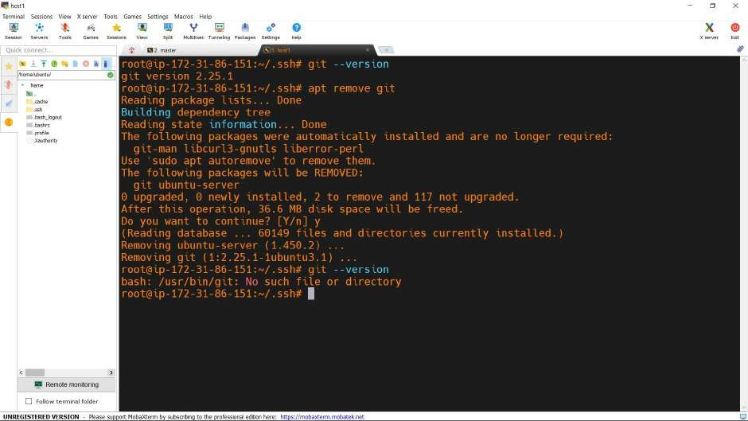

1. Now on master machine, run the command “ansible client_1 -m apt -a “name=git state=present” --become. You should get the changed message.

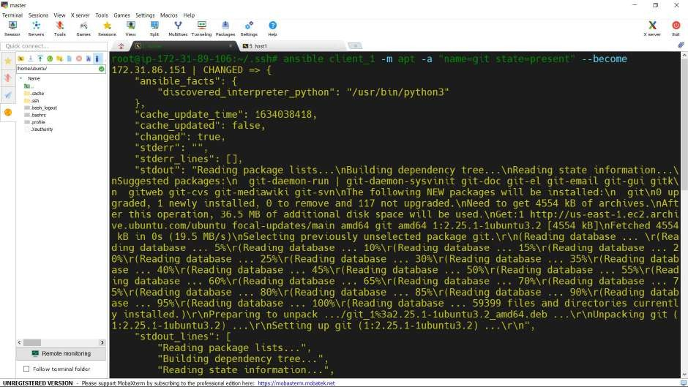

1. Now test if installed on host machine by running the command, “git -- version”. If it returns a git version, we have successfully installed git package on host machine using master.

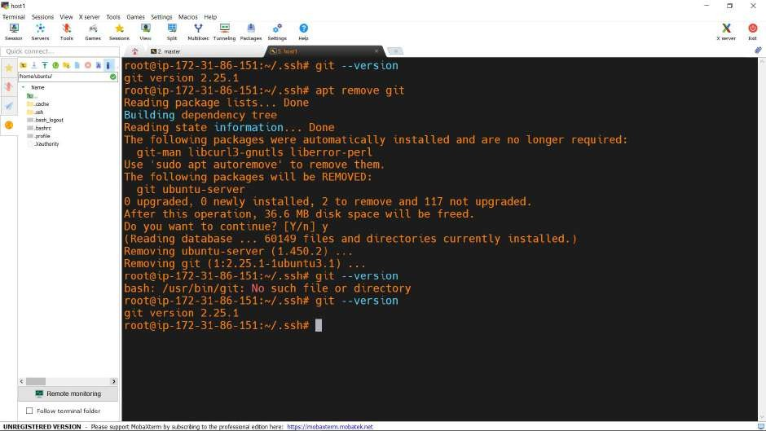

1. We can test the same by installing a nginx service on host using master.
2. First, test if nginx is installed on host by running command, “service nginx status’. If the service couldn’t be found we can continue installing it through master using the similar steps.

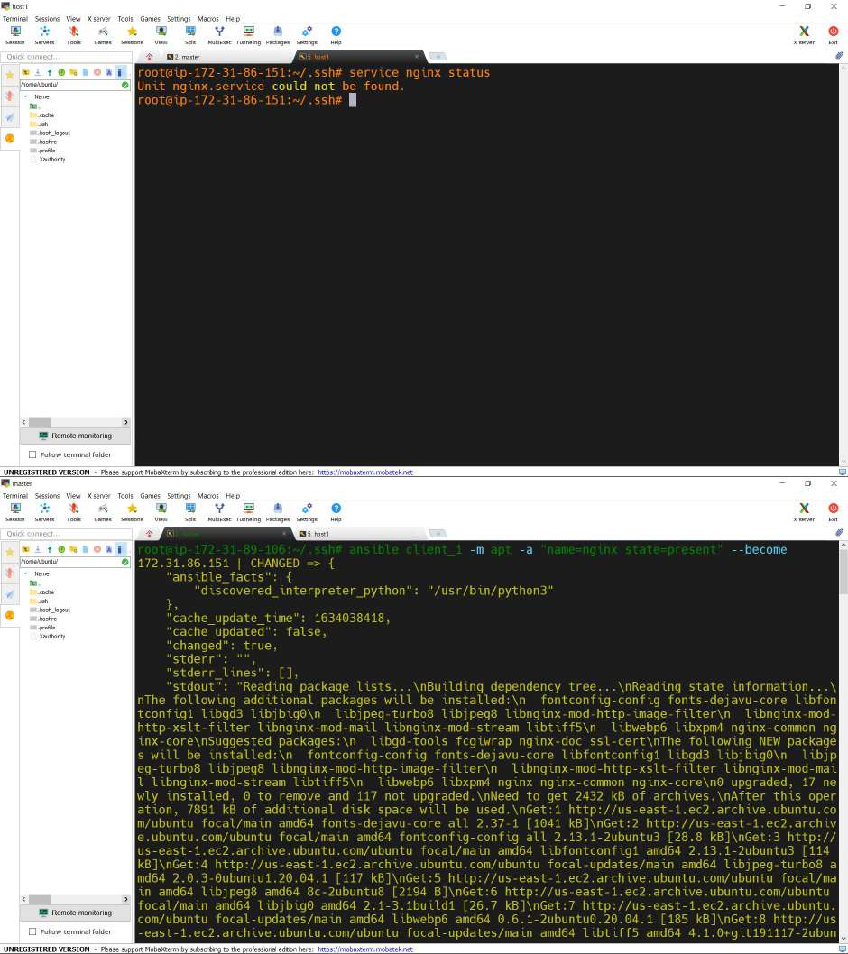

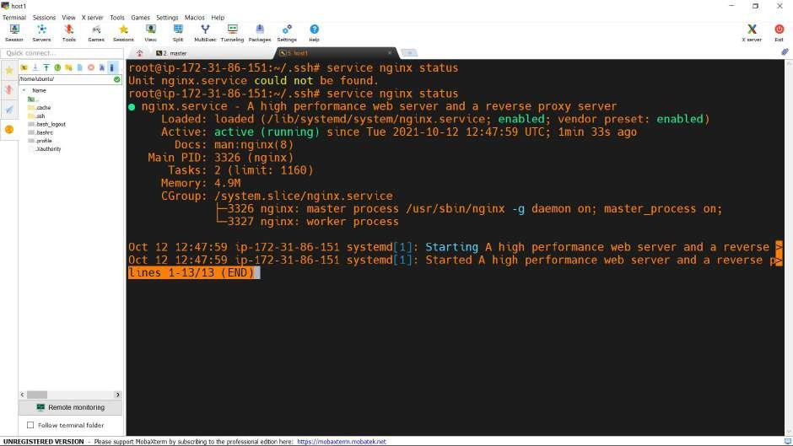

1. We can verify if nginx is running, by going to the public IP address of host machine.

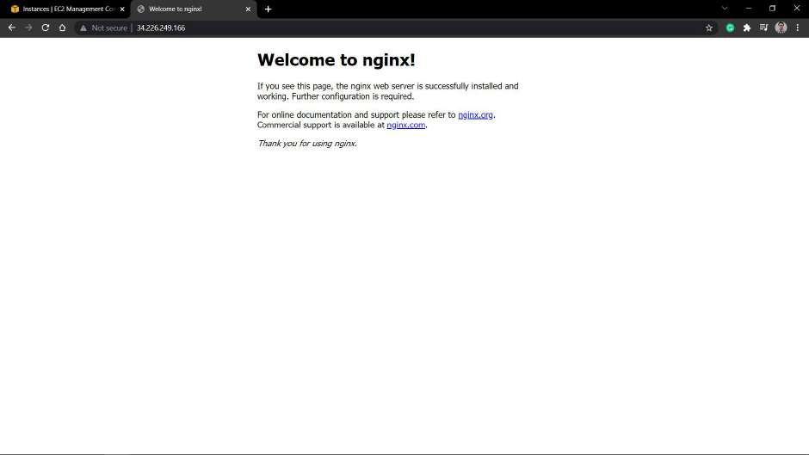

1. You can also controll the status of service from master machine. To stop the nginx server running on host machine, run the command “ansible client_1 - m service -a “name=nginx state=stopped” --become”

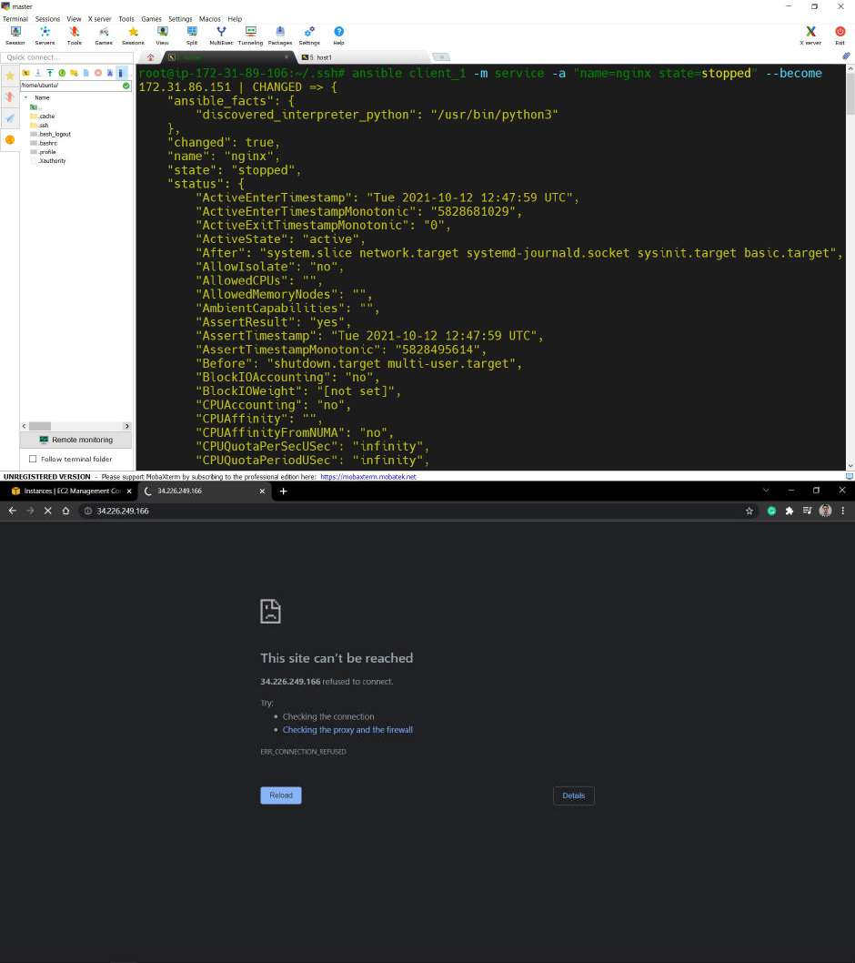

Conclusion: We have successfuly installed Ansible on top of AWS instance and configured SSH access to Ansible host and set up ansible host and tested connection.

**Ramrao Adik Institute of Technology DEPARTMENT OF INFORMATION TECHNOLOGY ACADEMIC YEAR: 2021-2022**

## COURSE NAME : DevOps Lab

|  |  |  |  |  |  |  |  |  |
| --- | --- | --- | --- | --- | --- | --- | --- | --- |
| **COURSE CODE** | | | **ITL504** | | | | | |
| **EXPERIMENT NO.** | | | **11** | | | | | |
| **EXPERIMENT TITLE** | | | **TO DEPLOY A WEB APPLICATION BY PROVISIONING LAMP STACK USING ANSIBLE PLAYBOOK.** | | | | | |
| **NAME OF STUDENT** | | | **GAURAV SINGH** | | | | | |
| **ROLL NO.** | | | **19IT1074** | | | | | |
| **CLASS** | | | **TE - IT** | | | | | |
| **SEMESTER** | | | **V** | | | | | |
| **GIVEN DATE** | | | **06-10-2021** | | | | | |
| **SUBMISSION DATE** | | |  | | | | | |
| **CORRECTION DATE** | | |  | | | | | |
| **REMARK** | | |  | | | | | |
| **TIMELY SUBMISSION** | | **PRESENTATION** | | | **UNDERSTANDING** | | **TOTAL MARKS** | |
|  | **4** |  | | **4** |  | **7** |  | **15** |
| **NAME& SIGN. OF FACULTY** | | **Prof. Sujata Oak** | | |  | | | |

#### PRACTICAL NO: 11

**Aim:** To deploy a web application by provisioning LAMP stack using Ansible Playbook.

#### Theory:

**Ansible:**

Ansible is an open-source software provisioning, configuration management, and application-deployment tool enabling infrastructure as code. It runs on many Unix-like systems, and can configure both Unix-like systems as well as Microsoft Windows. It includes its own declarative language to describe system configuration. Ansible was written by Michael De Haan and acquired by Red Hat in 2015. Ansible is agentless, temporarily connecting remotely via SSH or Windows Remote Management (allowing remote PowerShell execution) to do its tasks.

#### Ansible Playbook:

An Ansible® playbook is a blueprint of automation tasks—which are complex IT actions executed with limited or no human involvement. Ansible playbooks are executed on a set, group, or classification of hosts, which together make up an Ansible inventory.

Ansible playbooks are essentially frameworks, which are prewritten code developers can use ad-hoc or as starting template. Ansible playbooks are regularly used to automate IT infrastructure (such as operating systems and Kubernetes platforms), networks, security systems, and developer personas (such as Git and Red Hat CodeReady Studio).

Ansible playbooks help IT staff program applications, services, server nodes, or other devices without the manual overhead of creating everything from scratch. And Ansible playbooks—as well as the conditions, variables, and tasks within them—can be saved, shared, or reused indefinitely.

Ansible Playbooks offer a repeatable, re-usable, simple configuration management and multi-machine deployment system, one that is well suited to

deploying complex applications. If you need to execute a task with Ansible more than once, write a playbook and put it under source control. Then you can use the playbook to push out new configuration or confirm the configuration of remote systems.

Implementation and Output:

1. We will first verify if mysql, apache2 and php by checking their respective version commands. If any of the packages are installed, uninstall it as we’ll install again through the playbook.

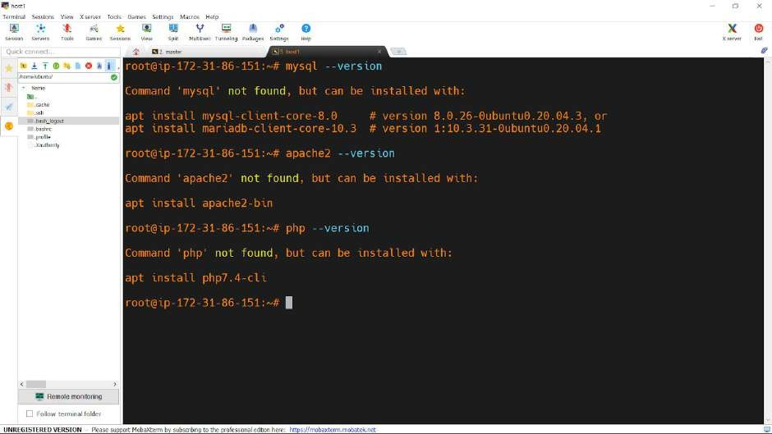

1. Go the url <https://github.com/sujataoak799/ansible-codes>, click on Green code button and copy the url.

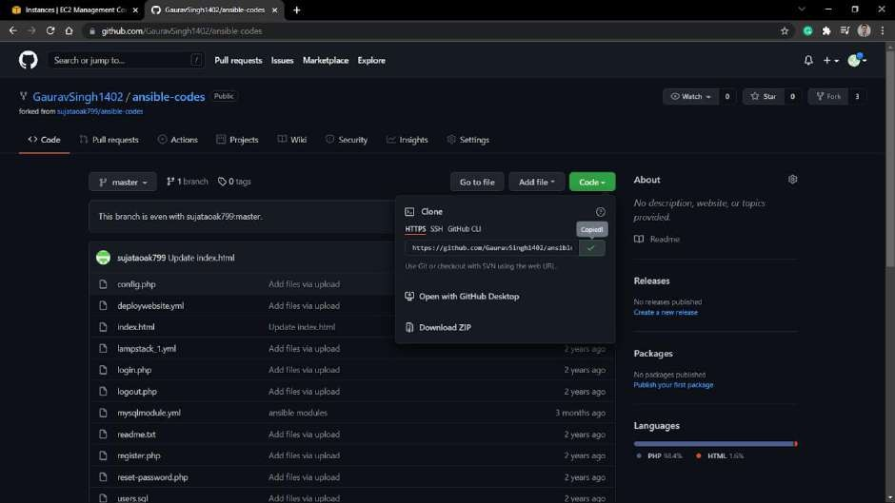

1. On root folder, create a directory for executing the code. We name it ansible. Inside this folder, clone the repository and go inside the ansible-codes directory.

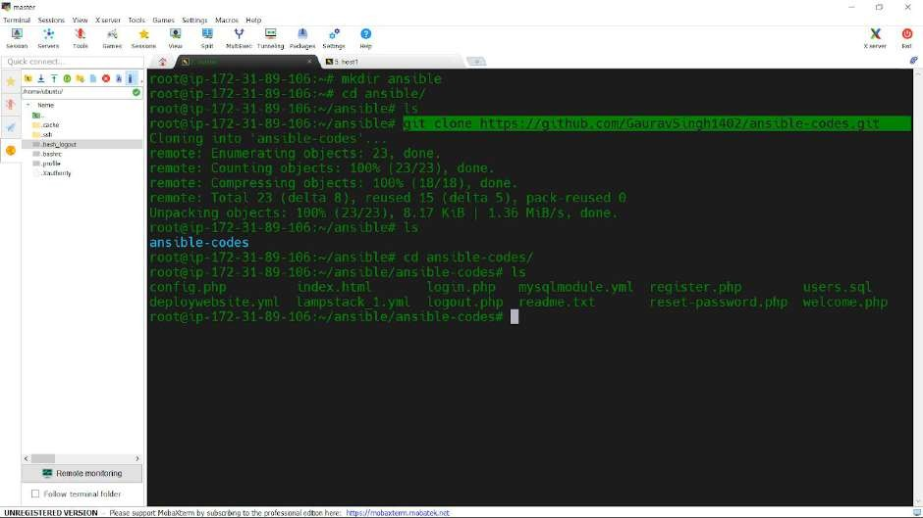

1. You can check the playbook file by opening in nano editor.

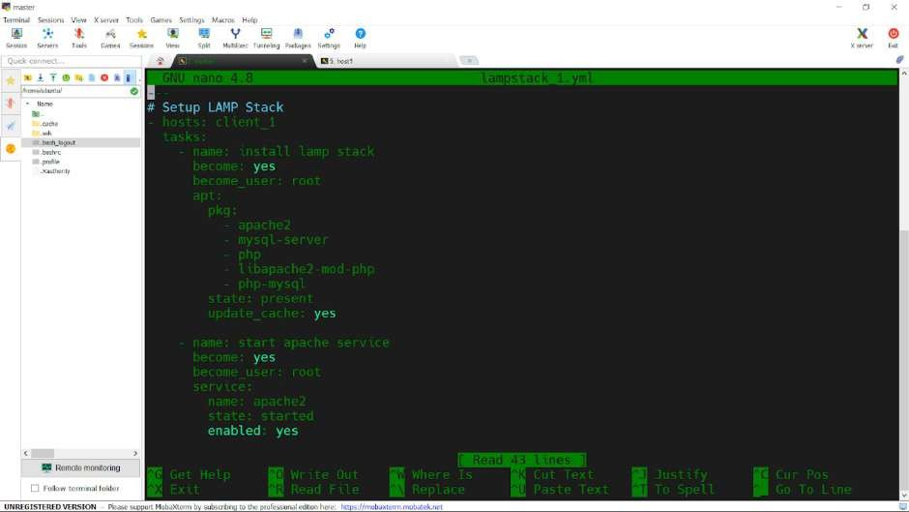

1. Make sure, nginx or other services are not already running on host machine. Run the playbook file by running the command “ansible-playbook lampstack_1.yml”

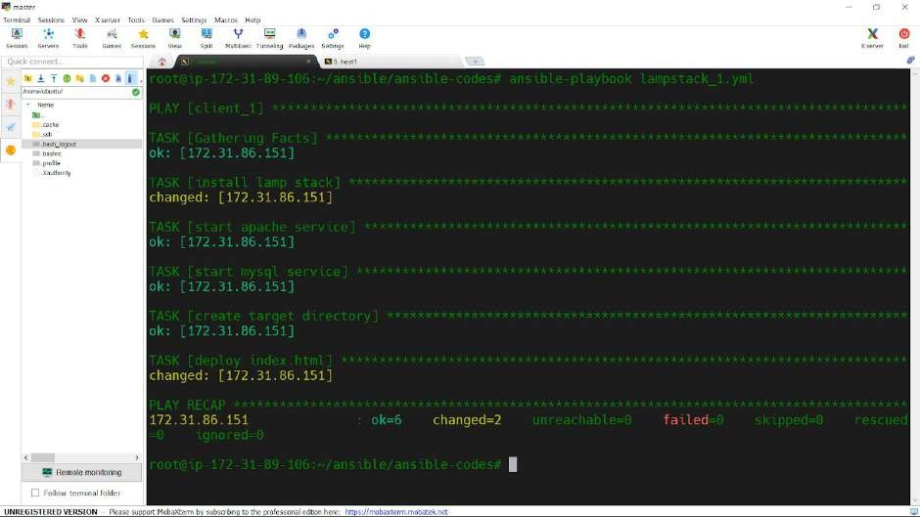

1. If the playbook command is successful, you can check the output by going to the public IP address of host in browser.

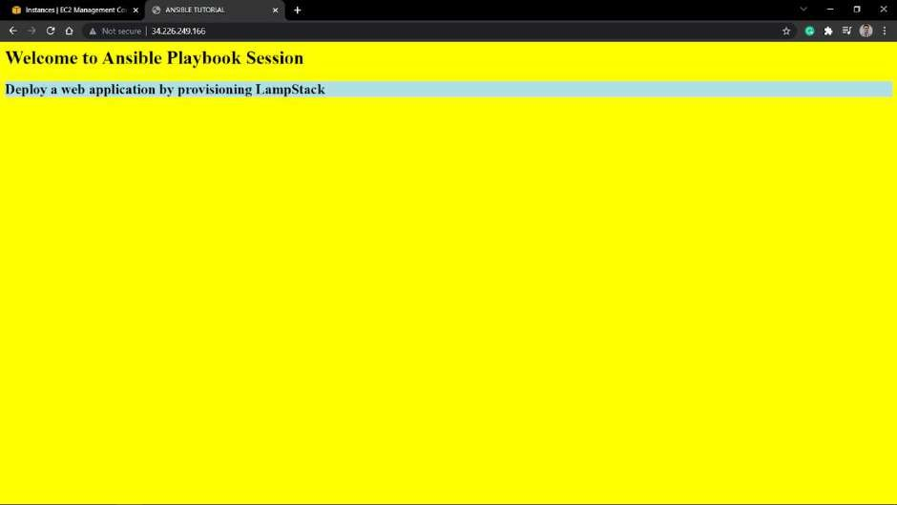

**Conclusion:** We have successfully deployed a web application by provisioning LAMP stack using Ansible Playbook.

**Ramrao Adik Institute of Technology DEPARTMENT OF INFORMATION TECHNOLOGY ACADEMIC YEAR: 2021-2022**

## COURSE NAME : DevOps Lab

|  |  |  |  |  |  |  |  |  |
| --- | --- | --- | --- | --- | --- | --- | --- | --- |
| **COURSE CODE** | | | **ITL504** | | | | | |
| **EXPERIMENT NO.** | | | **12** | | | | | |
| **EXPERIMENT TITLE** | | | **TO DEPLOY A WEBSITE CODE ON THE NODE BY PROVISIONING MYSQL SERVER AND DATABASE USING ANSIBLE PLAYBOOK.** | | | | | |
| **NAME OF STUDENT** | | | **GAURAV SINGH** | | | | | |
| **ROLL NO.** | | | **19IT1074** | | | | | |
| **CLASS** | | | **TE - IT** | | | | | |
| **SEMESTER** | | | **V** | | | | | |
| **GIVEN DATE** | | | **13-10-2021** | | | | | |
| **SUBMISSION DATE** | | |  | | | | | |
| **CORRECTION DATE** | | |  | | | | | |
| **REMARK** | | |  | | | | | |
| **TIMELY SUBMISSION** | | **PRESENTATION** | | | **UNDERSTANDING** | | **TOTAL MARKS** | |
|  | **4** |  | | **4** |  | **7** |  | **15** |
| **NAME& SIGN. OF FACULTY** | | **Prof. Sujata Oak** | | |  | | | |

#### PRACTICAL NO: 12

**Aim**: To deploy a website code on the node by provisioning MySQL server and Database using Ansible Playbook.

#### Theory:

**Ansible:**

Ansible is an open-source software provisioning, configuration management, and application-deployment tool enabling infrastructure as code. It runs on many Unix-like systems, and can configure both Unix-like systems as well as Microsoft Windows. It includes its own declarative language to describe system configuration. Ansible was written by Michael De Haan and acquired by Red Hat in 2015. Ansible is agentless, temporarily connecting remotely via SSH or Windows Remote Management (allowing remote PowerShell execution) to do its tasks.

#### Ansible Playbook:

An Ansible® playbook is a blueprint of automation tasks—which are complex IT actions executed with limited or no human involvement. Ansible playbooks are executed on a set, group, or classification of hosts, which together make up an Ansible inventory.

Ansible playbooks are essentially frameworks, which are prewritten code developers can use ad-hoc or as starting template. Ansible playbooks are regularly used to automate IT infrastructure (such as operating systems and Kubernetes platforms), networks, security systems, and developer personas (such as Git and Red Hat CodeReady Studio).

Ansible playbooks help IT staff program applications, services, server nodes, or other devices without the manual overhead of creating everything from scratch. And Ansible playbooks—as well as the conditions, variables, and tasks within them—can be saved, shared, or reused indefinitely.

Ansible Playbooks offer a repeatable, re-usable, simple configuration management and multi-machine deployment system, one that is well suited to deploying complex applications. If you need to execute a task with Ansible more than once, write a playbook and put it under source control. Then you can use the playbook to push out new configuration or confirm the configuration of remote systems.

#### Implementation and Output:

1. First, we’ll setup a database, add a user and copy sample data in it by running the playbook mysqlmodule.yml.

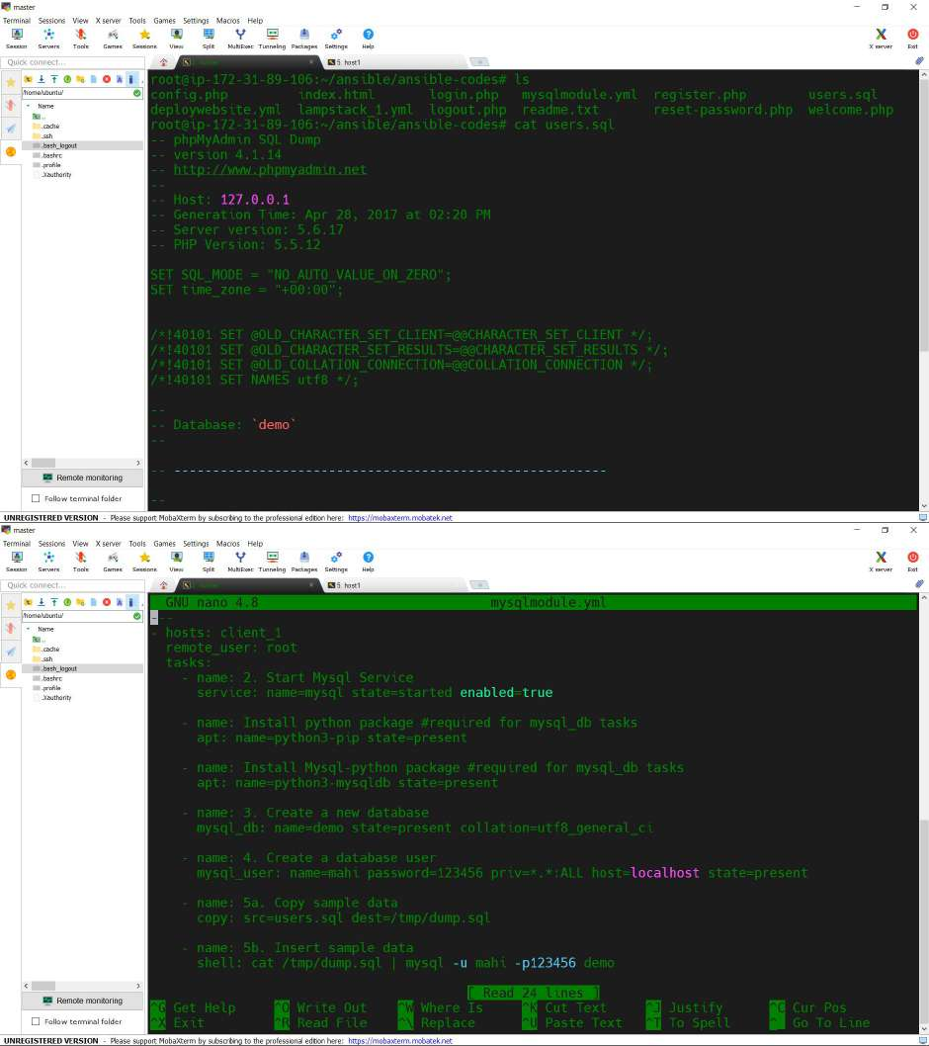

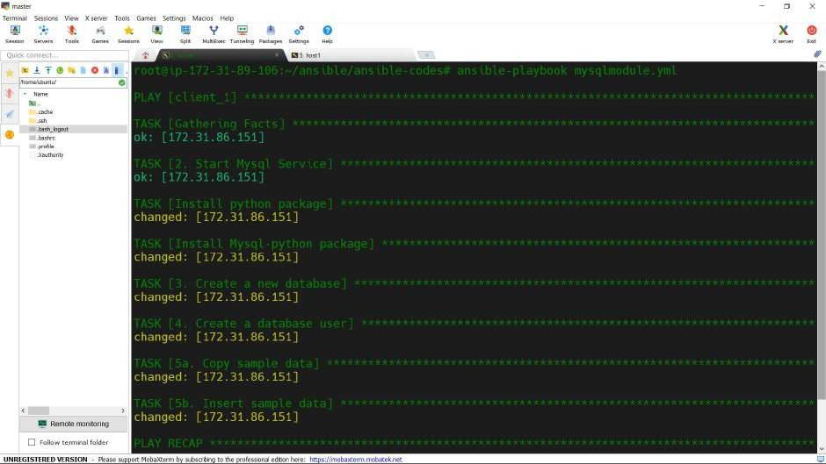

1. You can check the database and sample data on host machine.

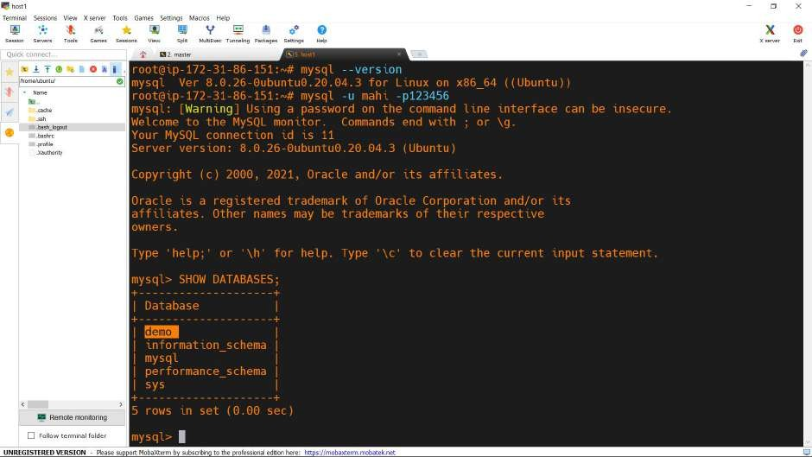

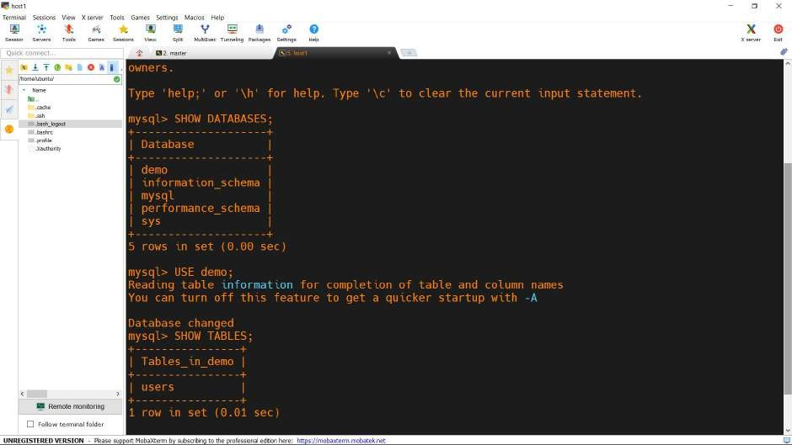

1. Now we’ll deploy the website, by running the deploywebsite.yml playbook file

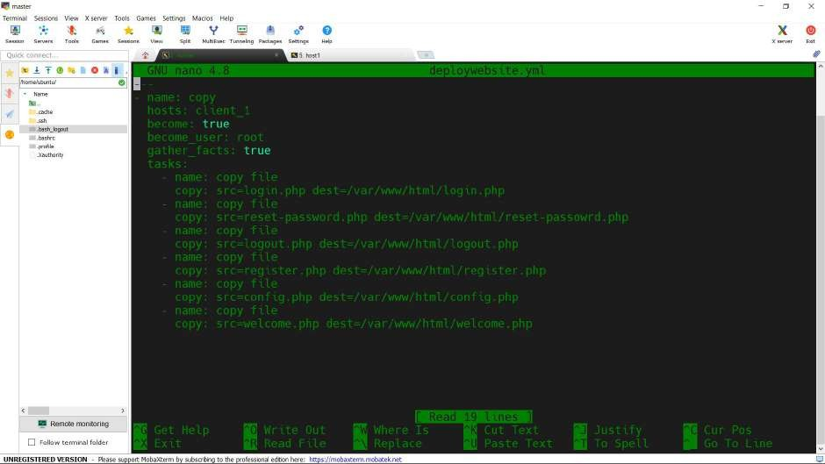

1. Once the website is deployed we can check the different endpoints on host public IP addresses.
2. First on the register.php endpoint, we register a new user by giving username, password and confirm password input. If the credentials are properly validated a new user will be created and added to the database.

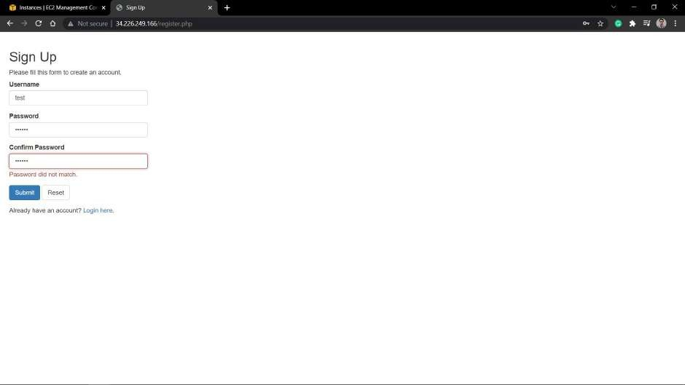

1. On the login.php route, we can login using the same credentials.

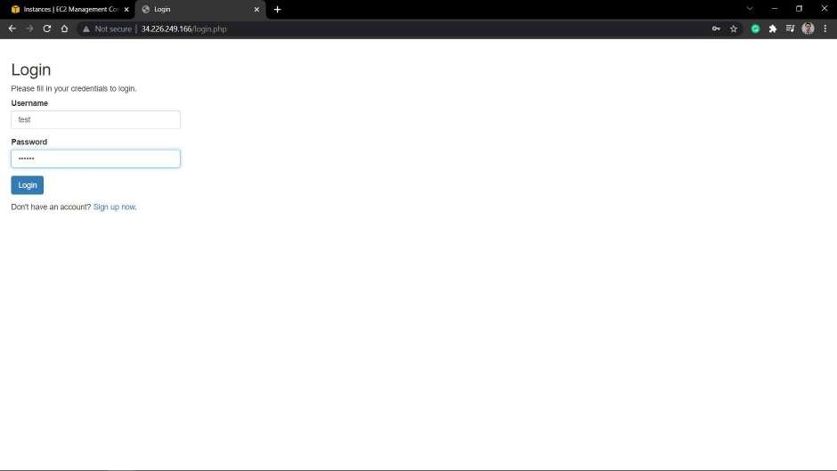

1. If the credentials are correct, we are redirected to the home page.

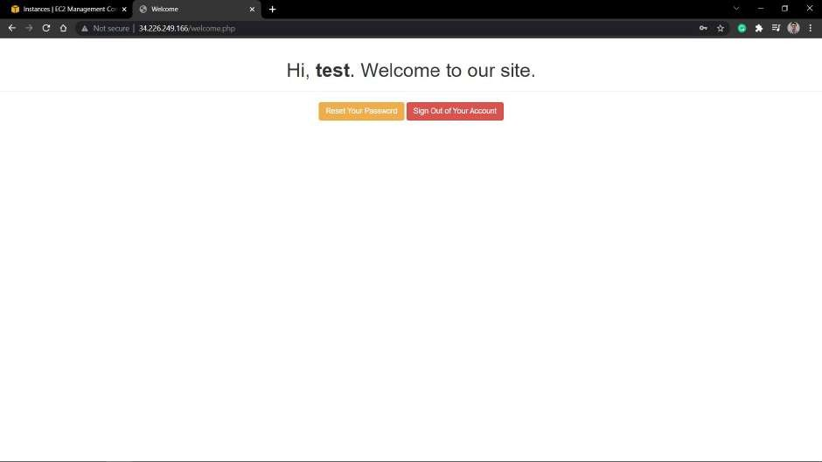

**Conclusion**: We have successfully deployed a website code on the node by provisioning MySQL server and Database using Ansible Playbook.

Class: TE IT B Batch: B3

# ASSIGNMENT NO. 1

### CASE STUDY ON NETFLIX

Netflix is currently the largest media service provider. According to Statista, more than 207 million people are paid subscribers of Netflix. Out of the whole count, around 74 million people from the US and Canada, hold the largest portion of the global subscriber base. The adoption of the DevOps approach was crucial in the overwhelming subscriber base, that Netflix currently has.

With the help of DevOps, Netflix was able to create and deploy software, features, and services that were once unimaginable.

**Netflix: Problem**

In the initial phase of Netflix, they were using a development practice called Monolith. Monolith is a system where all the codes are written at once. That means for software that serves 10 features, in a monolithic system, you will write 10 features altogether first, then proceed to deployment.

The monolithic approach is quite popular. However, it has a huge drawback that is “Complexity”. Software gets bigger and bigger and it turns into a lot more complex coding. This is the exact problem that Netflix faced; extremely complex code development.

As Netflix was grabbing more and more subscribers, their system was getting more and more complicated. Whenever a new bug was noticed, it took days to write the proper code. Also later took days to go for operation. If the operation failed, again the whole process started to repeat at a similar pace. For a company that is growing rapidly, it is a huge concern as well as a risk to continue with the same approach.

Class: TE IT B Batch: B3

## Netflix: Solution — DevOps

Due to huge complications in the monolithic approach, Netflix started to move to DevOps. They moved to an AWS cloud-based architecture.

As they moved to DevOps, or Development + Operation system, their both departments merged. Because of this, they can develop, check and deploy services together. Here, there is no need to wait for the development team to write another long code again which may take several days to complete. Afterward, it also eradicates repeating scenarios of failure, if any occurs during the deployment. As a result of DevOps, they were able to enhance the pace of the development operation.

But how do they do that? To solve this problem, they have built two tools.

**Tool 1: Chaos Monkey**

It creates situations where a server may turn down, or any other facility, instantly!

Although this may sound terrible, this was done to find solutions. This is exactly the main goal of the tool called Chaos Monkey. This allows any of the team members to be always ready to fight against any possible worst-case scenarios. That is so in the most unfavorable environment.

What are the benefits?

* Top class application development
* High-resilience systems
* Stable application system

In the face of Chaos Monkey, the DevOps strategy thrived. The system becomes more efficient and productive as a result of this tool.

**Tool 2: Titus**

Titus is a container management tool. The procedure of Titus is very simple: make containers of standardized units of package software. Like a series of little units

Class: TE IT B Batch: B3

which form a whole. The main job of Titus is to simply run the existing application inside the container. Here nothing will be changed inside.

Just like scanning computers for viruses takes a lot of time while scanning individual disks is faster, the same thing goes here. Titus allows running the whole application in a smaller container which will surely take much less time, compared to running in the whole system. This allows faster results while eliminating complexity issues, thus enhancing efficiency.

Another interesting fact about Titus is that it is integrated with AWS or Amazon Web Services. What these services do is to make the whole process cost-effective as well as highly productive. Netflix utilizes Titus to incorporate recommendations with the content system since it is ASW-compliant.

The benefits of Titus are:

* Deploy a code within 2 minutes
* Can release applications frequently

Netflix wasn’t performing well with its monolith system. Their struggle became clearer and clearer as their number of subscribers started to sky-rocket. Turning to DevOps was the key point that helped them deal with such a high volume of subscribers, in a much simpler manner. Today most of the populations of the world are dependent on Netflix. Yes, to the company which initially was a DVD rental corporation. So what are the benefits that DevOps serves?

* It eliminated the communication silos between the development and the deployment departments
* It helped the product to have much better quality, due to continuous testing and rechecking.
* Development of services has become faster than ever before, thanks to the cooperation of developers and deployers.
* Build an extremely reliable service that can work against any possible failure at any time.

Class: TE IT B Batch: B3

## Conclusion and Final Verdict:

In the era of highly dependable web services, the systems need to be extremely dynamic to fight against any of the possible scenarios. However, to build a dynamic application, DevOps is one of the best systems that you can use for your business. Based on microservices, this approach lets you work on a smaller scale where you can develop, test, and deploy, all simultaneously.

Therefore, DevOps Strategy or a well-designed plan should be formulated which can help you to build the system. With the help of DevOps, you will be left with highly resilient software, which can offer newer features, benefits, and services with the speed of a sports car.

Class: TE IT B Batch: B3

## References:

1. <https://medium.com/geekculture/how-netflix-excelled-with-devops-e0dda0605396>
2. <https://insights.sei.cmu.edu/blog/devops-case-study-netflix-and-the-chaos-monkey/>
3. <https://www.amido.com/blog/a-case-study-of-dev-ops-at-netflix>
4. <https://www.bunnyshell.com/blog/how-netflix-does-devops>

# ASSIGNMENT NO. 2

**IMPLEMENT A CI/CD PIPELINE JOB FOR A NODE.JS APPLICATION USING AWS CODEPIPELINE**

1. We will be creating a pipeline job of a node.js application called musician-app.

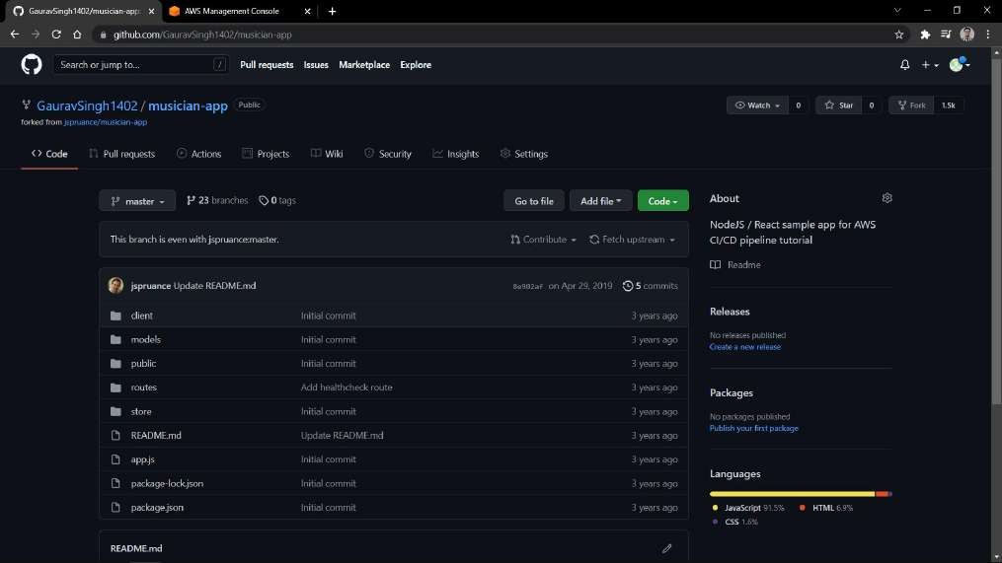

1. Login to AWS console and search for elastic beanstalk. Among the search results, click on elastic beanstalk

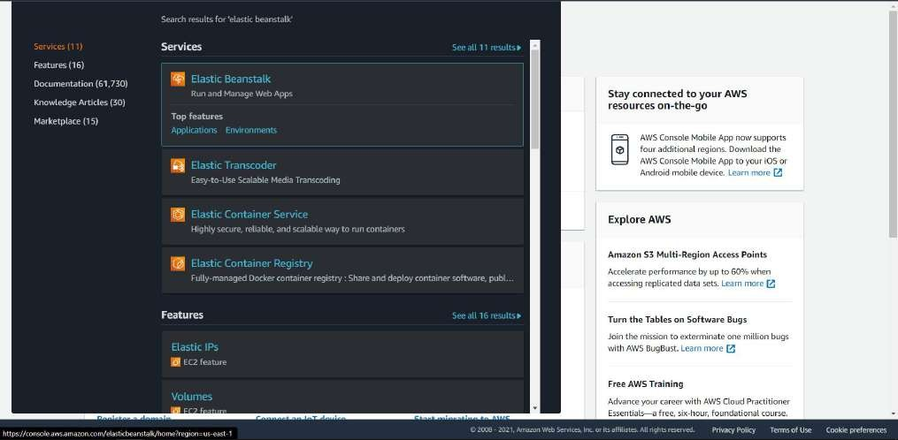

1. On the elastic beanstalk page, click on Create Application

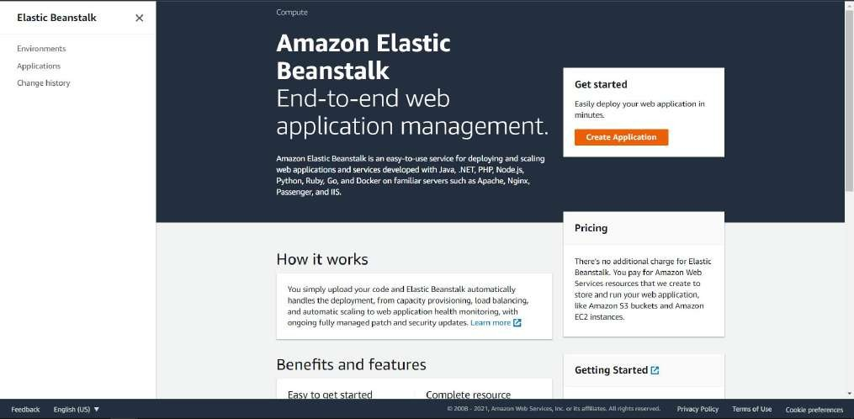

1. Then, in app configuration, provide an application name. Under, platform select Node.js, the other options such as platform branch and platform version will be automatically selected, keep those default. In application code, select Sample Application as we’ll be providing the application later through github.

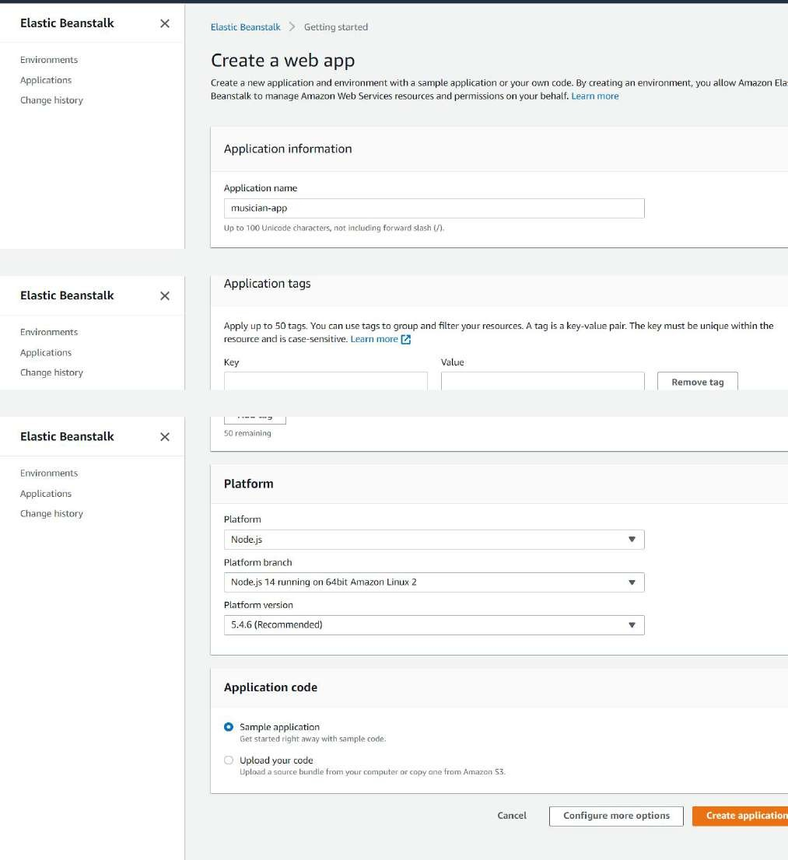

1. Once the configuration is setup, click on Create Application. It will start creating the application and provisioning a default environment to it. This process will take time, let it finish before moving to next step.

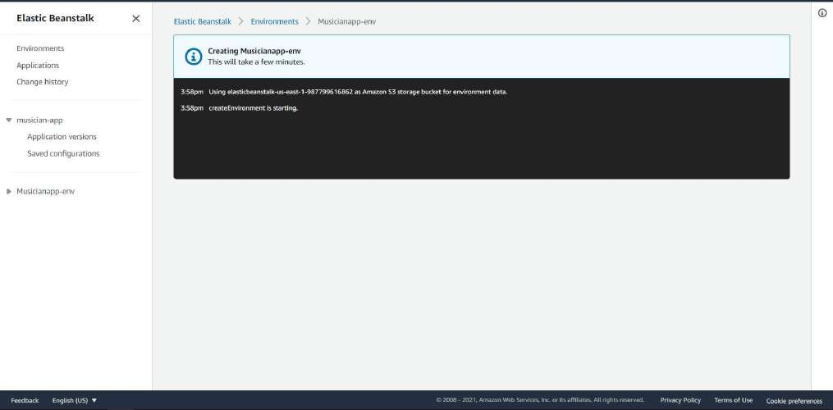

1. Once the application and environment is ready, a dashboard will appear which will display the App health and also display the URL at which the app is deployed.

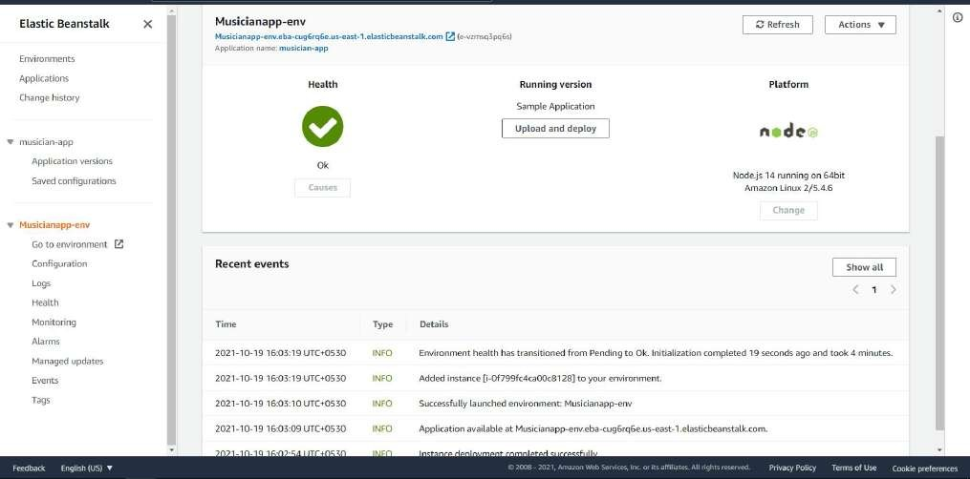

1. Clicking on the URL will display the sample node.js application provisioned by AWS, deployed.

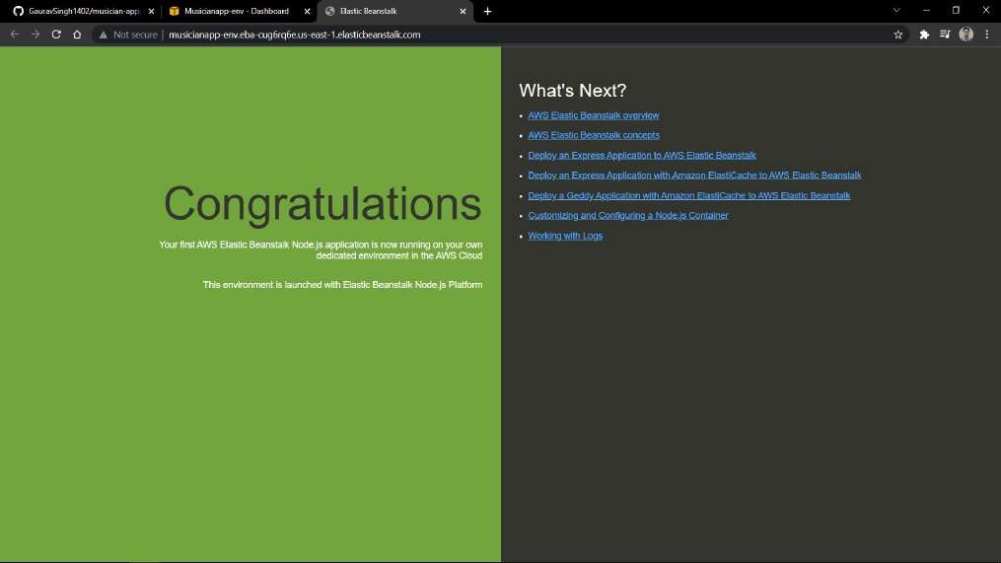

1. Now search and click on CodePipeline service.

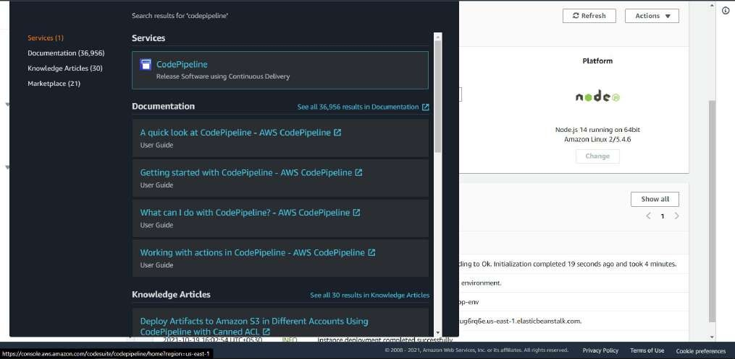

1. On the CodePipeline dashboard, click on create pipeline.

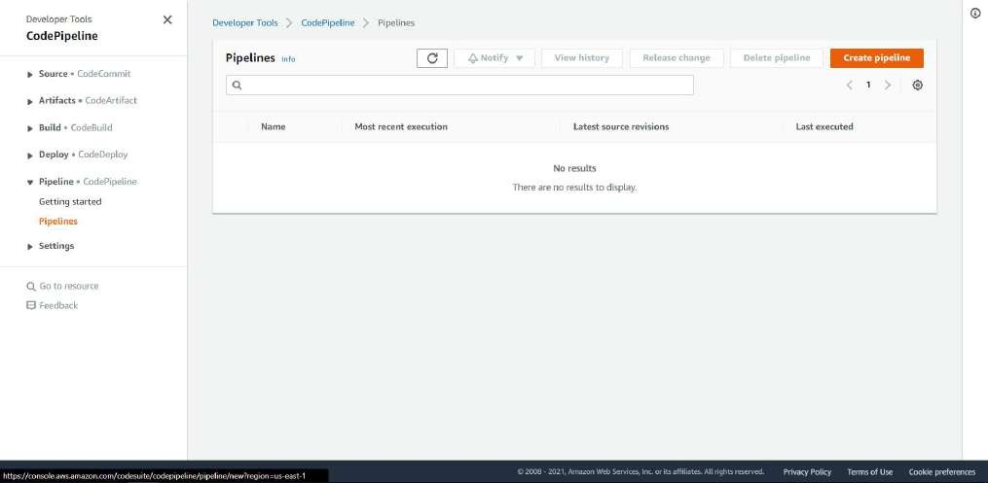

1. Then provide a pipeline name, such as ‘musician-app-pipeline’, in service role, select ‘new service role’. Keep the role name default and checkbox checked. In the advanced settings keep everything as default.

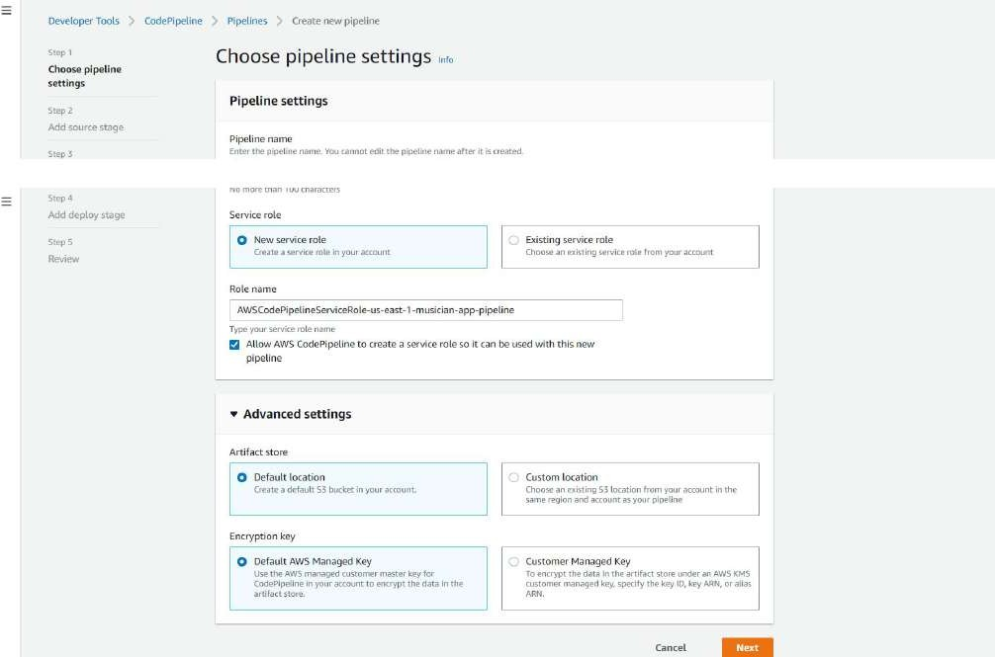

1. Click Next. In Source Stage, select Source Provider as GitHub. Then click on Connect Button and Authorize AWS with Github. Once the connection is successful, select the repository and Branch from the dropdown options. In change detection options, keep it to Github webhooks, as this will ensure, that everytime a new commit is made, it is reflected on the deployed url.

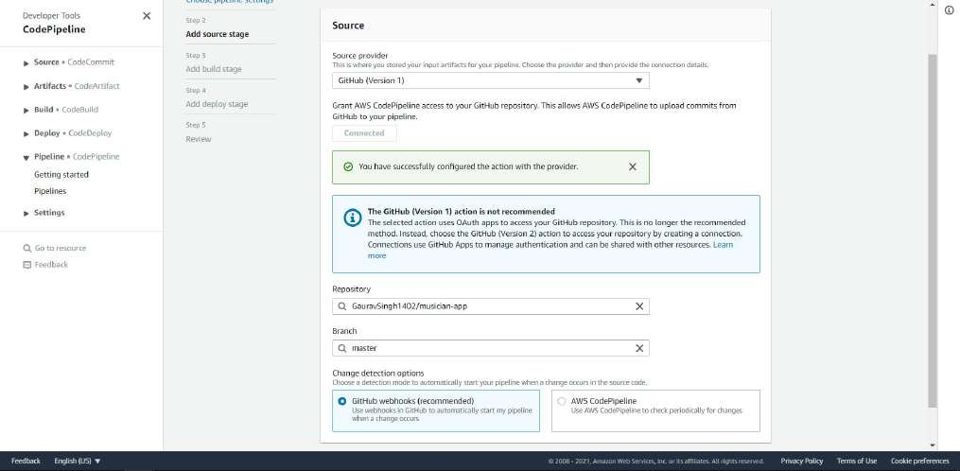

1. Skip the Build Stage as it is not required for the current project.

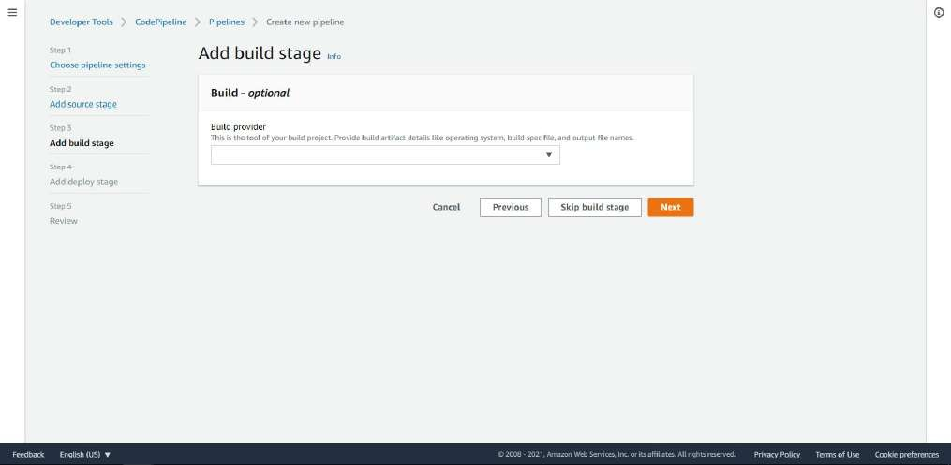

1. In deploy stage, select deploy provider as AWS Elastic Beanstalk, keep the region as default in which your AWS services are functional. Then, select the Application Name and Environment name as specified in Elastic Beanstalk from the dropdown.

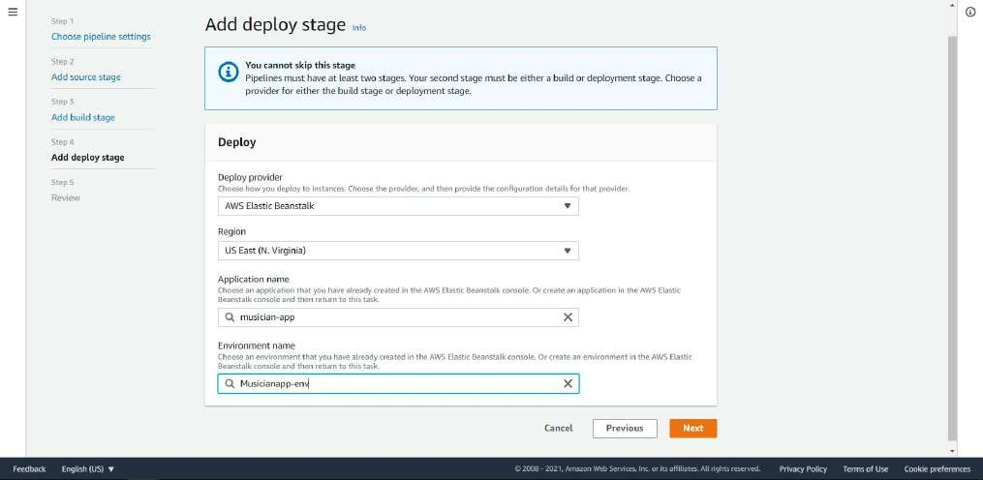

1. Click Next and Review the entire configuration, if everything is correct, click on Create Pipeline.

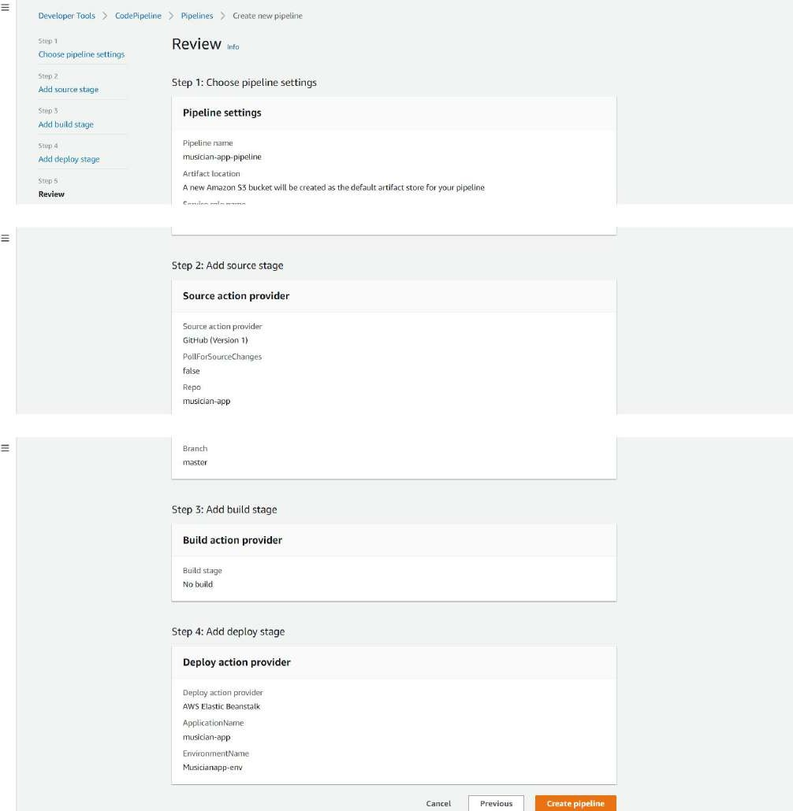

1. Now the pipeline will be generated through two steps, source and deploy. Wait for both the steps to get completed.

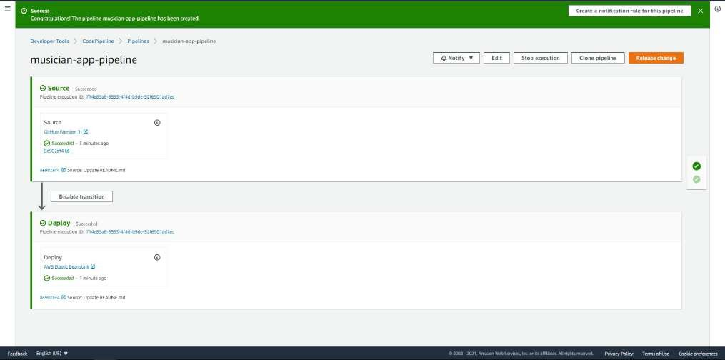

1. After both the steps are finished, we can see the application live on the URL. (In case of encountering an error such as ‘502 Bad Request’, ensure that the backend server is exposed on port 8080).

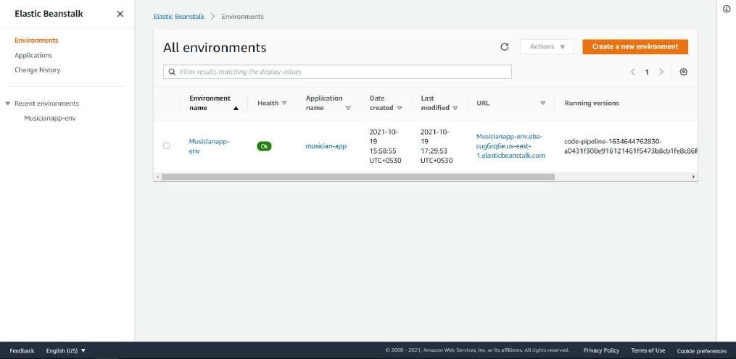

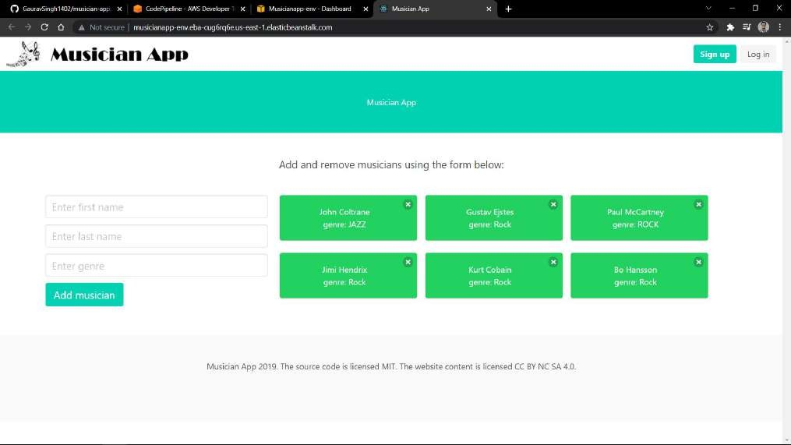

1. Now, to demonstrate the continuos deployment, we’ll make some changes to the app, such as creating a sample route.

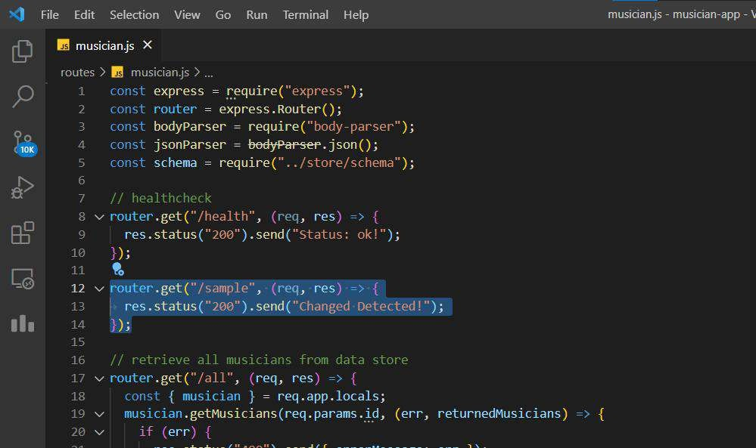

1. After adding the route, we’ll commit and push the changes to the remote GitHub repository.

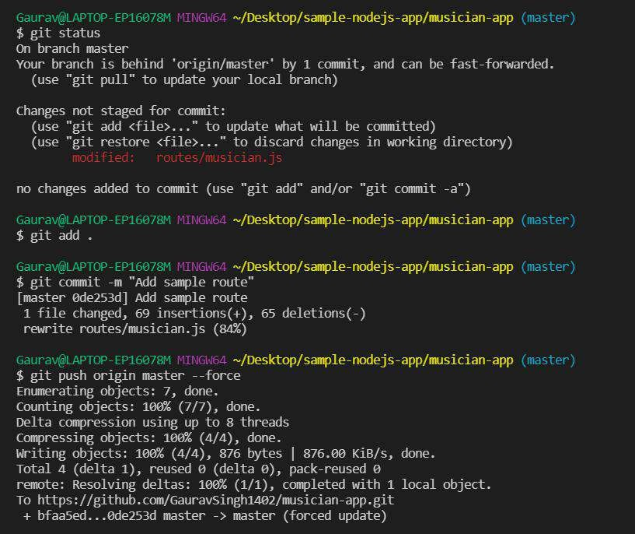

1. After commiting the changes, the pipeline will automatically detect it and deploy the changes.

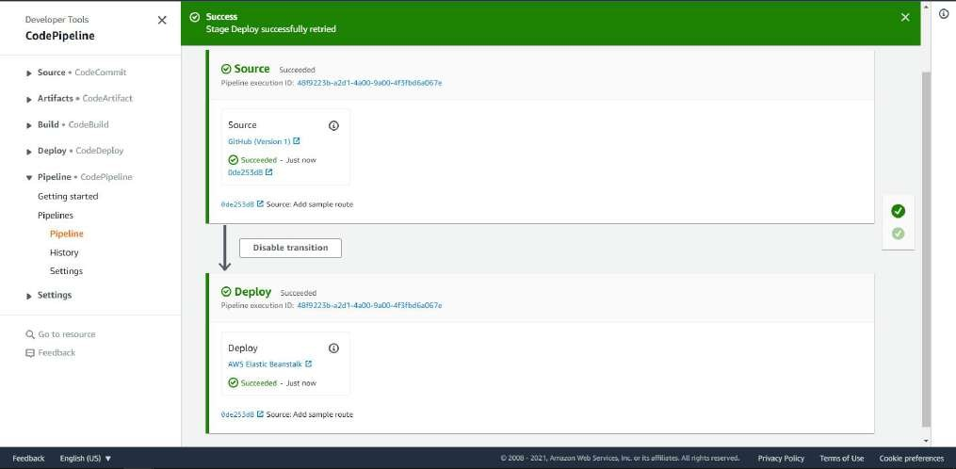

1. After the new automatic deployment has finished, we can go the URL and check the new sample route. The sample route will display the response as specified in the code.



1. Everytime new changes are pushed to the repository, the pipeline will automatically detect and deploy the changes.
2. Thus, we have successfully implemented a CI/CD pipeline job for a node.js application using AWS CodePipeline.